**NAME:**

**PAPER A**

**Date to be handed in:**

**MARK (out of 100):**

|  |  |  |  |  |  |  |  |  |  |  |  |  |  |
| --- | --- | --- | --- | --- | --- | --- | --- | --- | --- | --- | --- | --- | --- |
| **Qu** | **1** | **2** | **3** | **4** | **5** | **6** | **7** | **8** | **9** | **10** | **11** | **12** | **13** |
|  |  |  |  |  |  |  |  |  |  |  |  |  |  |

**Practice Paper A:**

**Time 2 hours**

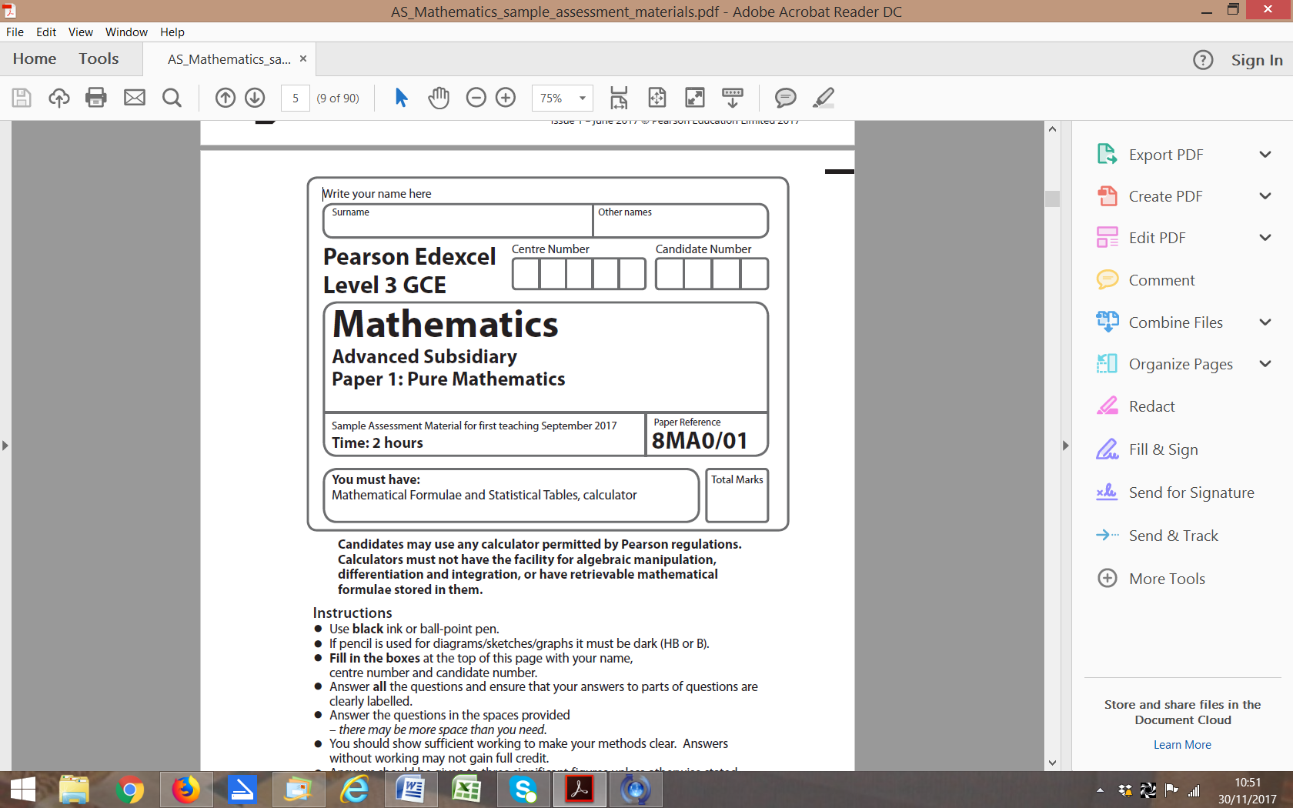

**Questions to revise:**

1. Prove that, for all values of *x*,

.

**(Total 4 marks)**

**___________________________________________________________________________**

**2.** (*a*)Find an equation of the straight line passing through the points with coordinates (4, −7) and (−6, 11), giving your answer in the form *ax* + *by* + *c* = 0,where *a*, *b* and *c* are integers.

**(3)**

The line crosses the *x*-axis at point *A* and the *y*-axis at point *B* and *O* is the origin.

(*b*) Find the area of triangle *AOB*.

**(3)**

**(Total 6 marks)**

**___________________________________________________________________________**

**3**. Find, to 1 decimal place, the values of *θ* in the interval 0 ⩽ *θ* ⩽ 180° for which

4√3 sin (3*θ* + 20°) = 4 cos (3*θ* + 20°).

**(Total 6 marks)**

**___________________________________________________________________________**

**4.** log11 (2*x* – 1) = 1 – log11(*x* + 4).

Find the value of *x*showing detailed reasoning.

**(Total 6 marks)**

**___________________________________________________________________________**

**5.** Given that the resultant of the vectors **a** = 2*p***i** – 5**j** and **b** = 6**i** – 3*p***j** is parallel to the vector **c**= 4**i** – 5**j**,

(*a*) find the value of *p*,

**(4)**

(*b*) find the resultant of the vectors **a** and **b**.

**(2)**

**(Total 6 marks)**

**___________________________________________________________________________**

**6.** The population, *P*, of bacteria in an experiment can be modelled by the formula *P* = 100e0.4*t*, where *t* is the time in hours after the experiment began.

(*a*) Use the model to estimate the population of bacteria 7 hours after the experiment began.

**(2)**

(*b*) Interpret the meaning of the constant 100 in the model.

**(1)**

(*c*) How many whole hours after the experiment began does the population of bacteria first exceed 1 million, according to the model?

**(3)**

**(Total 6 marks)**

**___________________________________________________________________________**

**7.** The line with equation *mx* – *y* – 2 = 0 touches the circle with equation *x*2 + 6*x* +*y*2 – 8*y* = 4.

Find the two possible values of *m*, giving your answersin exact form.

**(Total 7 marks)**

**___________________________________________________________________________**

**8.** Given that point *A* has the position vector 4**i** + 7**j** and point *B* has the position vector 10**i** + *q***j**, where *q* is a constant, find

(*a*) the vector in terms of *q*.

**(2)**

(*b*) Given further that, find the two possible values of *q* showing detailed reasoning in your working.

**(5)**

**(Total 7 marks)**

**___________________________________________________________________________**

**9.** (*a*) Find thefirst four terms, in ascending powers of *x*, of the binomial expansion of (2 + *px*)9.

**(4)**

Given that the coefficient of the *x*3 term in the expansion is −84.

(*b*) (i) Find the value of *p*.

**(2)**

(ii) Find the numerical values for the coefficients of the *x* and *x*2 terms.

**(2)**

**(8 marks)**

**___________________________________________________________________________**

**10.** The diagram shows the position of three boats, *P*, *Q* and *R*. Boat *Q* is 7 km from boat *P* on a bearing of 327°. Boat *R* is 15 km from boat *P* on a bearing of 041°.

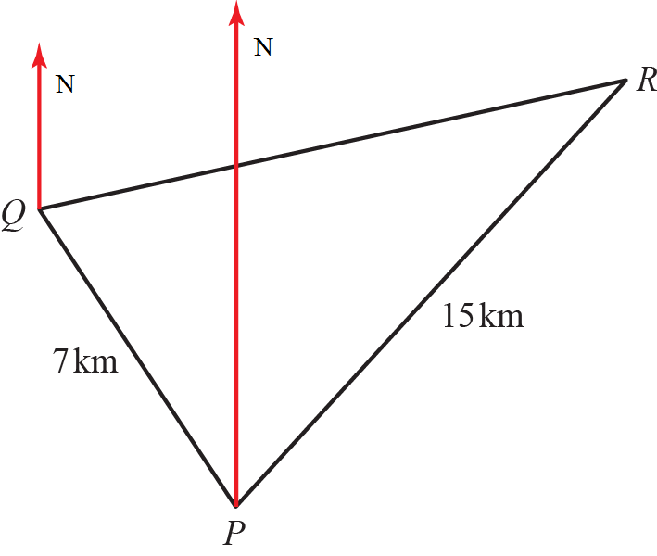

(*a*) Find the distance between boats *Q* and *R* to 1 decimal place.

**(5)**

(*b*) Find the 3 figure bearing of boat *R* from boat *Q*.

**(5)**

**(10 marks)**

**___________________________________________________________________________**

**11.** A fish tank in the shape of a cuboid is to be made from 1600 cm2 of glass.  
The fish tank will have a square base of side length *x* cm, and no lid. No glass is wasted.  
The glass can be assumed to be very thin.

(*a*) Show that the volume, *V* cm3, of the fish tank is given by 

**(5)**

(*b*) Given that *x* can vary, use differentiation to find the maximum or minimum value of *V*.

**(4)**

(*c*) Justify that the value of *V* you found in part **b** is a maximum.

**(2)**

**(Total 11 marks)**

**___________________________________________________________________________**

**12.** The graph shows part of the curve *C* with equation 

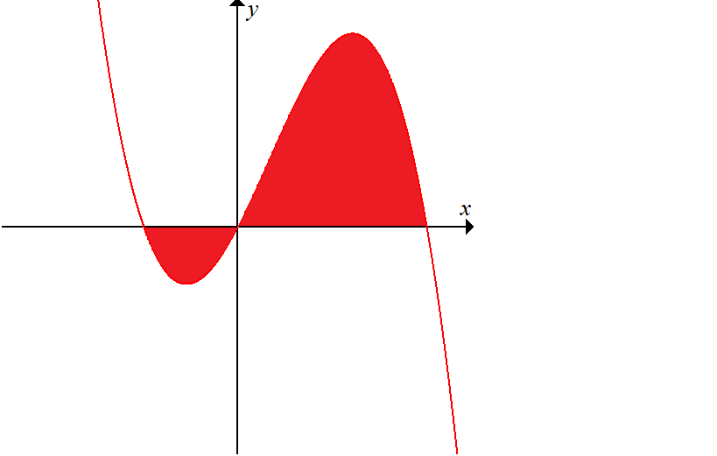

**Figure 1**

The curve *C* crosses the *x*-axis at the origin *O* and at points *A* and *B*.

(*a*) Using an appropriate algebraic method, find the coordinates of *A* and *B*.

**(3)**

(*b*) The finite region shown shaded is bounded by the curve *C* and the *x*-axis.  
 Use calculus to find the total area of the shaded region.

**(8)**

**(Total 11 marks)**

**___________________________________________________________________________**

**13. **,  ****.

(*a*) Solve the equation q(*x*) = 0. Write your answer in the form where *a* and *b* are integers to be found.

**(2)**

(*b*) Sketch the graphs of *y* = p(*x*) and *y* = q(*x*) on the same set of axes.   
 Label all points where the curves intersect the coordinate axes.

**(4)**

(*c*) Use an algebraic method to find the coordinates of any point of intersection of the graphs *y* = p(*x*) and *y* = q(*x*).

**(4)**

(*d*) Write down, using set notation, the set of values of *x* for which p(*x*) < q(*x*).

**(2)**

**(Total 12 marks)**

**___________________________________________________________________________**

**END OF PAPER (TOTAL: 100 MARKS)**

**BLANK PAGE**