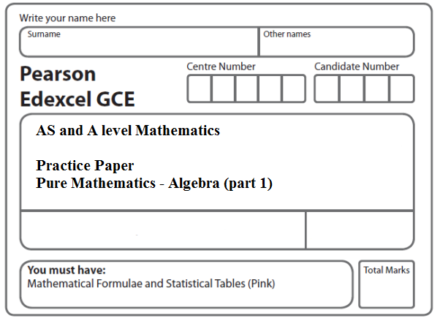
Instructions
- Use black ink or ball-point pen.
- If pencil is used for diagrams/sketches/graphs it must be dark (HB or B).
- Fill in the boxes at the top of this page with your name, centre number and candidate number.
- Answer all the questions and ensure that your answers to parts of questions are clearly labelled.
- Answer the questions in the spaces provided – there may be more space than you need.
- You should show sufficient working to make your methods clear. Answers without working may not gain full credit.
- Inexact answers should be given to three significant figures unless otherwise stated.
Information
- A booklet ‘Mathematical Formulae and Statistical Tables’ is provided.
- There are 17 questions in this question paper. The total mark for this paper is 80.
- The marks for each question are shown in brackets – use this as a guide as to how much time to spend on each question.
- Calculators must not be used for questions marked with a * sign.
Advice
• Read each question carefully before you start to answer it.
• Try to answer every question.
• Check your answers if you have time at the end.
• If you change your mind about an answer, cross it out and put your new answer and any working underneath.
1*. Show that $\frac{2}{√\text{12}−√8}$ can be written in the form √a + √b, where a and b are integers.
(Total 5 marks)
___________________________________________________________________________

2*. (a) Simplify

giving your answer in the form a, where a is an integer.
(2)
(b) Hence, or otherwise, simplify

giving your answer in the form b, where b and c are integers and b ≠ 1
(3)
(Total 5 marks)
___________________________________________________________________________
3*. (a) Write down the value of ${\text{32}}^{\frac{1}{5}}$
(1)
(b) Simplify fully $(\text{32}x^{5})^{−\frac{2}{5}}$
(3)
(Total 4 marks)
___________________________________________________________________________
4*. (a) Evaluate
(2)
(b) Simplify fully
(2)
(Total 4 marks)
___________________________________________________________________________

5*. (a) Find the value of ${\text{16}}^{−\frac{1}{4}}$
(2)
(b) Simplify $x{\left(2x^{−\frac{1}{4}}\right)}^{4}$
(2)
(Total 4 marks)
___________________________________________________________________________

6*. (a) Evaluate $(\text{32})^{\frac{3}{5}}$, giving your answer as an integer.
(2)
(b) Simplify fully ${\left(\frac{\text{25}x^{4}}{4}\right)}^{−\frac{1}{2}}$
(2)
(Total 4 marks)
___________________________________________________________________________
7*. (a) Find the value of $8^{\frac{5}{3}}$
(2)
(b) Simplify fully $\frac{(2x^{\frac{1}{2}})^{3}}{4x^{2}}$
(3)
(Total 5 marks)
___________________________________________________________________________

8*. Express 8^{2x + 3} in the form 2^{y}, stating y in terms of x.
(Total 2 marks)
___________________________________________________________________________

9*. Express 9^{3x + 1} in the form 3^{y}, giving y in the form ax + b, where a and b are constants.
(Total 2 marks)
___________________________________________________________________________
10*. f(x) = x² – 8x + 19
(a) Express f(x) in the form (x + a)² + b, where a and b are constants.
(2)

The curve C with equation y = f(x) crosses the y-axis at the point P and has a minimum
point at the point Q.
(b) Sketch the graph of C showing the coordinates of point P and the coordinates of
point Q.
(3)
(c) Find the distance PQ, writing your answer as a simplified surd.
(3)
(Total 8 marks)
___________________________________________________________________________

11*. f(x) = x² + (k + 3)x + k,
where k is a real constant.
(a) Find the discriminant of f(x) in terms of k.
(2)
(b) Show that the discriminant of f(x) can be expressed in the form (k + a)² + b, where a and b are integers to be found.
(2)
(c) Show that, for all values of k, the equation f(x) = 0 has real roots.
(2)
(Total 6 marks)
___________________________________________________________________________

12*. 4x – 5 – x² = q – (x + p)²,

where p and q are integers.
(a) Find the value of p and the value of q.
(3)
(b) Calculate the discriminant of 4x – 5 – x².
(2)
(c) Sketch the curve with equation y = 4x – 5 – x², showing clearly the coordinates of any points where the curve crosses the coordinate axes.
(3)
(Total 8 marks)
___________________________________________________________________________

13*. Given that y = 2^{x},
(a) express 4^{x} in terms of y.
(1)
(b) Hence, or otherwise, solve
8(4^{x}) – 9(2^{x}) + 1 = 0.
(4)
(Total 5 marks)
___________________________________________________________________________

14*. Factorise completely x − 4x³
(Total 3 marks)
___________________________________________________________________________

15*. Factorise fully 25x – 9x³
(Total 3 marks)
___________________________________________________________________________

16. f(x) = 2x³ – 7x² – 10x + 24.

(a) Use the factor theorem to show that (x + 2) is a factor of f(x).
(2)
(b) Factorise f(x) completely.
(4)
(Total 6 marks)
___________________________________________________________________________

17. f(x) = 2x³ – 7x² + 4x + 4.
(a) Use the factor theorem to show that (x – 2) is a factor of f(x).
(2)
(b) Factorise f(x) completely.
(4)
(Total 6 marks)

TOTAL FOR PAPER: 80 MARKS

