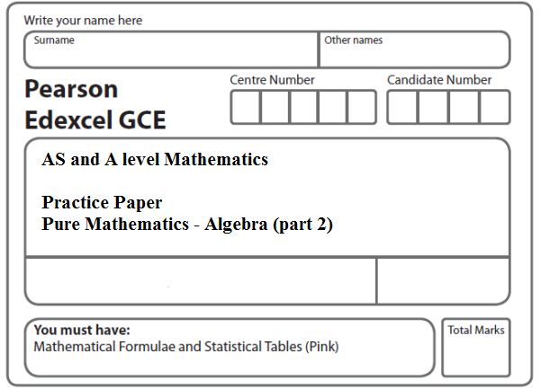
Instructions
- Use black ink or ball-point pen.
- If pencil is used for diagrams/sketches/graphs it must be dark (HB or B).
- Fill in the boxes at the top of this page with your name, centre number and candidate number.
- Answer all the questions and ensure that your answers to parts of questions are clearly labelled.
- Answer the questions in the spaces provided – there may be more space than you need.
- You should show sufficient working to make your methods clear. Answers without working may not gain full credit.
- Inexact answers should be given to three significant figures unless otherwise stated.
Information
- A booklet ‘Mathematical Formulae and Statistical Tables’ is provided.
- There are 12 questions in this question paper. The total mark for this paper is 85.
- The marks for each question are shown in brackets – use this as a guide as to how much time to spend on each question.
- Calculators must not be used for all questions.
Advice
• Read each question carefully before you start to answer it.
• Try to answer every question.
• Check your answers if you have time at the end.
• If you change your mind about an answer, cross it out and put your new answer and any working underneath.
1. Solve the simultaneous equations
x + y = 2
4y² – x² = 11
(Total 7 marks)
___________________________________________________________________________

2. Solve the simultaneous equations

y + 4x + 1 = 0

y² + 5x² + 2x = 0
(Total 6 marks)
___________________________________________________________________________

3. Solve the simultaneous equations
y – 2x – 4 = 0
4x² + y² + 20x = 0
(Total 7 marks)
___________________________________________________________________________

4. Given the simultaneous equations
2x + y = 1
x² – 4ky + 5k = 0
where k is a non zero constant,
(a) show that x² + 8kx + k = 0.
(2)
Given that x² + 8kx + k = 0 has equal roots,
(b) find the value of k.
(3)
(c) For this value of k, find the solution of the simultaneous equations.
(3)
(Total 8 marks)
___________________________________________________________________________

5. Find the set of values of x for which

(a) 4x − 5 > 15 − x,
(2)
(b) x(x − 4) > 12.
(4)
(Total 6 marks)
___________________________________________________________________________

6. Find the set of values of x for which
(a) 2(3x + 4) > 1 – x,
(2)
(b) 3x² + 8x – 3 < 0.
(4)
(Total 6 marks)
___________________________________________________________________________

7. Find the set of values of x for which
(a) 3x – 7 > 3 – x,
(2)
(b) x² – 9x ≤ 36,
(4)
(c) both 3x – 7 > 3 – x and x² – 9x ≤ 36.
(1)
(Total 7 marks)
___________________________________________________________________________

8. The equation x² + (k − 3)x + (3 − 2k) = 0, where k is a constant, has two distinct real roots.
(a) Show that k satisfies
k² + 2k − 3 > 0
(3)
(b) Find the set of possible values of k.
(4)
(Total 7 marks)
___________________________________________________________________________

9. The equation
(k + 3)x² + 6x + k = 5, where k is a constant,
has two distinct real solutions for x.
(a) Show that k satisfies
k² − 2k − 24 < 0.
(4)
(b) Hence find the set of possible values of k.
(3)
(Total 7 marks)
___________________________________________________________________________

10. The equation
(p – 1)x² + 4x + (p – 5) = 0, where p is a constant,
has no real roots.
(a) Show that p satisfies p² – 6p + 1 > 0.
(3)
(b) Hence find the set of possible values of p.
(4)
(Total 7 marks)
___________________________________________________________________________

11. The straight line with equation y = 3x – 7 does not cross or touch the curve with equation y = 2px² – 6px + 4p, where p is a constant.

(a) Show that 4p² – 20p + 9 < 0.
(4)
(b) Hence find the set of possible values of p.
(4)
(Total 8 marks)
___________________________________________________________________________

12.
Figure 1

Figure 1 shows the plan of a garden. The marked angles are right angles.
The six edges are straight lines.
The lengths shown in the diagram are given in metres.
Given that the perimeter of the garden is greater than 40 m,
(a) show that x > 1.7.
(3)
Given that the area of the garden is less than 120 m²,
(b) form and solve a quadratic inequality in x.
(5)
(c) Hence state the range of the possible values of x.
(1)
(Total 9 marks)

TOTAL FOR PAPER: 85 MARKS

