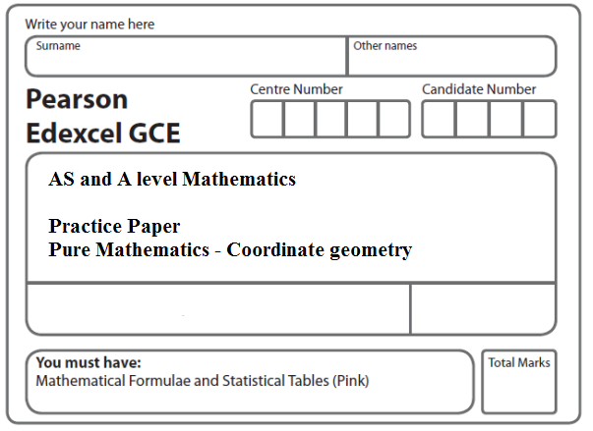
Instructions
- Use black ink or ball-point pen.
- If pencil is used for diagrams/sketches/graphs it must be dark (HB or B).
- Fill in the boxes at the top of this page with your name, centre number and candidate number.
- Answer all the questions and ensure that your answers to parts of questions are clearly labelled.
- Answer the questions in the spaces provided – there may be more space than you need.
- You should show sufficient working to make your methods clear. Answers without working may not gain full credit.
- Inexact answers should be given to three significant figures unless otherwise stated.
Information
- A booklet ‘Mathematical Formulae and Statistical Tables’ is provided.
- There are 12 questions in this question paper. The total mark for this paper is 100.
- The marks for each question are shown in brackets – use this as a guide as to how much time to spend on each question.
- Calculators must not be used for questions marked with a * sign.
Advice
• Read each question carefully before you start to answer it.
• Try to answer every question.
• Check your answers if you have time at the end.
• If you change your mind about an answer, cross it out and put your new answer and any working underneath.
1*. The points P and Q have coordinates (–1, 6) and (9, 0) respectively.
The line l is perpendicular to PQ and passes through the mid-point of PQ.
Find an equation for l, giving your answer in the form ax + by + c = 0, where a, b and c are integers.
(Total 5 marks)
___________________________________________________________________________

2*.
Figure 1

Figure 1 shows a right angled triangle LMN.
The points L and M have coordinates (–1, 2) and (7, –4) respectively.
(a) Find an equation for the straight line passing through the points L and M.
Give your answer in the form ax + by + c = 0, where a, b and c are integers.
(4)
Given that the coordinates of point N are (16, p), where p is a constant, and angle LMN = 90°,
(b) find the value of p.
(3)
Given that there is a point K such that the points L, M, N, and K form a rectangle,
(c) find the y coordinate of K.
(2)
(Total 9 marks)
___________________________________________________________________________

3*.

The straight line l₁ , shown in Figure 1, has equation 5y = 4x + 10
The point P with x coordinate 5 lies on l₁
The straight line l₂ is perpendicular to l₁ and passes through P.
(a) Find an equation for l₂ , writing your answer in the form ax + by + c = 0 where a, b
and c are integers.
(4)

The lines l₁ and l₂ cut the x-axis at the points S and T respectively, as shown in Figure 1.
(b) Calculate the area of triangle SPT.
(4)
(Total 8 marks)
___________________________________________________________________________
4*.
Figure 2

The line l₁, shown in Figure 2 has equation 2x + 3y = 26.
The line l₂ passes through the origin O and is perpendicular to l₁.
(a) Find an equation for the line l₂.
(4)
The line l₂ intersects the line l₁ at the point C. Line l₁ crosses the y-axis at the point B as shown in Figure 2.
(b) Find the area of triangle OBC. Give your answer in the form $\frac{a}{b}$, where a and b are integers to be determined.
(6)
(Total 10 marks)
___________________________________________________________________________

5*. The line L₁ has equation 4y + 3 = 2x.
The point A (p, 4) lies on L₁.
(a) Find the value of the constant p.
(1)
The line L₂ passes through the point C (2, 4) and is perpendicular to L₁.
(b) Find an equation for L₂ giving your answer in the form ax + by + c = 0, where a, b and c are integers.
(5)
The line L₁ and the line L₂ intersect at the point D.
(c) Find the coordinates of the point D.
(3)
(d) Show that the length of CD is $\frac{3}{2}$√5.
(3)
A point B lies on L₁ and the length of AB = √80.
The point E lies on L₂ such that the length of the line CDE = 3 times the length of CD.
(e) Find the area of the quadrilateral ACBE.
(3)
(Total 15 marks)
___________________________________________________________________________

6*.

Figure 3

The points P (0, 2) and Q (3, 7) lie on the line l₁, as shown in Figure 3.

The line l₂ is perpendicular to l₁, passes through Q and crosses the x-axis at the point R, as shown in Figure 3.

Find

(a) an equation for l₂, giving your answer in the form ax + by + c = 0, where a, b and c are integers,
(5)
(b) the exact coordinates of R,
(2)
(c) the exact area of the quadrilateral ORQP, where O is the origin.
(5)
(Total 12 marks)
___________________________________________________________________________

7. A circle C has centre (−1, 7) and passes through the point (0, 0). Find an equation for C.

(Total 4 marks)
___________________________________________________________________________

8.

Figure 4

The circle C has centre P(7, 8) and passes through the point Q(10, 13), as shown in Figure 4.

(a) Find the length PQ, giving your answer as an exact value.
(2)

(b) Hence write down an equation for C.
(2)

The line l is a tangent to C at the point Q, as shown in Figure 4.

(c) Find an equation for l, giving your answer in the form ax + by + c = 0, where a, b and c are integers.
(4)
(Total 8 marks)
___________________________________________________________________________
9. The circle C has equation
x² + y² + 4x − 2y −11 = 0.
Find
(a) the coordinates of the centre of C,
(2)
(b) the radius of C,
(2)
(c) the coordinates of the points where C crosses the y-axis, giving your answers as simplified surds.
(4)
(Total 8 marks)
___________________________________________________________________________

10. The circle C has equation
x² + y² – 10x + 6y + 30 = 0
Find
(a) the coordinates of the centre of C,
(2)
(b) the radius of C,
(2)
(c) the y coordinates of the points where the circle C crosses the line with equation x = 4,
giving your answers as simplified surds.
(3)
(Total 7 marks)
___________________________________________________________________________

11.
Figure 5

Figure 5 shows a circle C with centre Q and radius 4 and the point T which lies on C. The tangent to C at the point T passes through the origin O and OT = 6√5.
Given that the coordinates of Q are (11, k), where k is a positive constant,
(a) find the exact value of k,
(3)
(b) find an equation for C.
(2)
(Total 5 marks)
___________________________________________________________________________

12. The circle C, with centre A, passes through the point P with coordinates (–9, 8)
and the point Q with coordinates (15, –10).
Given that PQ is a diameter of the circle C,
(a) find the coordinates of A,
(2)
(b) find an equation for C.
(3)
A point R also lies on the circle C.
Given that the length of the chord PR is 20 units,
(c) find the length of the shortest distance from A to the chord PR.
Give your answer as a surd in its simplest form.
(2)
(d) Find the size of the angle ARQ, giving your answer to the nearest 0.1 of a degree.
(2)
(Total 9 marks)

TOTAL FOR PAPER: 100 MARKS

