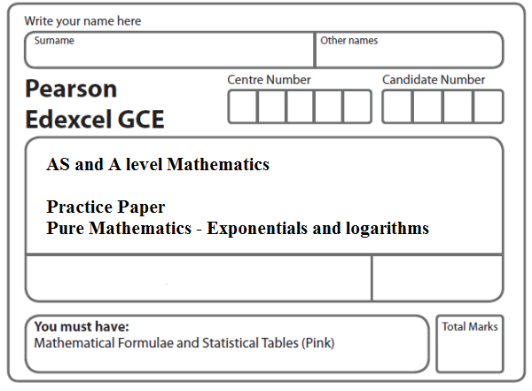
Instructions
- Use black ink or ball-point pen.
- If pencil is used for diagrams/sketches/graphs it must be dark (HB or B).
- Fill in the boxes at the top of this page with your name, centre number and candidate number.
- Answer all the questions and ensure that your answers to parts of questions are clearly labelled.
- Answer the questions in the spaces provided – there may be more space than you need.
- You should show sufficient working to make your methods clear. Answers without working may not gain full credit.
- Inexact answers should be given to three significant figures unless otherwise stated.
Information
- A booklet ‘Mathematical Formulae and Statistical Tables’ is provided.
- There are 12 questions in this question paper. The total mark for this paper is 79.
- The marks for each question are shown in brackets – use this as a guide as to how much time to spend on each question.
Advice
• Read each question carefully before you start to answer it.
• Try to answer every question.
• Check your answers if you have time at the end.
• If you change your mind about an answer, cross it out and put your new answer and any working underneath.
1. Find the values of x such that
2 log₃ x – log₃(x – 2) = 2
(Total 5 marks)
___________________________________________________________________________

2. Given that y = 3x²,
(a) show that log₃ y = 1 + 2 log₃ x.
(3)
(b) Hence, or otherwise, solve the equation
1 + 2 log₃ x = log₃ (28x − 9).
(3)
(Total 6 marks)
___________________________________________________________________________

3. Given that 2 log₂ (x + 15) − log₂ x = 6,
(a) show that x² − 34x + 225 = 0.
(5)
(b) Hence, or otherwise, solve the equation 2 log₂ (x + 15) − log₂ x = 6.
(2)
(Total 7 marks)
___________________________________________________________________________

4. (i) Find the exact value of x for which
log₂ (2x) = log₂ (5x + 4) – 3.
(4)
(ii) Given that
log_{a} y + 3 log_{a} 2 = 5,
express y in terms of a.
Give your answer in its simplest form.
(3)
(Total 7 marks)
___________________________________________________________________________

5. (i) 2 log(x + a) = log(16a⁶), where a is a positive constant
Find x in terms of a, giving your answer in its simplest form.
(3)
(ii) log₃(9y + b) – log₃(2y – b) = 2, where b is a positive constant
Find y in terms of b, giving your answer in its simplest form.
(4)
(Total 7 marks)
___________________________________________________________________________

6. Find, giving your answer to 3 significant figures where appropriate, the value of x for which
(a) 5^{x} = 10,
(2)
(b) log₃ (x − 2) = −1 .
(2)
(Total 4 marks)
___________________________________________________________________________

7. Find the exact solutions, in their simplest form, to the equations
(a) e^{3x – 9} = 8
(Total 3 marks)
___________________________________________________________________________
8. f(x) = –6x³ – 7x² + 40x + 21
(a) Use the factor theorem to show that (x + 3) is a factor of f(x)
(2)
(b) Factorise f(x) completely.
(4)
(c) Hence solve the equation
6(2^{3y}) + 7(2^{2y}) = 40(2^{y}) + 21
giving your answer to 2 decimal places.
(3)
(Total 9 marks)
___________________________________________________________________________

9. (i) Use logarithms to solve the equation 8^{2x + 1} = 24, giving your answer to 3 decimal places.
(3)
(ii) Find the values of y such that
log₂ (11y – 3) – log₂ 3 – 2 log₂ y = 1, y > $\frac{3}{\text{11}}$
(6)
(Total 9 marks)
___________________________________________________________________________

10. (i) Given that

log₃(3b + 1) – log₃(a – 2) = –1, a > 2,

express b in terms of a.
(3)
(ii) Solve the equation

2^{2x + 5} – 7(2^{x}) = 0,

giving your answer to 2 decimal places.

(Solutions based entirely on graphical or numerical methods are not acceptable.)
(4)
(Total 7 marks)
___________________________________________________________________________

11. (i) Solve
5^{y} = 8
giving your answers to 3 significant figures.
(2)
(ii) Use algebra to find the values of x for which
(6)
(Total 8 marks)
___________________________________________________________________________
12. (a) Sketch the graph of
y = 3^{x}, x ∈ ℝ,
showing the coordinates of any points at which the graph crosses the axes.
(2)
(b) Use algebra to solve the equation 3^{2x} – 9(3^{x}) + 18 = 0, giving your answers to 2 decimal places where appropriate.
(5)
(Total 7 marks)

TOTAL FOR PAPER: 79 MARKS

