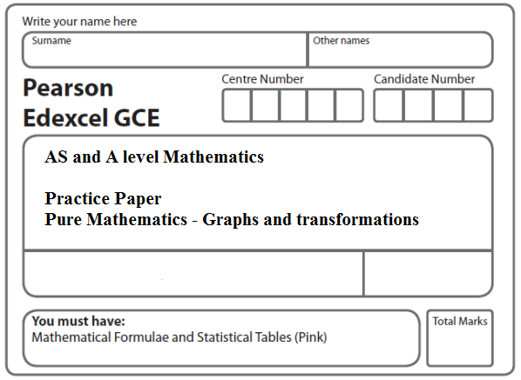
Instructions
- Use black ink or ball-point pen.
- If pencil is used for diagrams/sketches/graphs it must be dark (HB or B).
- Fill in the boxes at the top of this page with your name, centre number and candidate number.
- Answer all the questions and ensure that your answers to parts of questions are clearly labelled.
- Answer the questions in the spaces provided – there may be more space than you need.
- You should show sufficient working to make your methods clear. Answers without working may not gain full credit.
- Inexact answers should be given to three significant figures unless otherwise stated.
Information
- A booklet ‘Mathematical Formulae and Statistical Tables’ is provided.
- There are 12 questions in this question paper. The total mark for this paper is 100.
- The marks for each question are shown in brackets – use this as a guide as to how much time to spend on each question.
- Calculators must not be used for all questions.
Advice
• Read each question carefully before you start to answer it.
• Try to answer every question.
• Check your answers if you have time at the end.
• If you change your mind about an answer, cross it out and put your new answer and any working underneath.
1.
Figure 1

Figure 1 shows a sketch of the curve C with equation
y = $\frac{1}{x}$ + 1, x ≠ 0.
The curve C crosses the x-axis at the point A.
(a) State the x-coordinate of the point A.
(1)
The curve D has equation y = x²(x – 2), for all real values of x.
(b) On a copy of Figure 1, sketch a graph of curve D. Show the coordinates of each point where the curve D crosses the coordinate axes.
(3)
(c) Using your sketch, state, giving a reason, the number of real solutions to the equation
x²(x – 2) = $\frac{1}{x}$ + 1
(1)
(Total 5 marks)
___________________________________________________________________________

2.

Figure 2

Figure 2 shows a sketch of part of the curve with equation y = f(x). The curve has a maximum point A at (–2, 4) and a minimum point B at (3, –8) and passes through the origin O.

On separate diagrams, sketch the curve with equation

(a) y = 3f(x),
(2)
(b) y = f(x) – 4.
(3)

On each diagram, show clearly the coordinates of the maximum and the minimum points and the coordinates of the point where the curve crosses the y-axis.
(Total 5 marks)

___________________________________________________________________________

3.

Figure 3

Figure 3 shows a sketch of the curve with equation y = f(x) where
f(x) = $\frac{x}{x−2}$, x ≠ 2.
The curve passes through the origin and has two asymptotes, with equations y = 1 and x = 2, as shown in Figure 1.
(a) In the space below, sketch the curve with equation y = f(x − 1) and state the equations of the asymptotes of this curve.
(3)
(b) Find the coordinates of the points where the curve with equation y = f(x − 1) crosses the coordinate axes.
(4)
(Total 7 marks)
___________________________________________________________________________

4.

Figure 4

Figure 4 shows a sketch of the curve with equation y = $\frac{2}{x}$, x ≠ 0.
The curve C has equation y = $\frac{2}{x}$ − 5, x ≠ 0, and the line l has equation y = 4x + 2.
(a) Sketch and clearly label the graphs of C and l on a single diagram.
On your diagram, show clearly the coordinates of the points where C and l cross the coordinate axes.
(5)
(b) Write down the equations of the asymptotes of the curve C.
(2)
(c) Find the coordinates of the points of intersection of y = $\frac{2}{x}$ − 5 and y = 4x + 2.
(5)
(Total 12 marks)
___________________________________________________________________________

5. (a) Factorise completely 9x – 4x³.
(3)
(b) Sketch the curve C with equation
y = 9x – 4x³.
Show on your sketch the coordinates at which the curve meets the x-axis.
(3)
The points A and B lie on C and have x coordinates of –2 and 1 respectively.
(c) Show that the length of AB is k √10, where k is a constant to be found.
(4)
(Total 10 marks)
___________________________________________________________________________

6.

Figure 5

Figure 5 shows a sketch of the curve C with equation y = f(x).
The curve C passes through the origin and through (6, 0).
The curve C has a minimum at the point (3, –1).
On separate diagrams, sketch the curve with equation
(a) y = f(2x),
(3)
(b) y = −f(x),
(3)
(c) y = f(x + p), where p is a constant and 0 < p < 3.
(4)
On each diagram show the coordinates of any points where the curve intersects the x-axis and of any minimum or maximum points.
(Total 10 marks)
___________________________________________________________________________
7.

Figure 6

Figure 6 shows a sketch of the curve with equation y = f(x) where
f(x) = (x + 3)² (x – 1), x ∈ℝ.
The curve crosses the x-axis at (1, 0), touches it at (–3, 0) and crosses the y-axis at (0, –9).
(a) Sketch the curve C with equation y = f(x + 2) and state the coordinates of the points where the curve C meets the x-axis.
(3)
(b) Write down an equation of the curve C.
(1)
(c) Use your answer to part (b) to find the coordinates of the point where the curve C meets the y-axis.
(2)
(Total 6 marks)
___________________________________________________________________________

8. (a) On separate axes sketch the graphs of
(i) y = –3x + c, where c is a positive constant,
(ii)
On each sketch show the coordinates of any point at which the graph crosses the
y-axis and the equation of any horizontal asymptote.
(4)
Given that y = –3x + c, where c is a positive constant, meets the curve at two
distinct points,
(b) show that (5 – c)² > 12
(3)
(c) Hence find the range of possible values for c.
(4)
(Total 11 marks)
___________________________________________________________________________

9. 4x² + 8x + 3 ≡ a(x + b)² + c
(a) Find the values of the constants a, b and c.
(3)
(b) Sketch the curve with equation y = 4x² + 8x + 3, showing clearly the coordinates of any points where the curve crosses the coordinate axes.
(4)
(Total 7 marks)
___________________________________________________________________________

10.

Figure 7

Figure 7 shows a sketch of the curve C with equation y = f(x), where
f(x) = x²(9 – 2x).
There is a minimum at the origin, a maximum at the point (3, 27) and C cuts the x-axis at the point A.
(a) Write down the coordinates of the point A.
(1)
(b) On separate diagrams sketch the curve with equation
- y = f(x + 3),

(ii) y = f(3x).
On each sketch you should indicate clearly the coordinates of the maximum point and any points where the curves cross or meet the coordinate axes.
(6)
The curve with equation y = f(x) + k, where k is a constant, has a maximum point at (3, 10).
(c) Write down the value of k.
(1)
(Total 8 marks)
___________________________________________________________________________

11.

Figure 8

Figure 8 shows a sketch of part of the curve y = f(x), x ∈ ℝ, where
f(x) = (2x – 5)² (x + 3)
(a) Given that
(i) the curve with equation y = f(x) – k, x ∈ ℝ, passes through the origin, find the
value of the constant k,
(ii) the curve with equation y = f(x + c), x ∈ ℝ, has a minimum point at the origin,
find the value of the constant c.
(3)
(b) Show that f ′(x) = 12x² – 16x – 35
(3)

Points A and B are distinct points that lie on the curve y = f(x).
The gradient of the curve at A is equal to the gradient of the curve at B.
Given that point A has x coordinate 3
(c) find the x coordinate of point B.
(5)
(Total 11 marks)
___________________________________________________________________________

12. (a) Sketch the graphs of
(i) y = x(x + 2)(3 − x),
(ii) y = –$\frac{2}{x}$.
showing clearly the coordinates of all the points where the curves cross the coordinate axes.
(6)
(b) Using your sketch state, giving a reason, the number of real solutions to the equation
x(x + 2)(3 – x) + $\frac{2}{x}$ = 0.
(2)
(Total 8 marks)

TOTAL FOR PAPER: 100 MARKS

