**Film Studies yr1**

Evaluative analysis

*Learners must complete an evaluative analysis of their production of between 1600 and 1800 words. This will include reference to the following:*

* **Aims** - the intended genre, where relevant, the intended visual style and the main audience for the production
* **Cinematic influences** on the narrative and visual/audio elements of the production (the short films we watched in class and your own personal feature film / short film choices (for some reason the exam board do not want you to mention TV shows etc.))
* Creating overall **meaning** - an evaluative analysis of how the production creates meanings for the spectator in relation to Film Form.

Learners must submit the evaluative analysis in the form of extended writing. It must be word-processed (typed) and may be illustrated with screen shots or screenplay extracts.

Possible structure:

-Intro

Refer to original assignment brief (which one did you choose and why) and what you wrote in your aims and context. Write story synopsis. Briefly discuss cinematic inspirations (you will want to elaborate later on, on this).

-Paragraph 1 – Genre and Narrative structure

-Paragraph 2 – Cinematography

-Paragraph 3 – Mise en scene

-Paragraph 4 – Sound and Editing

-Paragraph 5 – Short films watched in class

-Conclusion

“Overall I am happy…”

Include word count below conclusion

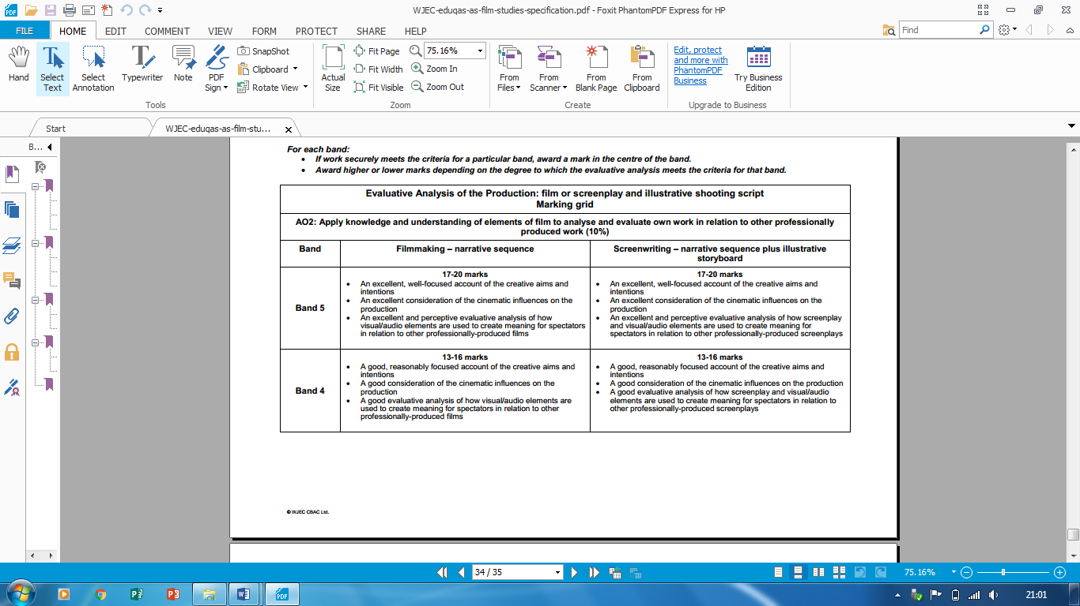

B

A

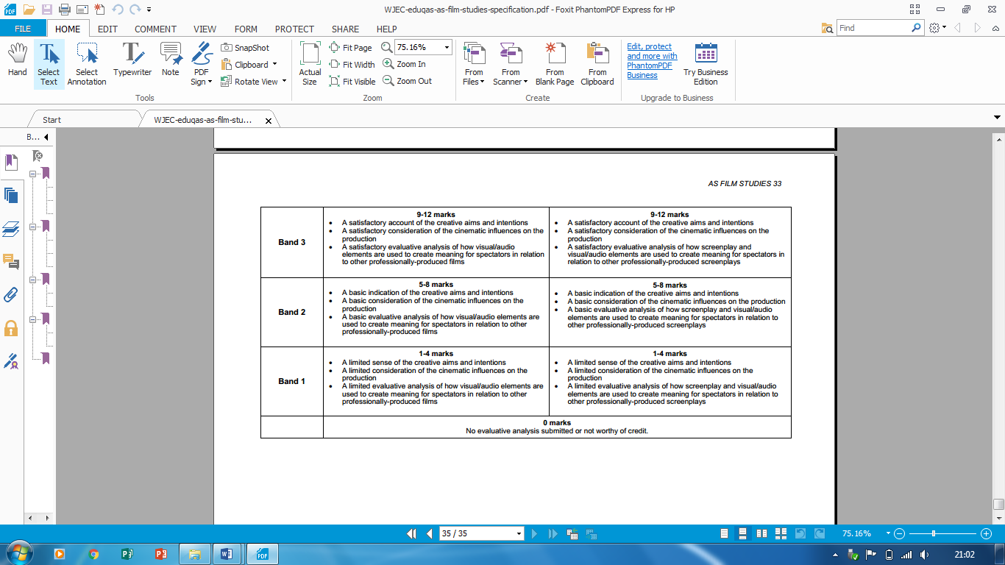

E

D

C