Preparing for Activity 1

Firstly you must obtain a USB (8GB recommended) to keep both Activity folders on –please go to Jono to get it formatted for Mac and PC. The examiner must be able to access your folders easily and find the information they want.

- PRODUCING EVIDENCE OF DIGITAL FILES FOR YOUR DIGITAL PORTFOLIO

As part of Activity 1 you need to create and submit screengrabs of the digital folders for all of your created and sourced materials you will be using in your final product.

I think that the best way to do this is to screenshot your filing system, with separate folders for primary, secondary and audio sources. The examiner does not need to access your files, but need to see you are organised and have labelled files accordingly – e.g. Scene 1 / take 1 / bicycle spokes.

Follow these steps;

- Create a UNIT 3 Digital Media Skills / ACTIVITY 1 / Assets folder (example below).

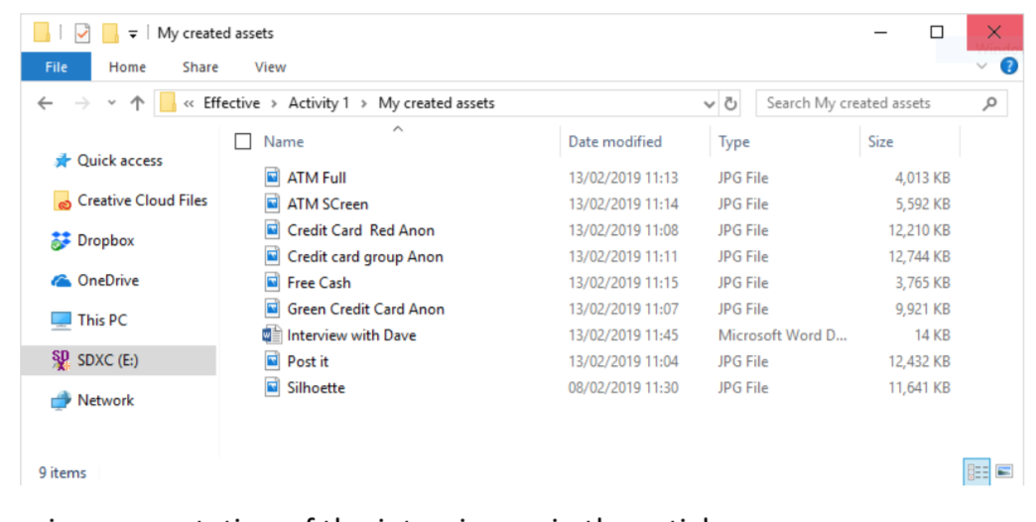

- Label your assets correctly and place them into the correct folders (primary / secondary / audio).

- Make screenshots of the folder system.

- Remember to label the actual files correctly too; ensure it has a file name which relates to the contents; e.g. Crosstown traffic-title sequence – MP3.

- EXPLAINING THE CREATIVE PROCESS

For Activity 1 you also need to provide evidence of ‘how’ you created original assets/material, such as annotated photographs of camera, lighting and audio recording set ups from a video shoot.

Justifications regarding the choice of assets/material from secondary sources and the relevance of the filmed footage in relation to the brief, such as:

I chose this song has it has a mysterious vibe to it and thought it may fit my idea well.

I filmed in this location as it has loads of forest areas which would help give the reserved, isolated feel I wanted to achieve.

Here is a real example of Distinction standard work –

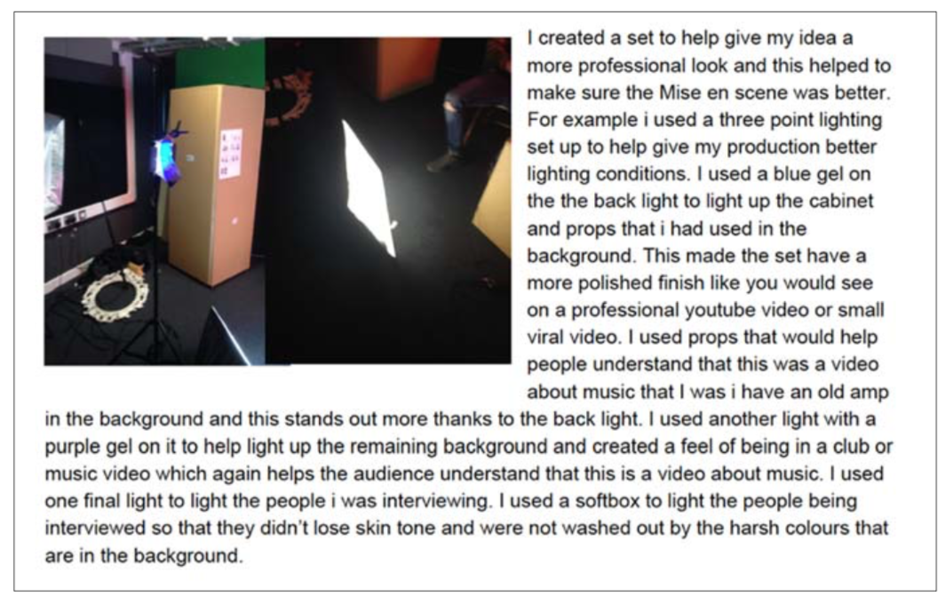
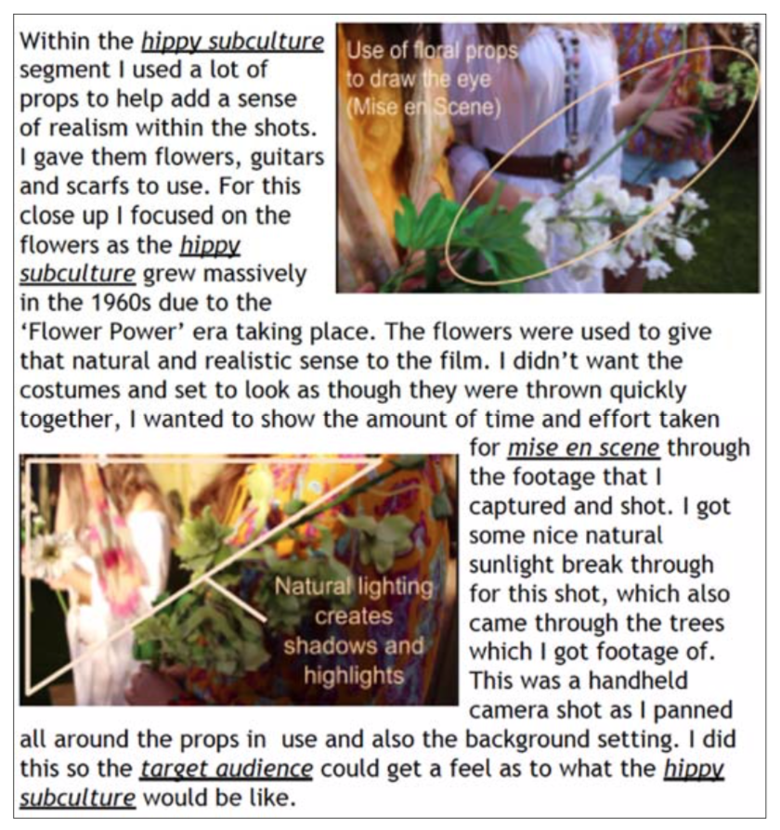

Things you may want to consider in your creative choices –

Lighting – natural / artificial / studio / 3-point / chiaroscuro etc.
Composition – continuity / rule of thirds / mise-en-scene etc.
Continuity set-ups – eye-line match / shot revere shot etc.
Camera framing , angles and movement
Graphics – 3D, 2D, animated etc.
Audio – ambient, diegetic, non-diegetic, parallel / contrapuntal etc.

This is something you can prepare for now – take screengrabs from your footage to evidence your ideas and start to consider the reasons for your creative choices.

- EXPLAINING THE PROCESS OF SOURCING MATERIALS

You will also need to explain the process involved in sourcing assets/material. In other words, you may use assets/material from secondary sources but must demonstrate an understanding of copyright regulations. For example, by considering alternative sources and the clearances/permissions/acknowledgements/royalties/licensing implications that need to be secured/paid/included in their product in order to comply with copyright regulations.

You should explain the process of legally sourcing material from secondary sources for use in the context of the brief i.e. a media product which will be made commercially available to the public by Takeover News Productions.

You should provide evidence of the process of considering different assets/material from secondary sources, which will enable you to provide a justification for the selected assets/material in relation to the brief. So, consider the following;

- Who is the copyright holder? Is it copyright free? Is it from a footage library – if so do they have a rate card?
- How can you contact them? This might take some digging around to find.
- How much would it cost to use the material in the real world for a local news website?
- Is the source material best quality or appropriate for the production?
- Are there alternatives to this material?

DO NOT JUST WRITE – ‘I got it from YouTube, so it is free to use’

Again, this is something you can do now – take screengrabs from the websites you obtained the footage / sound effects / music from. Evidence how you have looked into copyright issues.

ACTIVITY 1 should amount to approx. 5 pages (including screengrabs).

