

How will I be assessed?

This is an evidence based qualification. You will be completing Evidence Booklets as confirmation of your understanding and knowledge of this subject.

You will complete five units throughout the course gathering evidence both in class and while on work experience. To successfully complete each unit, all criterion set out by the exam board must be met to a satisfactory level. Your evidence should demonstrate breadth as well as depth to demonstrate knowledge, understanding and skills of employability.

The evidence booklet will be centre-assessed in the first instance and externally moderated by OCR. All deadlines must be met to ensure you complete the qualification within the timeframe.

What else will I do?

Along with the employability skills qualification you will be working towards gaining level 2 English and Maths qualifications. You will also complete a substantial amount of time on a work placement.

With our assistance, you will be expected to find rewarding employment or work experience that is relevant to your aspirations. You must gain college approval for your placement before you commence your experience as a Health and Safety assessment will need to be completed.

You should work on your evidence booklet whenever possible so that your experiences at work help you gain your employability skills qualification.

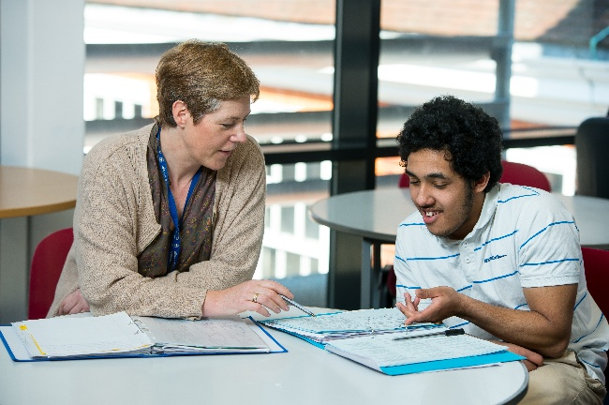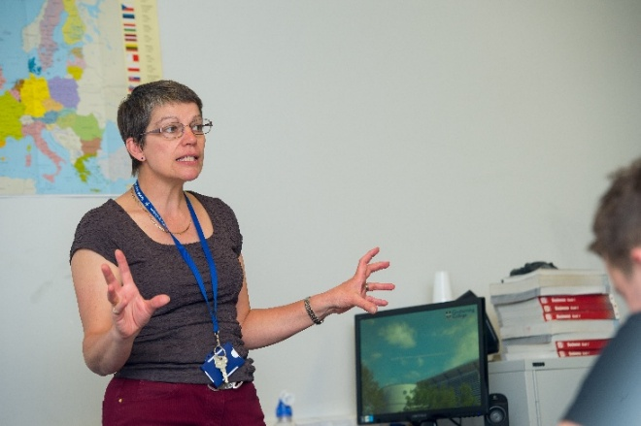

**ACCESS TO EMPLOYMENT**

* Employability Skills Qualification
* English and Maths Qualification
* Work Placement

Tuesley Lane, Godalming

GU7 1RS

T: 01483 423526

E: [college@godalming.ac.uk](mailto:college@godalming.ac.uk)

W: www.godalming.ac.uk

Tuesley Lane

Godalming

Surrey

GU7 1RS

T: 01483

E: [college@godalming.ac.uk](mailto:college@godalming.ac.uk)

W: [www.godalming.ac.uk](http://www.godalming.ac.uk)

This qualification is designed for learners who are seeking to enter employment and wish to develop the skills that will help them overcome barriers to entering employment. It will help you improve your qualifications, confidence and understand of the world of work.

As part of the Access to Employment Course you will spend up to two days a week at work and up to 2.5 days a week at college where you will gain three qualifications:

* Employability Skills
* English Functional Skills
* Use of Maths

The Employability Skills qualification is designed to accredit the knowledge and understanding of learners from a variety of different backgrounds. They are suitable for any person wishing to gain a broad understanding of the wider world of the workplace.

The aim of these qualifications is to give learners the opportunity to:

• develop their skills and competences in employment skills

• achieve a nationally recognised qualification

• progress to employment.

What is the department like?

You will be working with the Access team. We are here to help students who wish to develop the essential transferable skills to enter the world of work or want to progress to further study at A level or BTEC level 3 but do not yet have sufficient GCSE grades to do so.

The Access team work together to support students through a range of learning opportunities such as GCSE and BTEC qualifications at level 2. Students should choose the programme that is suitable for their needs.

Learning support and careers guidance is available wherever appropriate.

What are the entry requirements?

A minimum of three GCSE subjects at Grade D or above.

If you have not achieved at least a grade C in English and Math’s at GCSE you will be expected to retake these subjects at the college.

.

What are the progression routes for this qualification?

The course is a one year course and students will be helped to find employment after successful completion of the course.

What is the course about?

What sort of work will I be doing?

This qualification is part classroom and part practical experience of the workplace.

Through research and feedback you will assess your own silks and qualities for the world of work. You will identify appropriate work routes that you could take and apply for jobs that are suitable for you.

For part of this course you will take up to two days a week in work experience, either paid or unpaid. This will give you an opportunity to gather evidence of your competencies and qualities valued by an employer.

Finally you will reflect on your leaning and experience and identify personal goals and areas for improvement to move forward from this course.