

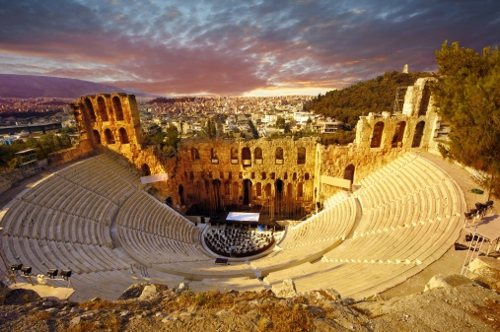

How will I be assessed?

You will be assessed on your ability to write essays using ancient sources and your own knowledge. Both the AS and A Level courses are 100% examined, each consisting of two exams.

What are the entry requirements?

Five GCSE subjects at Grade 4 or above including Grade 4 or above in GCSE English and History, if taken. Prior knowledge in Ancient History is not expected and newcomers to the subject are welcome.

What extra work can I do?

Wider reading and critical reflection on it are vital for success at the highest level. The Department issues a reading list as well as recommending, when appropriate, further reading. There are also lots of opportunities to see the Ancient world first hand by visiting archaeological sites or nearby museums such as the British Museum.

**ANCIENT HISTORY** AS/A Level

OCR

Tuesley Lane, Godalming

GU7 1RS

T: 01483 423526

E: [college@godalming.ac.uk](mailto:college@godalming.ac.uk)

W: www.godalming.ac.uk

Tuesley Lane

Godalming

Surrey

GU7 1RS

T: 01483

E: [college@godalming.ac.uk](mailto:college@godalming.ac.uk)

W: [www.godalming.ac.uk](http://www.godalming.ac.uk)

What is the department like?

Ancient History is part of the History and Politics department, which is one of the largest departments in college. The department has a record of achieving excellent results including both value added and high grades. This is based on an ethos of supporting student learning that sees the department offer weekly support sessions and a range of revision lectures and tutorials. The department also prides itself on its enthusiastic and inventive teaching which encourages students to learn in a variety of ways and maintains high expectations. We make considerable use of online resources and IT to provide students with up-to-date materials and develop their research skills. The department also works closely with the College Library to provide further reading opportunities including, academic texts, eBooks and recent articles.

Work done in the classroom is supported by other activities such as day visits and attendance at relevant lecture conferences. The department also has a strong reputation of providing cultural and historical enrichment trips, within the UK and abroad, to broaden and deepen the experience of students. Consequently, many students from the History department go on to take the subject, or a related degree, at a range of Russell Group universities and Oxford and Cambridge.

What sort of work will I be doing?

The aim of the course is to engage students in an exciting period of history that has tremendous relevance in the modern world, by developing a strong sense of enquiry and the skills to pursue this. The primary form of assessment is through essay writing where students use their own knowledge of topics and of primary sources, to analyse key issues of Greek and Roman history. The study of contemporary sources also forms an important part of the course as students will investigate a range of literary, political and artistic sources to gain a deeper appreciation of the societies from which they came. In addition to this, students will gain an understanding of how historians have interpreted these Ancient topics and will be able to evaluate these views using their own knowledge.

Lessons encourage students to learn in a variety of ways. Research tasks, student presentations, groups work and debate are all used in addition to independent work, to build students’ understanding of topics and discuss this with their peers.

**Ancient History gives students the chance to study a range of significant societies, individuals and events from the classical world, focusing of Greek and Roman history.**

**Students will study the following topics:**

**First Year**

* Relations between Greek and non-Greek states, 492-404 BC
* The Julio-Claudian Emperors, 31 BC-AD 68

**Second Year**

* The Politics and Culture of Athens, c.460-399 BC
* Ruling Roman Britain, AD 43-c.128

**Students taking the AS qualification will only take the first year topics.**

What is the course about?

What are the progression routes for this qualification?

Ancient History compliments a wide variety of other subjects both in the Arts and Sciences. It demonstrates a number of impressive academic skills that strengthen applications to study humanities-based subjects at university, or other disciplines. Students go on to a wide range of courses and a considerable number will take a degree in Ancient History, Classical Civilisation or Archaeology. Others continue on to related fields such as History, English, Law, Economics, Philosophy, Theology or Politics, where an A-Level in Ancient History is a real advantage. The subject also equips students with a range of transferrable skills such as critical analysis, structured writing and research, all of which are highly valued in professions including Law, Management, Finance, Journalism and Politics.