

How will I be assessed?

You will be assessed through a mixture of exams (assessed by Edexcel) and assignments (assessed by us and moderated by Edexcel). Each unit is awarded points, which are translated into an overall grade (Pass, Merit, Distinction or Distinction*) at the end of the course.

All students’ work is submitted in line with strict deadlines, throughout each assignment.

**First Year**

|  |  |  |
| --- | --- | --- |
| **Unit** | **Assessment** | **Proportion** |
| 1: Principles and applications of science | 90 minute exam in  June | 25% |
| 2: Practical scientific procedures and techniques | Internal assignment | 25% |

If you choose to leave the course in the first year you can achieve a BTEC National Level 3 Certificate in Applied Science (equivalent to ½ A-level).

**Second Year**

|  |  |  |
| --- | --- | --- |
| **Unit** | **Assessment** | **Proportion** |
| 3: Science investigation skills | Task based  (practical) exam in  June | 33.3% |
| 12: Diseases and infections | Internal assignment | 16.6% |

After the second year you will have achieved a BTEC National Level 3 certificate in Applied Science (equivalent to 1 A-level).

What extra work can I do?

A thorough knowledge of GCSE Science to higher level allows you to progress smoothly onto the course. It is suggested that you use a GCSE textbook or an Access guide e.g. ‘Mind the Gap’ if you feel that your knowledge is not up to standard.

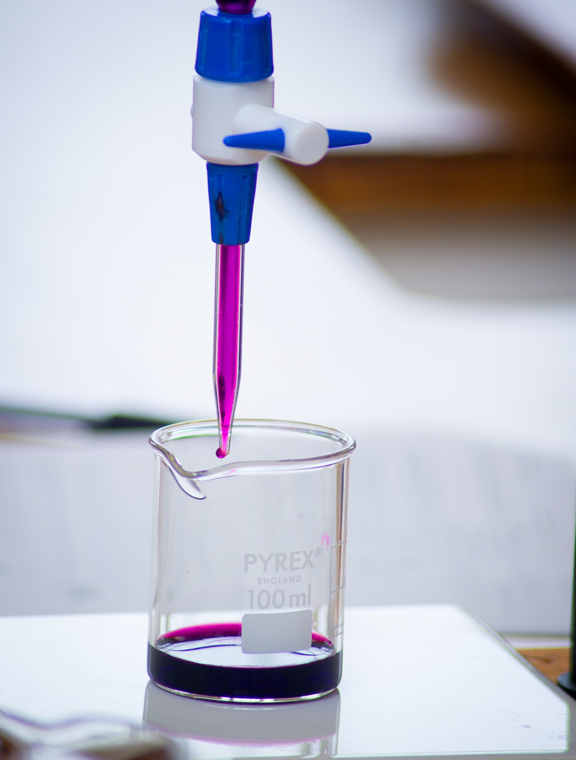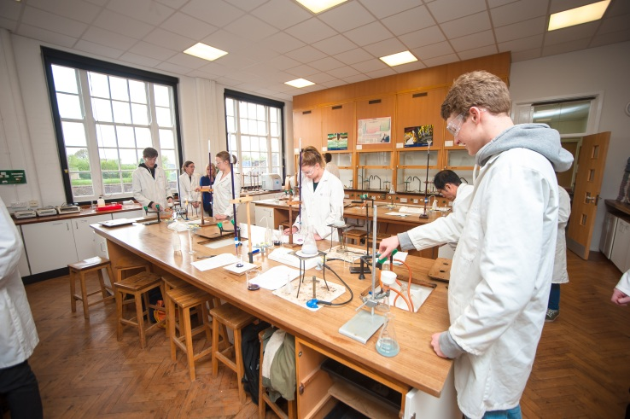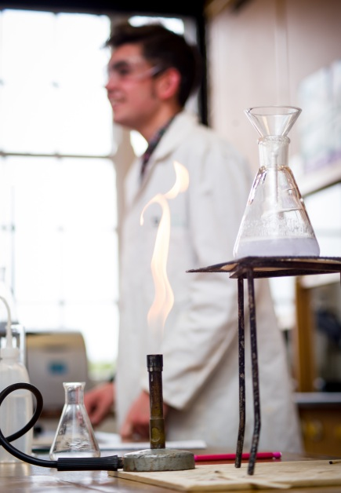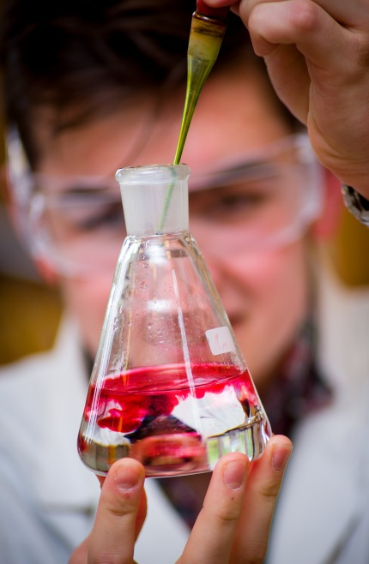

**APPLIED SCIENCE**

BTEC National Level 3 Extended Certificate

EDEXCEL

Tuesley Lane, Godalming

GU7 1RS

T: 01483 423526

E: [college@godalming.ac.uk](mailto:college@godalming.ac.uk)

W: www.godalming.ac.uk

Tuesley Lane

Godalming

Surrey

GU7 1RS

T: 01483

E: [college@godalming.ac.uk](mailto:college@godalming.ac.uk)

W: [www.godalming.ac.uk](http://www.godalming.ac.uk)

What are the entry requirements?

A minimum of five GCSE subjects at Grade 4 or above, (including English and Mathematics at grade 4) are required for entry onto the course together with both Core and Additional Science, both at grade 4.

What is the department like?

The Chemistry Department is housed in two large airy well-equipped recently refurbished laboratories. The labs are fitted with up-to-date visual aids equipment as well as a suite of laptops for use in the lab.

The staff are enthusiastic and knowledgeable; they are unstinting in their support of students.

There are about 45 students in Applied Science across the two year-groups. Our results have been consistently above national averages.

The teaching is done using a variety of approaches designed to suit different abilities and learning styles.

The course builds upon all three of the sciences. It focuses on broadening your understanding of science and in the second year looks at diseases and infections.

In the first year students will study two units. Unit 1 covers key concepts across all of the sciences, building upon GCSE knowledge. This will be externally assessed with an exam.

Unit 2 is very practically based looking into quantitative laboratory techniques (titrations, colorimetry, chromatography and calorimetry). It will be internally assessed and externally moderated in several assignments throughout the year.

Units 1 and 2 provide a grounding for the second year units. If a student wishes to leave the course in the first year they can achieve a BTEC National Certificate in Applied Science which is equivalent to

half an A-level.

In the second year students will study two more units. Unit 3 will develop their skills in planning investigations across all of the sciences (investigating enzyme activity, diffusion, plant growth, energy of fuels and electrical circuits). This unit will be assessed by an externally written task in which students will have to carry out a specified investigation.

Unit 12 will also be studied in the second year, students will investigate the 5 types of diseases, their causes and how to prevent and treat them. This is internally assessed and externally moderated in assignments set throughout the second year.

What skills will I develop during this course?

The BTEC National Level 3 Extended Certificate will provide the opportunity to develop your skills in numeracy, scientific communication and IT as well as improving your study, presentation and research skills.

What is the course about?

What are the progression routes for this qualification?

The requirements of the qualification are such that students will develop transferable skills which are valued by both higher education and employers.

The qualification can be taken with many other subjects leaving many progression routes open.

An ever-increasing number of degree related courses are now available to extend your understanding and operation of science.

Students could go straight into employment as they will develop analytical and processing skills valued by many, both inside and outside the Science Industry.