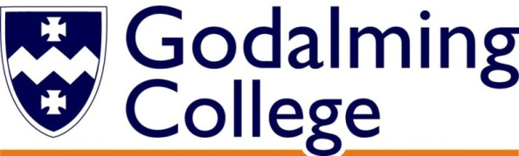

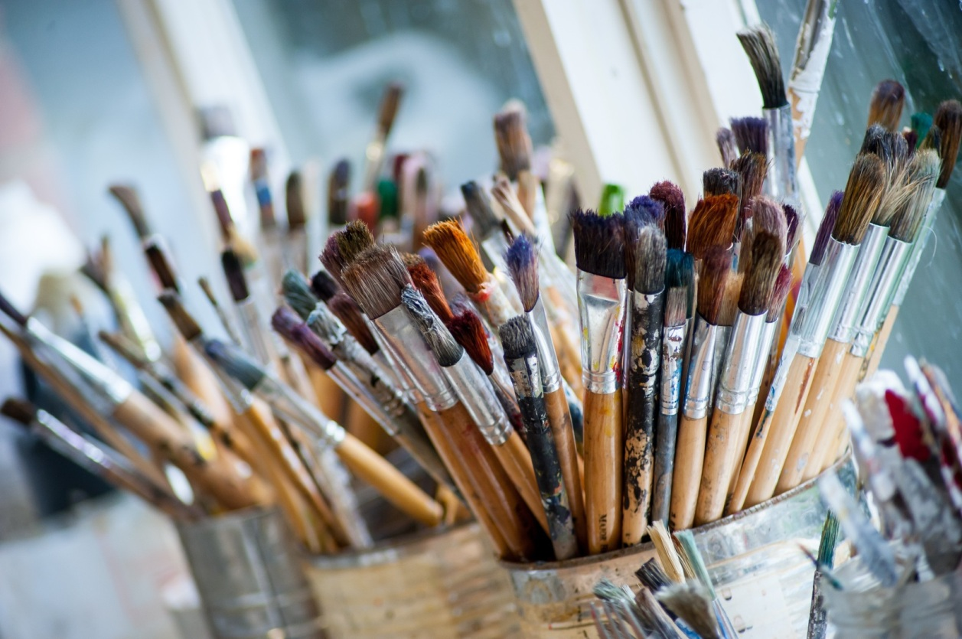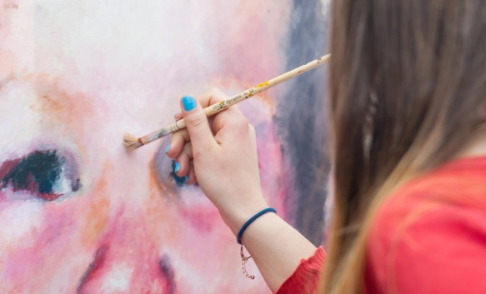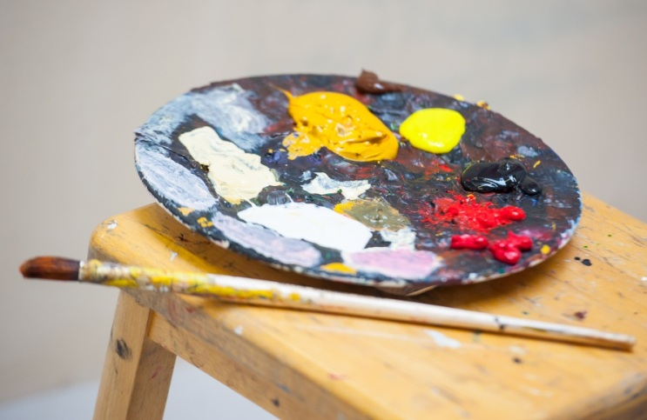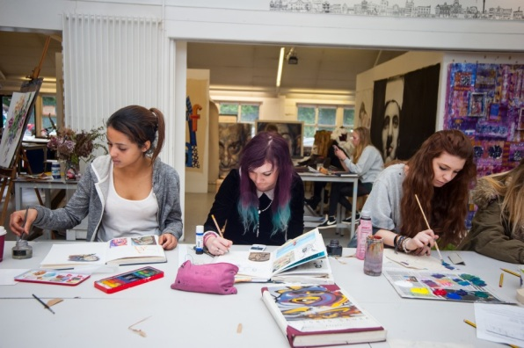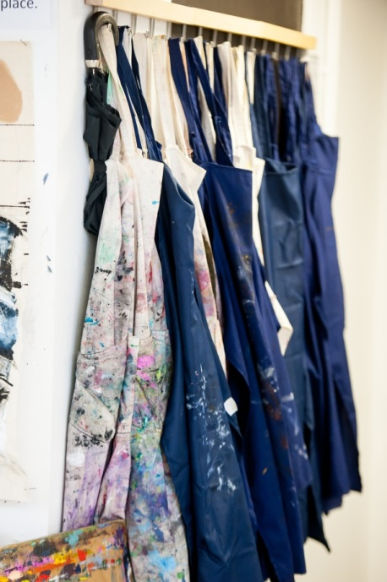

|  |  |  |
| --- | --- | --- |
| **AS Level** | **Weighting** | **Method of Assessment** |
| Component 1 | 50%  of AS Level | Internally set  Internally marked  Externally moderated |
| Component 2 | 50%  of AS Level | Externally set  Internally marked  Externally moderated |

|  |  |  |
| --- | --- | --- |
| **A Level** | **Weighting** | **Method of Assessment** |
| Component 1 | 60%  of A Level | Internally set  Internally marked  Externally moderated |
| Component 2 | 40%  of A Level | Externally set  Internally marked  Externally moderated |

Nowhere else in the country gets more A and A* grades in A Level Art than Godalming College Art Department!

How will I be assessed?

**ART** AS/A Level

EDEXCEL

Tuesley Lane, Godalming

GU7 1RS

T: 01483 423526

E: [college@godalming.ac.uk](mailto:college@godalming.ac.uk)

W: www.godalming.ac.uk

Tuesley Lane

Godalming

Surrey

GU7 1RS

T: 01483

E: [college@godalming.ac.uk](mailto:college@godalming.ac.uk)

W: [www.godalming.ac.uk](http://www.godalming.ac.uk)

What is the department like?

The Art Department is situated in a new well equipped, purpose built complex consisting of three specialist rooms.

What extra work can I do?

You are also expected to keep up to date with current exhibitions by visiting galleries and making sketches and studies in your sketchbooks.

There is a small yearly charge (currently £25) levied on this course to pay for all necessary materials to successfully complete the course.

**And finally….**

**The Art Department has very high expectations - we believe that everyone can be an artist and that every student has the potential to produce work of the highest standard!**

Ofsted recognise the

Art Department as being

one of the best in the country

What are the progression routes for this qualification

A high percentage of our students go onto study at Art College. The diversity of the course makes it ideally suited if you are intending to go on to Foundation Art & Design and degree courses specialising in many aspects of Art such as Fine Art, Fashion/Textiles, Film/Animation, Ceramics, Graphics, Furniture, Interior, and Jewellery Design.

If you study Art & Design you may also have the option to study AS Fine Art Constructed Textiles or AS Art & Design (Digital Photography).

The main purpose of the Art & Design course is to develop your ability to appreciate the visual world and to enable you to respond in a personal and creative way.

The Art Department staff devise and implement projects which encourage you to:

* Question all preconceived notions of art and personal ability.
* Trust your creative instincts.
* Express your ideas and feelings through the controlled use of a broad range of materials and techniques.
* Investigate and relate to all the evolutionary processes that are inherent in the development of good artwork.
* Articulate issues relating to the work of other artists from a variety of cultures, past and present.

What sort of work will I be doing?

On the Art course you will get the chance to explore all aspects of Art & Design. You will gain experience in painting and drawing, sculpture, ceramics, printmaking, textile design, animation, digital photography and Photoshop. We don’t have a “house style” and we cater for all approaches from figurative to abstract to conceptual - you could even invent a whole new art form!

What are the entry requirements?

A minimum of five GCSE subjects at Grade 4 or above, preferably including GCSE Art & Design.

What is the course about?