

How will I be assessed?

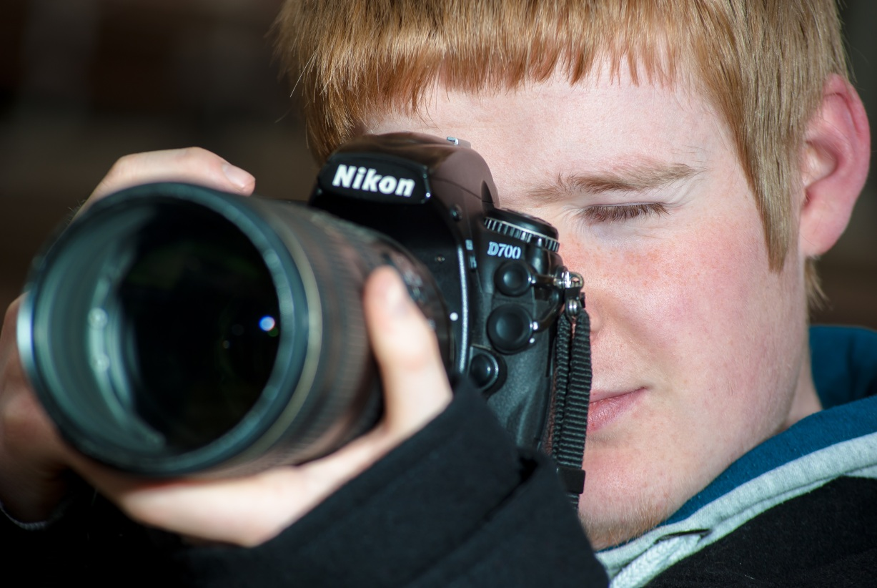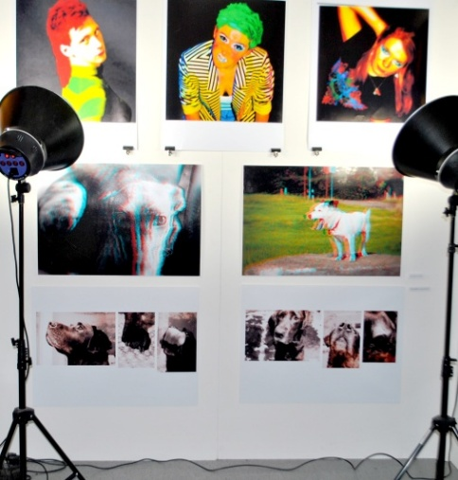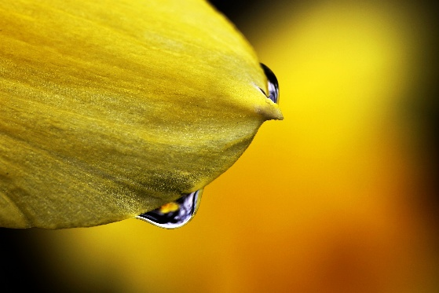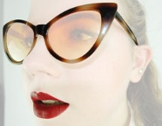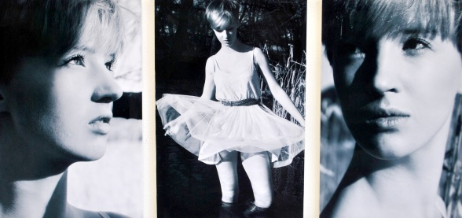

**ART PHOTOGRAPHY** AS and A Level

EDEXCEL

and finally….

The Art department has very high expectations - we believe that everyone has the potential to be creative in a personal and meaningful way. You must be keen to produce images every week and work as much outside class times as within the time-tabled classes. Learning how to become a fully functioning artist/photographer is hard work but also a lot of fun!

Both levels are comprised of two units.

Each unit involves: research into photographers and artists, analysis of examples of their work, development and presentation of your own ideas/images.

The AS and A Level Art & Design (Digital Photography) courses are each comprised of two units. The two units are:

|  |  |  |
| --- | --- | --- |
| **Component** | **Weighting** | **Method of Assessment** |
| Unit 1  Coursework | 50% of AS or A Level | Internally set  Internally marked  Externally moderated |
| Unit 2  Externally Set Assignment | 50% of AS or A Level | Internally set  Internally marked  Externally moderated |

Tuesley Lane, Godalming

GU7 1RS

T: 01483 423526

E: [college@godalming.ac.uk](mailto:college@godalming.ac.uk)

W: www.godalming.ac.uk

Tuesley Lane

Godalming

Surrey

GU7 1RS

T: 01483

E: [college@godalming.ac.uk](mailto:college@godalming.ac.uk)

W: [www.godalming.ac.uk](http://www.godalming.ac.uk)

What are the progression routes for this qualification?

Students may go on to Foundation Art & Design and degree courses specialising in many aspects of Art Photography including vocational, creative and editorial approaches. The course is relevant to any career involving digital media and working with images.

If you study Art & Design (Digital Photography) you may also have the option to study AS Fine Art Constructed Textiles or AS Art & Design.

What is the course about?

What is the department like?

The Art Department is made up of three areas: General Art & Design, Art & Design Textiles and Art & Design Photography.

We have a studio with lights and backdrops, classrooms with computers supporting appropriate software and high quality printers and a small darkroom.

What extra work can I do?

You are expected to keep up to date with current exhibitions by visiting galleries and making sketches and photographic studies in your workbooks, and by collecting and studying material from books and magazines. You are expected to spend as much time outside class time working in your workbook and taking photographs as you do during the lesson each week.

There is a small yearly charge (currently £25.00) levied on this course to pay for all specialist materials to successfully complete the course

What are the entry requirements?

A minimum of five GCSE subjects at Grade 4 or above, including a grade 4 or above in a Creative subject such as: GCSE Art, Photography, Textiles, DT Graphic / Product Design or a creative vocational courses such as a BTEC level 2 in Media.

What sort of work will I be doing?

You will have access to cameras or be able to use your own camera and be required to work in a variety of areas of photography, which may include:

* Portraiture, documentary and /or photo-journalism
* Landscape photography
* Working from objects, still life or the natural world
* Experimental imagery

You will be encouraged to use modern digital techniques in order to produce and manipulate photographic images. At the heart of your work will be a workbook for each unit where your ideas and images are developed.

* Investigate and relate to all the evolutionary processes that are inherent in the development of good artwork.
* Articulate issues relating to the work of other artists/photographers from a variety of cultures, past and present.
* Learn how to use cameras to do this.

The main purpose of the Art & Design (Digital Photography) course is to develop your ability to appreciate the visual world and to enable you to respond in a personal and creative way.

The art department staff devise and implement projects which will encourage you to:

* Question all preconceived notions of art and photography and personal ability.
* Trust your creative instincts.
* Express your ideas and feelings through the controlled use of a broad range of materials and techniques.