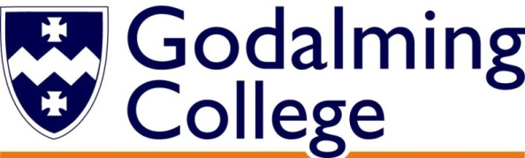

How will I be assessed?

|  |  |  |
| --- | --- | --- |
| **AS Level** | Weighting | **Method of Assessment** |
| Component 1  Coursework | 50% of AS | Internally set  Internally marked  Externally moderated |
| Component 2  Externally  Set Assignment | 50% of AS | Externally set  Internally marked  Externally moderated |

|  |  |  |
| --- | --- | --- |
| **A Level** | Weighting | **Method of Assessment** |
| Component 1  Coursework | 60% of A Level | Internally set  Internally marked  Externally moderated |
| Component 2  Externally  Set Assignment | 40% of A Level | Externally set  Internally marked  Externally moderated |

And finally….

The Art department has very high expectations - we believe that every student has the potential to be creative in a personal and meaningful way. Learning how to become a fully functioning textile artist is hard work but also a lot of fun!

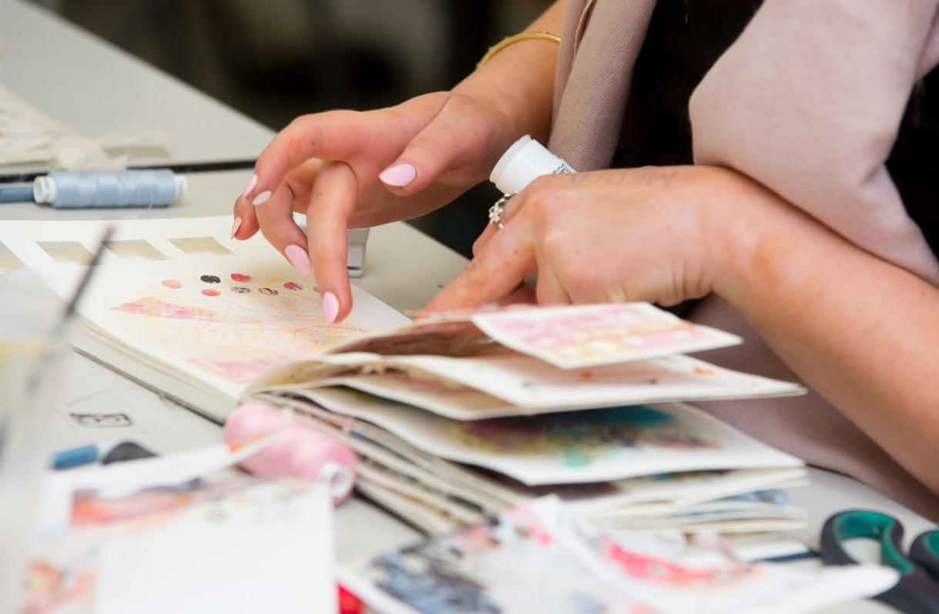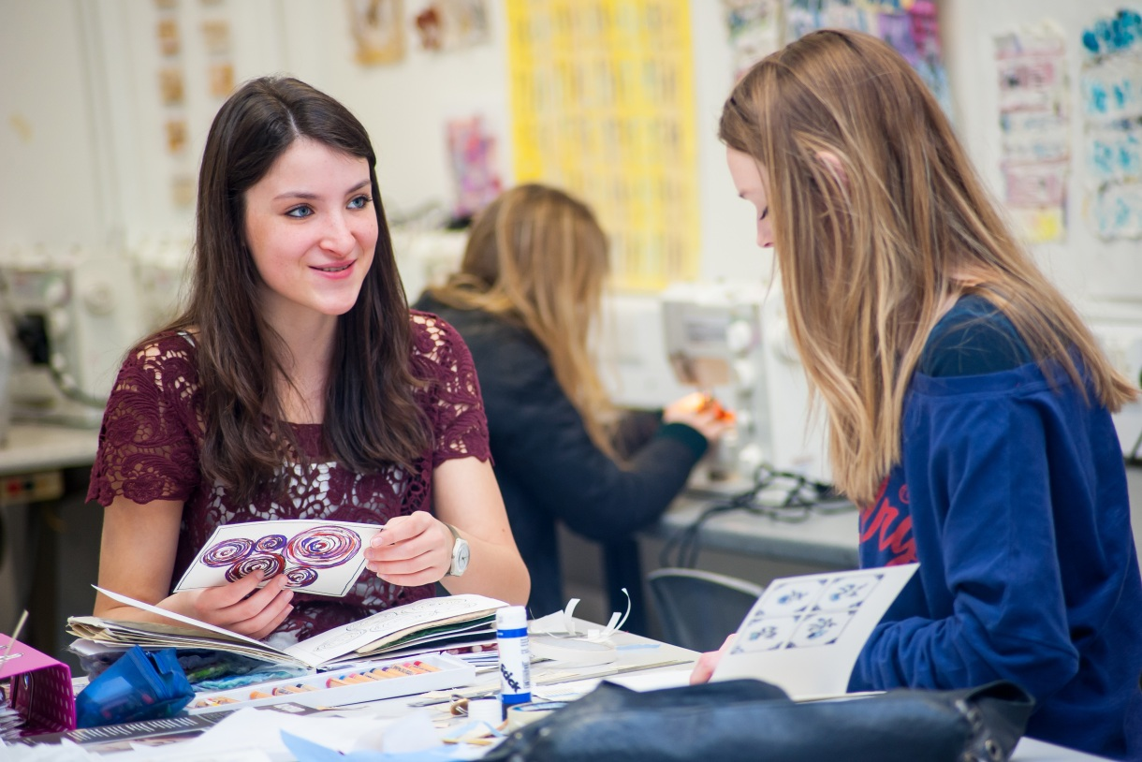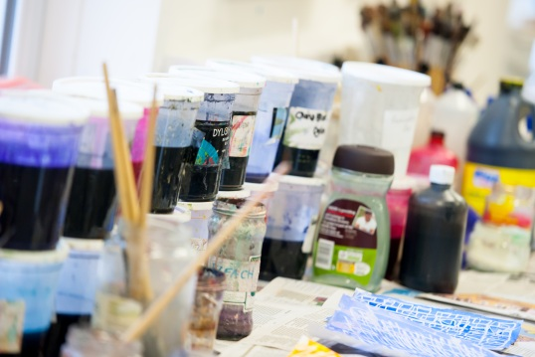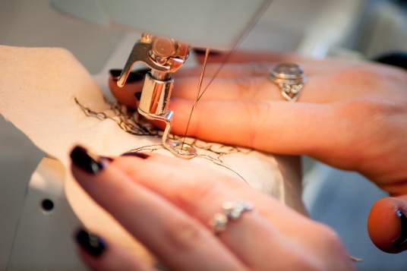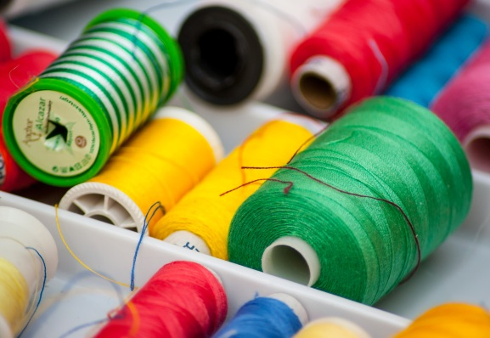

**Art Textiles** AS/A Level

EDEXCEL

Tuesley Lane, Godalming

GU7 1RS

T: 01483 423526

E: [college@godalming.ac.uk](mailto:college@godalming.ac.uk)

W: www.godalming.ac.uk

Tuesley Lane

Godalming

Surrey

GU7 1RS

T: 01483

E: [college@godalming.ac.uk](mailto:college@godalming.ac.uk)

W: [www.godalming.ac.uk](http://www.godalming.ac.uk)

What is the department like?

The Art Department is situated in

a new well equipped, purpose

built complex consisting of three specialist rooms. The textile room is a fantastic light and airy studio well equipped with 18 sewing machines, looms, a batik area

and printing facilities.

What extra work can I do?

You are expected to keep up to date with current exhibitions by visiting galleries and making sketches and studies in your sketchbooks.

There is a small yearly charge (currently £25) levied on this course to pay for all necessary materials to successfully complete the course.

The main purpose of the Fine Art Constructed Textiles course is to develop your ability to appreciate the visual world and to enable you to respond in a personal and creative way through hands on making. The textiles staff devise projects that encourage you to explore your creative instincts through a wide range of materials and techniques.

What are the entry requirements?

A minimum of five GCSE subjects at Grade 4 or above, preferably including GCSE Art & Design or GCSE Textiles at 4 or above.

What sort of work will I be doing?

The Art and Design Textiles course offers exciting opportunities to extend your skills in textile design. You will gain a thorough understanding of the following essential techniques: felting, weaving, knitting, silk screen, block and mono-printing, mark-making, drawing, machine embroidery, papermaking, dyeing, batik, rusting, scorching, sculptural basketry techniques, pleating and steaming.

Enjoy working a variety of colour palettes from muted tones through to zesty colours. Explore the formal elements of tone, scale and proportion in design through hands on making and manipulation of materials.

You are taught how to create a sketchbook and how to capture and develop your ideas. We explain how to design your page layout, learn the terminology for recording techniques and analysing samples. You will have weekly individual tutorials where we support and guide your learning, working with you as a creative individual to extend you own practice.

Your textile creations are placed in a wider context by studying practitioners’ work and learning from their techniques and processes; thus enriching your own work and understanding. During the course we run trips to the Victoria & Albert Museum, New Designers, London, New York and Paris.

The course culminates in an annual end of year show for upper sixth students, as part of the Godalming College Arts Festival. This proves inspirational to the lower sixth students and provides an exciting end and showcase for the upper sixth year.

What is the department like

What are the entry requirements?

A minimum of five GCSE subjects at Grade C or above.

What are the progression routes for this qualification?

The majority of our students go on to

further study on Art Foundation courses

and have been highly successful in their applications straight

onto degree courses from A level. Previous alumni have continued on to study degrees in Textile design, Fashion design, Surface pattern, Fashion Marketing, Ceramics, Applied Arts, Graphic Design, Embroidery, Make up and Prosthetics for film and Television, Costume Design and Jewellery.

The diversity of our course makes it ideally suited if you are intending to go on to study in a more specialized area of art and design. It is an excellent pre degree course and will provide you with a rich and vibrant portfolio work.

If you study Fine Art Constructed Textiles

you may also have the option to study AS Art & Design or AS Art & Design (Digital Photography).

What is the course about?