

How will I be assessed?

* On the AS course there are summer examinations for each of the two modules each contributing to 50% of the AS.
* On the A level course there are three summer examinations each contributing 331/3% of the A level. These exams will be taken at the end of the second year.

.

‘Biology Futures’ Programme

Workshops deliver enrichment activities designed to stretch and challenge students. Students have the opportunity to enter the British Biology Olympiad, and in previous years we have had several medalists. In summer 2012, one of our gold medallists was selected to represent Great Britain at the finals in Singapore, winning a silver medal and in 2013 a student travelled to Switzerland, also winning a silver medal. In recent years a number of our students have achieved gold medals in the UK competition. Recently two of our students made it through to the second round and one to the selection round at Warwick University, narrowly missing the opportunity to represent the UK at the international competition.

What extra work can I do?

Wide reading is essential and is encouraged, as is the use of a wide range of other media (television, radio, and internet) to broaden and enrich student’s knowledge. Students are supported in accessing appropriate periodicals and journal articles, and relevant lectures and courses that students can attend are advertised.

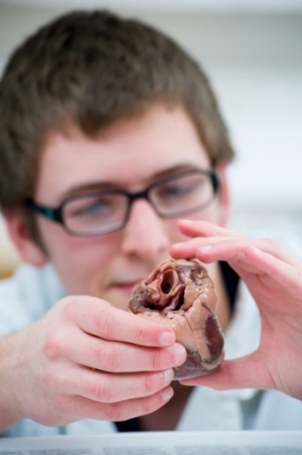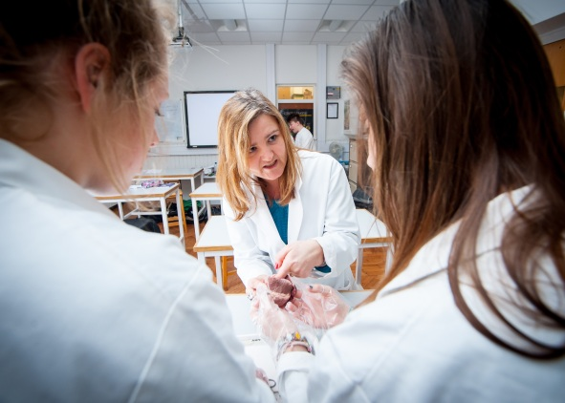

**Biology** A Level

AQA

Tuesley Lane, Godalming

GU7 1RS

T: 01483 423526

E: [college@godalming.ac.uk](mailto:college@godalming.ac.uk)

W: www.godalming.ac.uk

Tuesley Lane

Godalming

Surrey

GU7 1RS

T: 01483

E: [college@godalming.ac.uk](mailto:college@godalming.ac.uk)

W: [www.godalming.ac.uk](http://www.godalming.ac.uk)

What are the progression routes for this qualification?

Biological science is one of the broadest and most important subjects in the world today. Put simply, biology is the study of life. [Biology](https://www.topuniversities.com/courses/biological-sciences/guide) encompasses everything from the molecular study of life processes right up to the study of animal and plant communities. A level Biology is a great choice for people who want a career in health and clinical professions, including medicine, dentistry, veterinary science, physiotherapy, nursing and forensic science. It is also necessary for a degree in any of the Biological sciences which range from neuroscience, genetics, biomedical science, biochemistry, zoology, conservation and marine biology. The skills developed in a Biology A level are also valued in careers within the pharmaceutical industry, biological economics, science publishing, government policy, education and biotechnology.

The Department offers the AQA Biology specification.

**AS qualification (1 year)** - Students study 4 core concepts of Biology which includes; The structure and function of Biological molecules, Cell structure and replication, how organisms exchange substances with their environment (including gas exchange, transport and nutrition) and genetic information, variation and relationships between organisms. Assessment of practical skills in this AS specification will be by written exams only.

**Biology A level (2 years)** – For A level Biology students study the core concepts of Biology (as above) but they also study 4 further components which are separated into Energy Transfers in and between organisms (photosynthesis and respiration), Organisms response to the internal and external environment (the nervous system and homeostasis), Genetics, populations, evolution and ecosystems, and The control of gene expression including genetic engineering

12 compulsory practicals are completed towards the new practical endorsement. Other practical work will be carried out where appropriate to support biological theory.

What is the course about?

What sort of work will I be doing?

Teaching and learning takes advantage of a wide range of approaches including class discussions, practical work, group work and independent guided study. Considerable use is made of Godalming ‘on-line’ resources both during teaching and for individual study. On-line resources include a full set of topic notes, video clips, past paper questions and answers, quizzes, help forums, as well as teachers’ powerpoint presentations. Practical work forms a very important part of the course and students undertake a number of investigative experiments, as well as microscope work.

What are the entry requirements?

Levels 6.6 in Science and Additional Science or two level 6 grades in Biology and Chemistry, together with a good GCSE background including English and Maths at level 6.

What are the entry requirements?

A minimum of five GCSE subjects at Grade C or above.

What are the progression routes for this qualification?

Advanced level biology studies are clearly valuable for students intending to embark upon scientific or biologically related careers (e.g. medicine, dentistry, agriculture, forestry, veterinary science, environmental biology). What is less often appreciated is the value of a biological science AS or A Level for students not intending to enter a scientific or biologically related career. This is because biology is a STEM subject which can help to develop objective, logical thinking as well as a wide range of other skills. In this sense biology mixes well with a wide variety of other AS or A level subjects and is suitable for careers as diverse as law, commerce and the arts.

What is the department like?

The Biology Department is

housed in 4 well-equipped and newly refurbished laboratories

and is resourced with a wide

range of modern apparatus, texts and reference resources. Specialist teachers within the department present material in an engaging and enjoyable way. Revision sessions are also provided, and students are encouraged to book 1-2-1 appointments with their teachers for help either when experiencing difficulties or to extend their knowledge. All Biology courses follow carefully structured schemes of work.

Would you like to know?

Do saturated fats cause heart disease? Why do some cells become cancerous? How closely related are we to chimpanzees? Why do fish die out of water? How do pacemakers work? Why can cows exist on a diet of grass and we can’t? Why are some people lactose intolerant?

That’s just the first year! In year two; Why are antibiotics ineffective against flu? How do painkillers work? What does DNA actually do? How can infertility arise? Is cloning acceptable? Can gene therapy cure diseases? How does the kidney work?