

How will I be assessed?

There are 8 units of work which comprise a written exam and 2 written tasks assessed by the exam board and 5

units of coursework which are assessed by us and moderated by the board. The weighting of the marks is 55/45 internal/external assessment. At the end of the

course you will achieve an overall grade of Pass, Merit or Distinction which equates to E, C or A at A level.

What skills will I develop during this course?

The BTEC Level 3 National Diploma in Business will

provide the opportunity to develop your skills in numeracy, communication and IT as well as improving your study, presentation and research skills.

What extra work can I do?

You will be given guidance on what you need to do to support your class-work but you can help your progress

and understanding and give yourself a better chance of a high grade if you get into good habits and do some background work.

A good deal can be achieved by reading newspapers, magazines and watching the News. You don’t need great detail, but you will find articles every week about

takeovers, new products, competition in markets, Europe and other issues which affect businesses. Read headlines and skim through articles to get a feel for what is going on.

Look at adverts wherever they appear, look at packaging

in the shops, look at product design and new products

being sold. Ask yourself how it all relates to the business involved and why they might be doing it.

Get a ‘feel’ for what is going on in the business world so

that it all fits together when you come to look at it in the classroom.

**Throw yourself into the course and enjoy it!**

**Your business knowledge will shape your future and benefit you for years to come.**

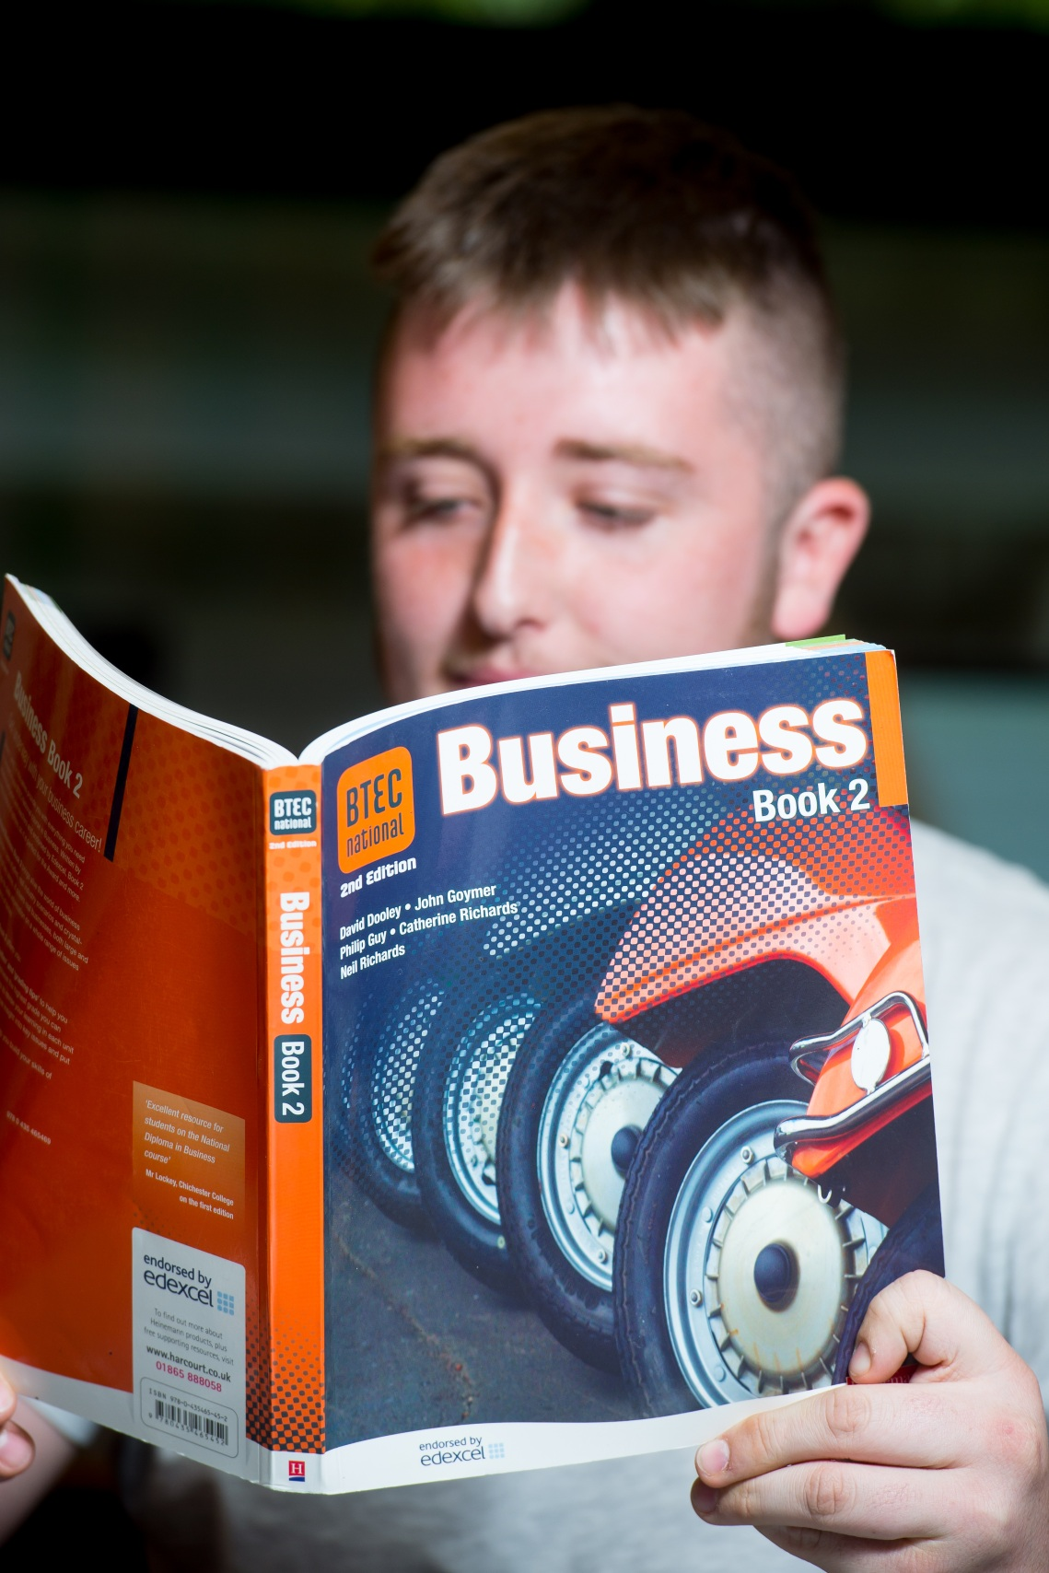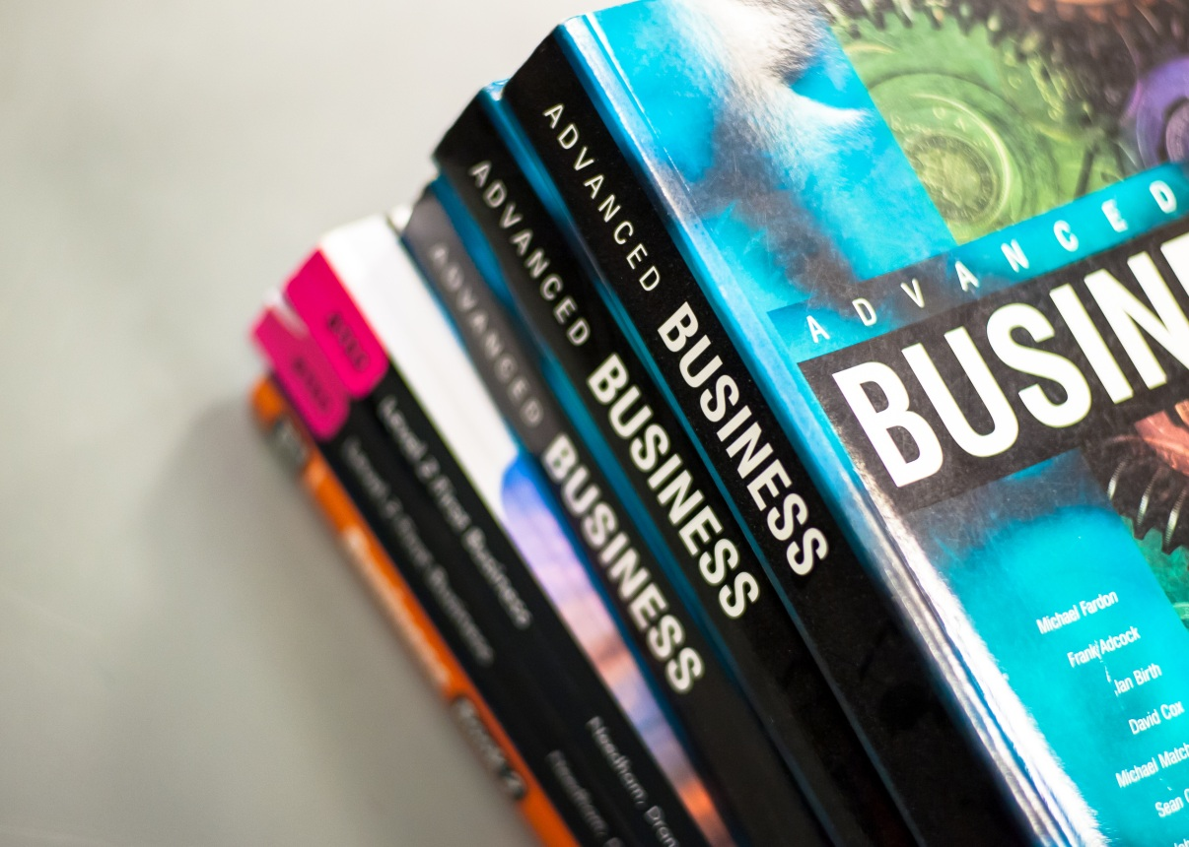

**Business** BTEC (Level 3) National Diploma

EDEXCEL

Tuesley Lane, Godalming

GU7 1RS

T: 01483 423526

E: [college@godalming.ac.uk](mailto:college@godalming.ac.uk)

W: www.godalming.ac.uk

Tuesley Lane

Godalming

Surrey

GU7 1RS

T: 01483

E: [college@godalming.ac.uk](mailto:college@godalming.ac.uk)

W: [www.godalming.ac.uk](http://www.godalming.ac.uk)

There are 6 mandatory units covering the key concepts of business

Unit 1: Exploring Business

Unit 2: Developing a Marketing Campaign

Unit 3: Personal and Business Finance

Unit 4: Managing an Event

Unit 5: International Business

Unit 6: Principles of Management

In addition to these there will be 2 additional optional units such as Recruitment & Selection and Creative Promotion

All topic areas are studied in the context of real life businesses

The BTEC Level 3 National Diploma in Businesses is equivalent to 2 A levels. Students who complete the first

year of this course will achieve a BTEC Level 3 National Extended Certificate which is equivalent to 1 A level.

**WHAT ARE THE PROGRESSION ROUTES WITH THIS QUALIFICATION?**

The BTEC Level 3 National Diploma in Business is widely accepted and accredited by the great majority of universities

as an excellent

foundation for degree study. Business

Studies is one of the fastest growing

university subjects and one of the largest.

You will be able to go

on to a wide variety of degree courses in Business, Management and many related

subjects or you can use your BTEC Level 3 National Diploma in Business to access the professional world when you leave College.

The BTEC Level 3 National Diploma in Business

will prepare you particularly for a career

in Business, Management, Administration, Marketing, Human Resources etc., but wherever you end up working, it is likely to

be in a business!

What sort of work will I be doing?

Your work will consist of producing a ‘**portfolio’** of work. This consists of a variety of written assignments as well as some verbal assessments such as presentations,

radio interviews and

group discussions that demonstrate your knowledge and skills and form the basis for the assessment of your

grades. You will encounter a wide variety of approaches, tasks and exercises. You will get

your basic knowledge

and understanding

through a combination of class-notes, articles, newspaper research, videos, T.V. and

practical exercises.

What are the entry requirements?

Ideally, you will need a minimum of five GCSE subjects at grade 4 or above including English and Mathematics, or the equivalent. Your GCSE subject profile is likely to include some subjects that have required you

to research from books and articles and to write reports and give presentations.

Some of you will have done GCSE or BTEC in Business, but many will not. It is not necessary

to have done it and we teach as if you are all starting from scratch. If you have done the

GCSE you will probably be more confident with the terminology and some of the concepts,

but don’t think you

know it all!

What is the department like?

Housed in modern classrooms and offices with fully equipped computer suites, the working environment is as good as you will find anywhere in the college.

Enthusiastic staff in this Grade One department will help

you enjoy your learning and progression.

Business BTEC students achieve excellent grades and progress to a wide range of university destinations. The teaching is undertaken using a variety of approaches designed to suit different abilities and learning styles. We pride ourselves on the work we do with individual students enabling them to manage their own learning and develop strategies to overcome any difficulties they may have as

well as stretching those with high academic ability.

Visits trips and speakers are built into the course and we

run activities such as share games to give you the opportunity to consider real business situations. We work hard with you and enjoy what we do and we hope that

you will too.

What is the course about?