

Course Outline

AS Components 1 and 2 / A Level Component 1:

Business Opportunities and Functions

* **Business Opportunities** focuses on new start-ups and small to medium sized enterprises (SMEs)
* **Business Functions** broadens the context for learners and includes all types of business organization, ranging from recently formed small businesses to well established MNCs.
* Topics include:

Business plans, Marketing, Finance, HRM and Operations Management

A Level Component 2: Business Analysis and Strategy

* This builds on component 1, which was covered in the AS year.
* Topics include:

Data analysis, market analysis, sales forecasting, analysing financial and non-financial performance, aims and objectives, strategy and implementation, decision-making models, investment appraisal, special order decision making.

A Level Component 3: Business in a Changing World

* This focuses on how businesses adapt to succeed in a dynamic external environment.
* Topics include:

Change, risk management, PEST factors, ethical factors, legal and environmental factors, international trade, globalization and the European Union.

**Business Objectives and Strategy** –growth; stakeholders; risk and uncertainty 1

**Change** – causes and effects of change

**External Influences** – PEST analysis and the international context

**Business Analysis** – Measures of performance: financial and non-financial

**Unit 4: Business Strategy and Practice:** How business objectives are to be achieved once they have been decided.

**Business Objectives and Strategy** – risk and uncertainty 2, data analysis

**Business Analysis** – marketing, finance, people; operations

*Both A2 modules are assessed in a June exam*

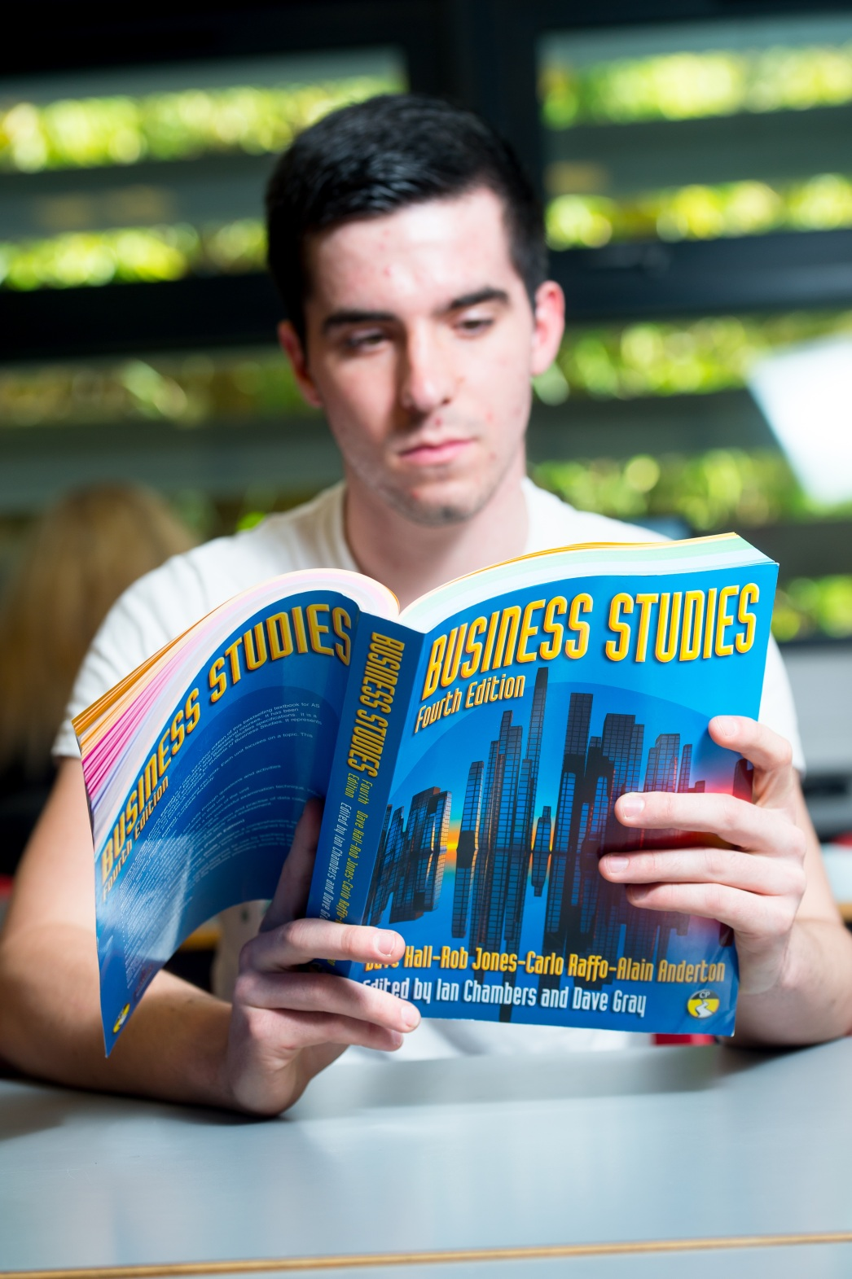

**Business (Linear)**

AS/A Level

WJEC

Tuesley Lane, Godalming

GU7 1RS

T: 01483 423526

E: [college@godalming.ac.uk](mailto:college@godalming.ac.uk)

W: www.godalming.ac.uk

Tuesley Lane

Godalming

Surrey

GU7 1RS

T: 01483

E: [college@godalming.ac.uk](mailto:college@godalming.ac.uk)

W: [www.godalming.ac.uk](http://www.godalming.ac.uk)

Here are some quotes from some famous business people you might recognise and aspire to be like:

“Quality is more important than quantity. One home run is much better than two doubles.” – Steve Jobs

“Your most unhappy customers are your greatest source of learning.” – Bill Gates

“Do not be embarrassed by your failures, learn from

them and start again.” – Richard Branson

What is the department like?

Guest speakers and business visits enable you to see the theory in practice. Join the business department and be part of a forward thinking, dynamic and supportive team.

What sort of work will I be doing?

Do you see yourself working in business or in the city? Owning your own business and being your own boss, perhaps? Managing a team? Being instrumental in a firm’s future? If so, Business Studies is the course for you.

On the course, you will learn what makes some businesses succeed, and some businesses fail. You will understand what influences business decisions and be able to make judgements about how to improve businesses.

* You will learn how to **motivate** your staff and **lead** your organisations of the future.
* You will be able to discuss the **legal**, **economic**, **political**, **sociological** and **technological** influences on businesses and how to cope with them.
* You will learn how to manage and interpret business **accounts** and look deeply into businesses financial situations.
* You will also learn how **marketing** and **advertising** are instrumental to a firm’s success.

The modules start relatively simply and get increasingly complex as the course progresses, to develop an enthusiasm for the subject and a holistic understanding of Business.

We will teach you to be ***visionary***, think ***strategically*** and ***develop*** your business into one of the best in its industry.

What are the entry requirements?

A minimum of five GCSE subjects at Grade 4 or above including English and Maths. No previous knowledge of Business Studies is required. You should have an interest in the business world and have an enquiring, analytical mind. You will be required to keep up to date with current affairs and what is going on in the real business world. You should be numerate, but no high level maths is included on the course. It is not necessary to have previously studied Business Studies at GCSE.

We will spend a lot of time helping you to improve your skills to enable you to see why business decisions have been made.

What is the course about?