

How will I be assessed?

The syllabus covered in the first year comprises 10 Topics leading to an AS qualification.

|  |  |  |
| --- | --- | --- |
| **Paper 1** | **Paper 2** | **Practical** |
| Core Inorganic and Physical Chemistry | Core Organic and Physical Chemistry | Laboratory Skills |
| Written paper  1hr 30min | Written paper  1hr 30 min | Teacher Assessed  8 Core Practicals |

In the second year a further 9 topics are covered, which, together with the 10 AS topics lead to a full A level qualification. There is a separate practical assessment which is teacher assessed

|  |  |  |
| --- | --- | --- |
| **Paper 1** | **Paper 2** | **Paper 3** |
| Advanced Inorganic and Physical Chemistry | Advanced Organic and Physical Chemistry | General and Practical Principles in Chemistry |
| Written paper  1hr 45min | Written paper  1hr 45min | Written Paper  2hrs 30min |

What extra work can I do?

A thorough knowledge of GCSE Chemistry to the Higher level allows you to progress smoothly onto the course. It is suggested that you use a GCSE textbook or an Access guide e.g. ‘Mind the Gap’ if you feel that your knowledge is not up to standard.

During the course consulting the up-to-date section in the library and reading periodicals such as Chemistry Review and New Scientist as well as using the Internet.

In the L6 summer holidays.

Extra reading about current developments in Chemistry has proved helpful to students preparing for interviews.

Joining the RSC ChemNet provides additional material and support.

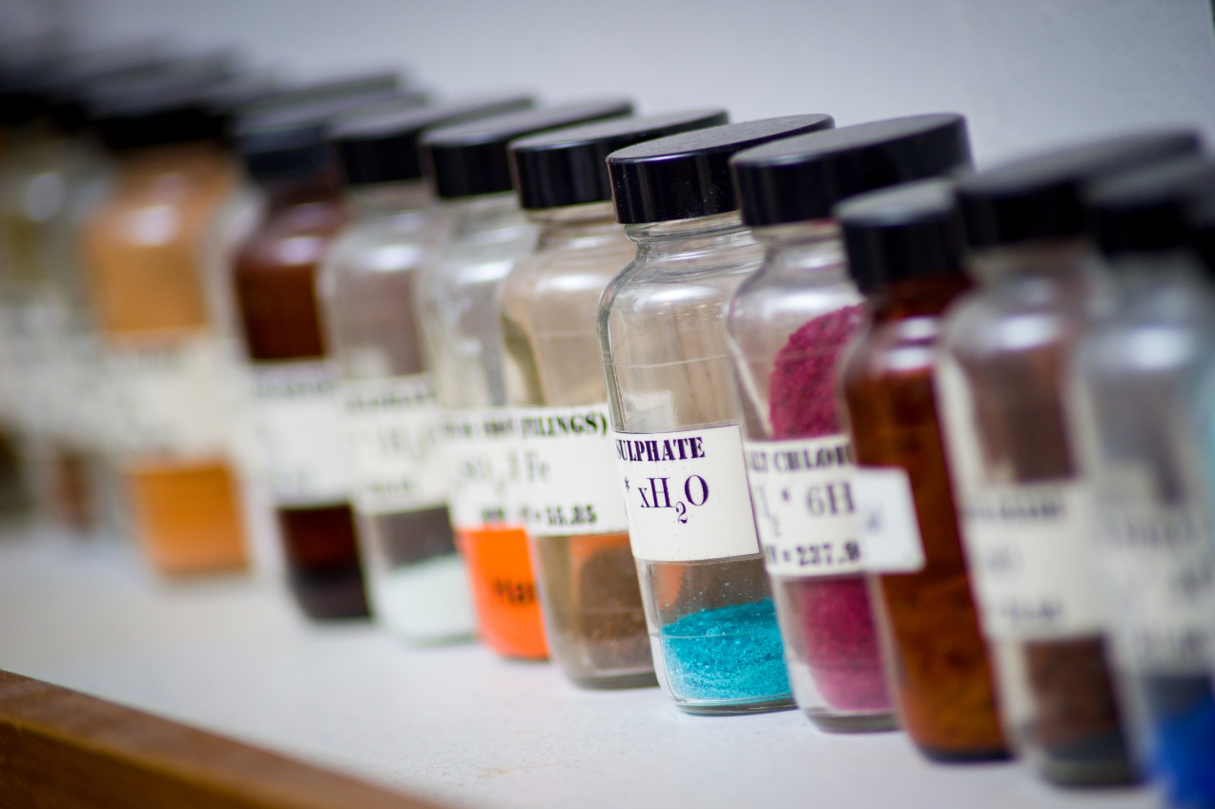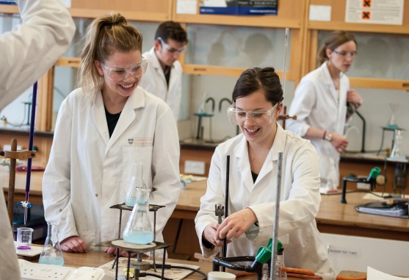

**CHEMISTRY** AS/A Level

EDEXCEL

Tuesley Lane, Godalming

GU7 1RS

T: 01483 423526

E: [college@godalming.ac.uk](mailto:college@godalming.ac.uk)

W: www.godalming.ac.uk

Tuesley Lane

Godalming

Surrey

GU7 1RS

T: 01483

E: [college@godalming.ac.uk](mailto:college@godalming.ac.uk)

W: [www.godalming.ac.uk](http://www.godalming.ac.uk)

What are the entry requirements?

A minimum of five GCSE subjects including Grade 6 in either Chemistry or Science and Mathematics Grade 6.

.

We find the subject exciting and hope that you will enjoy the opportunities we provide.

What sort of work will I be doing?

* Flexible learning packs. These include theoretical information, associated practical exercises and internet links together with examination questions for practice.
* Practical work is a major component of the course enabling you to develop a wide variety of skills and understanding of chemical techniques.
* Use is made of videos and the Internet to illustrate relevant concepts.
* Computers are used extensively for data-logging, interrogation of databases and in interactive learning programs.
* E-learning is being used extensively within the Department. This consists of externally accessed support materials, additional activities and tutor support.
* Godalming Online contains a variety of resources as well as past examination questions and mark schemes.

What are the entry requirements?

What is the course about?

## *Chemistry is ‘a quest for truth’*

Ever since the ancient Greeks, scholars have searched for what we are made up of. The study of Chemistry A' level aims to bring one closer to the answer by stimulating and sustaining your interest in chemistry allowing you to gain an understanding and knowledge of the subject. It also helps you appreciate the interlinking patterns which are a feature of this subject. The course shows the inter-relationship between the development of the subject and its application and value in today’s society.

What are the progression routes for this qualification?

Chemistry is suitable

for a wide variety of scientific and non-scientific degree courses since it encompasses all the key skill areas; it also encourages imaginative critical and logical thinking for problem solving. In science, Chemistry plays central role impinging on a wide variety of disciplines. A level Chemistry is a compulsory course requirement for students intending to study the medical, veterinary or dental sciences, biochemistry and chemistry. In addition, most biological and environmental courses require a sound A' level pass. As a subject, it is valued for the analytical powers and the academic rigour of its training and thus it lays a suitable foundation for careers such as law, accountancy and economics where these qualities are valued.

What is the department like?

We are housed in two large airy well-equipped recently refurbished laboratories. The labs are fitted with up-to-date visual aids equipment as well as a suite of laptops for use in the lab.

The staff are enthusiastic and knowledgeable; they are unstinting in their support of students.

There are over 150 students in Chemistry across the two year-groups. Our results have been consistently above national averages with over 40% of our students gaining A* or A grades.

The teaching is done using a variety of approaches designed to suit different abilities and learning styles. We support students with additional Maths lessons. We aim to stretch those with high academic ability and provide opportunities to address the interests and needs of the highest performing students; All students have the opportunity to take part in the Chemistry Olympiad and Cambridge chemistry challenge

Many of our students take part in the Aim High program which aims to stretch our most able students and has included visiting speakers, problem solving challenges and a trip to Oxford University In the summer term. In the autumn term we support students sitting the Bmat exam for entry into medicine as well as preparation for interview.

Would you like to know?