|  |  |  |
| --- | --- | --- |
| **CLASSACTION PRODUCTIONS (include)** | | |
| **2017** | **RENT (20th Anniversary Production)**  **Every Brilliant Thing (School’s Tour)**  **American Idiot** | \\godalming.ac.uk\dfs\Users\Staff\AWP\PAN\2015-2016\Light Burns Blue\Photos\P1020997.JPG |
| **2016**  **2015** | **The Light Burns Blue**  **13**  **I Don’t Like Mondays**  **Romeo & Juliet**  **Sunshine On Leith**  **Love Bites** | Jamie |
| **2014** | **Earthquakes In London**  **Marine Parade**  (The Manor Hotel)  **This Bloodied Man** |  |
| **2013** | **Everything In Colour** (Guildford Fringe)  **Cabaret**  **BlackOut**  (Farnham Maltings)  **Laramie Project** |  |
| **2012** | **Everything In Colour**  (Wimbledon Theatre)  **Pornography**  (Ivy Arts Centre)  **Babel**  **Riot:Deliverance** |  |
| **2011** | **Spring Awakening**  (Studio 816 @ Guilfest)  **The Nativity**  (Promenade - Godalming)  **Generation Freefall**  **Germany Live!**  (Lyric–Shaftesbury Avenue) |  |



Tuesley Lane, Godalming

GU7 1RS

T: 01483 423526

E: [college@godalming.ac.uk](mailto:college@godalming.ac.uk)

W: www.godalming.ac.uk

Tuesley Lane

Godalming

Surrey

GU7 1RS

T: 01483

E: [college@godalming.ac.uk](mailto:college@godalming.ac.uk)

W: [www.godalming.ac.uk](http://www.godalming.ac.uk)

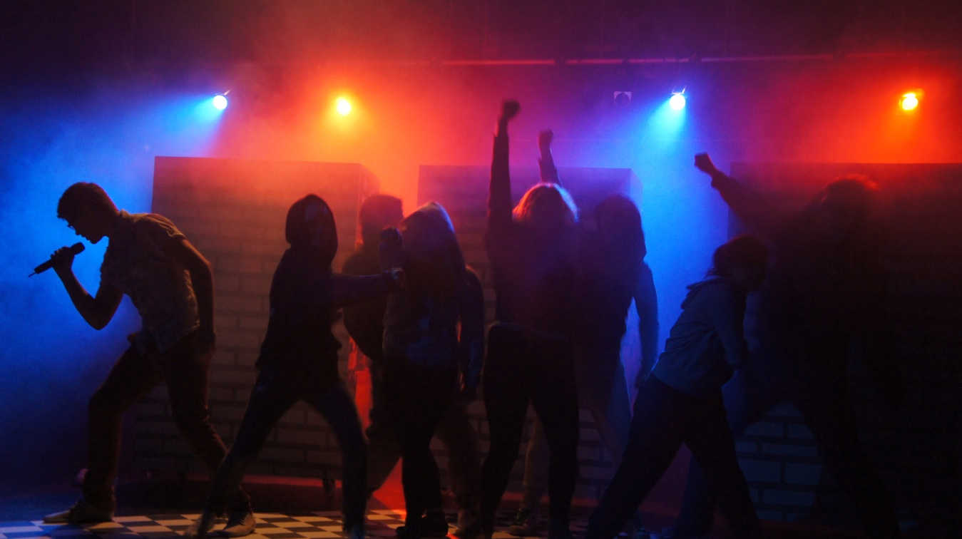

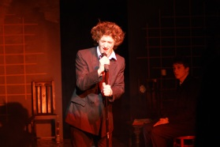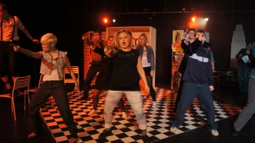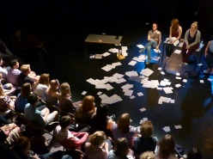H:\PAN\LOGO\CATheatre\ClassAction\ClassActionBLACK.png

**CLASSACTION**

Performing Arts Activities

WHO IS CLASSACTION?

ClassAction is you, working alongside the tutors. Our production companies are managed by students working backstage and in production support roles. We do not hold auditions to join ClassAction, but there may be auditions for productions. Students with any level of experience are able to participate, whether you are interested in performing or technical/back-stage work. You do not need to be taking a Performing Arts/Drama A level to be involved.

We want performing arts activities to be enjoyed by our young practitioners as together they develop their performing skills. To continue this development we run a master class/workshop programme alongside our production seasons. Recent workshops have included:

ThickSkin Theatre | Frantic Assembly | GSA | Lost Watch Theatre | Central School of Speech and Drama | Mountview | St Mary’s University | Idle Motion | Arts Ed |The Bridge Drama School | Guildford Fringe Theatre | Scene Productions | Les Enfants Terribles

Follow us on Twitter:

**@ClassAction01**

Search for our YouTube Channel

**ClassAction Theatre**

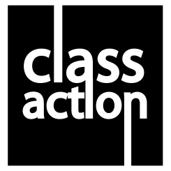 CLASSACTION 

WHAT IS CLASSACTION?

ClassAction is Godalming College’s performance company. It aims to promote theatre for participants and for informed audiences. Our focus is on our young practitioners as artists and as collaborators, thinkers and learners creating work that is provoking,   
entertaining, popular, eclectic, anarchic, contradictory and diverse.   
  
We want to be at the heart of our community here at Godalming College as well moving outside the college buildings into our wider community.   
  
We want to celebrate the creative power of collaboration. We want to encourage the next generation of practitioners. We want new thinking, we want to push boundaries and above all we want to take risks. We want to lurch wildly between high art and populism - hopefully achieving both at the same time.

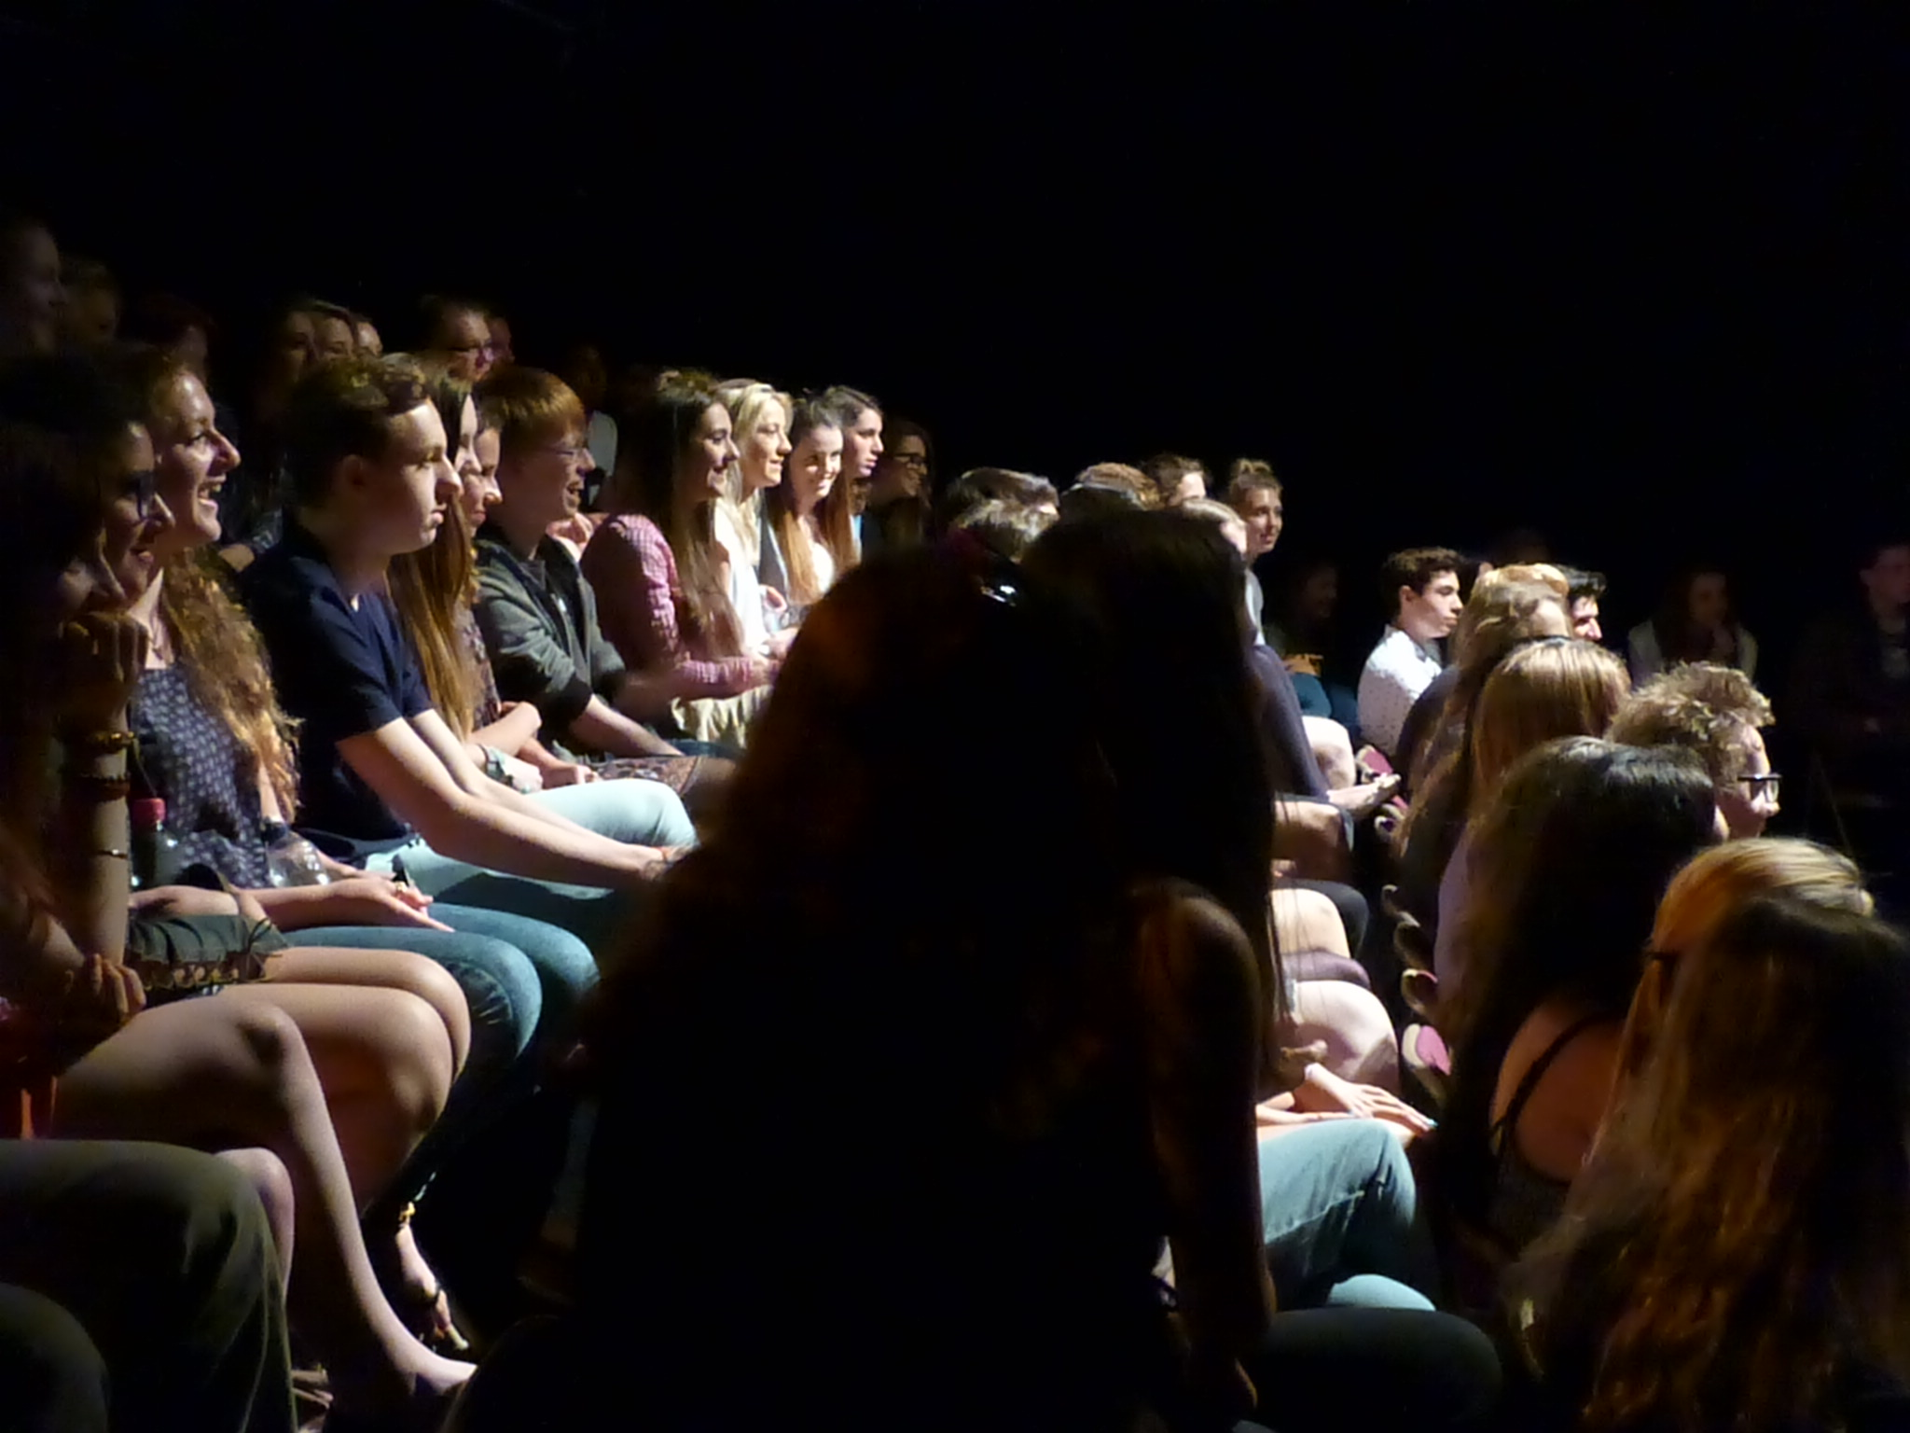

Production rehearsals are either integrated into student timetables, happen at lunch times or after college.

**Please remember to put PAN on your enrolment form in September.**

**OPPORTUNITIES**

Over the last few   
seasons ClassAction

have performed in

STUDIO 816 here at Godalming College and

also to venues beyond the college walls.

STUDIO 816 @ Godalming College

THE LYRIC THEATRE Shaftesbury Avenue

FARNHAM MALTINGS

WIMBLEDON THEATRE

IVY ARTS CENTRE

(Guildford School of Acting)

THE MANOR HOTEL

GODALMING BANDSTAND

THE PEPPERPOT

PHILLIP’S MEMORIAL

BACKROOM @ THE STAR (part of Guildford Fringe)

BACKROOM @ THE RED LION (part of Godalming Arts Festival)

THE THEATRE TENT (Guilfest)

ALICE HOLT FOREST

ELECTRIC THEATRE