j

How will I be assessed?

In the AS year, there will be a written examination and an on-screen test. Both will assess theoretical knowledge and the latter will assess your practical and programming skills.

For the full A level, there will also be similar written and on-screen tests, but these will be longer and will cover all aspects of the 2 year course There is also an individual project worth 20% of the assessment. You **must** enjoy doing coursework – it is a significant element on any advanced Computer Science course.

What skills will I develop?

Alongside Programing and systems design, Computer Science will provide the opportunity to develop your skills in information technology and communication, as well as improving your planning and study skills. The coursework in the second year focuses on the development of a complete technical solution to a problem of the student’s choice, which needs to be coded to a high standard and well documented.

What extra work can I do?

Students are encouraged follow academic and technical developments in the world Computer Science. Relevant social media feeds, podcasts and journals are well advertised. We welcome students with no previous experience of computer science and suggest they complete an online introduction to programming prior to starting the course.

**If you like the challenge of advanced software development, then Computer Science is for you!**

**The skills you learn will serve you well in both Higher Education and in your working life.**

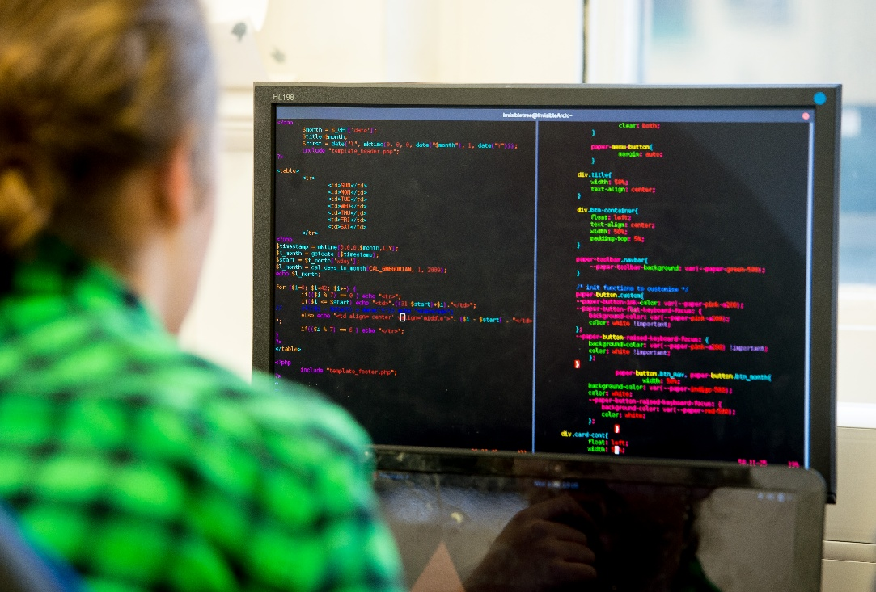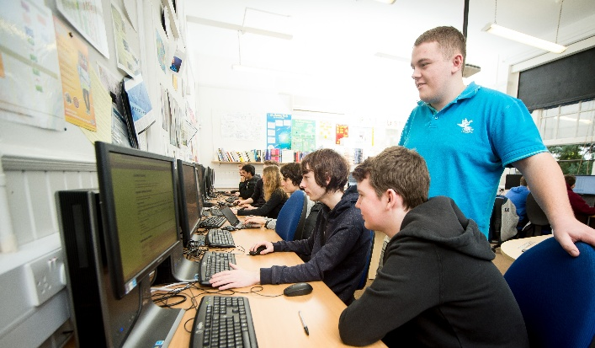

**COMPUTER SCIENCE** AS/A Level

AQA

Tuesley Lane, Godalming

GU7 1RS

T: 01483 423526

E: [college@godalming.ac.uk](mailto:college@godalming.ac.uk)

W: www.godalming.ac.uk

Tuesley Lane

Godalming

Surrey

GU7 1RS

T: 01483

E: [college@godalming.ac.uk](mailto:college@godalming.ac.uk)

W: [www.godalming.ac.uk](http://www.godalming.ac.uk)

Computer Science is much more than just using computers. It is the study of computation, data and information, and is a subject which will allow you to understand the fundamentals behinds the technological revolution that has transformed the world in the last 30 years.

Practical skills form the heart of Computer Science developing a systematic approach to solving problems. This, together with a strong focus on the models describing computer systems, provides a course that is recognised for its academic worth.

During the AS year you will develop strong programming skills. In the full A level, we look in more detail at systems development, processing and advanced programming techniques.

What is the department like?

The DCT and Computer Science departments share well-equipped rooms within the main college building. These are fitted with modern PCs, which are updated on a regular basis, and electronic whiteboards for demonstrations and presentations.

All computers are connected to the College Network, which also provides access to our e-learning system, ‘Godalming Online’ and to the Internet. Students are allocated a user area to store their College work and are provided with a College e-mail address.

The rooms contain peripheral devices including a colour laser printer/scanner/photocopier.

Friendly and enthusiastic tutors, who are supported by a team of efficient technicians, teach on the courses.

About 50 students study Computer Science at any one time. The Department has enjoyed an excellent pass rate in recent years and it is possible to achieve at the highest standard in what is acknowledged nationally to be a difficult subject.

We hope our students will derive enjoyment and satisfaction from the study of Computer Science.

What sort of work will I be doing?

At both AS and A-Level we make the classroom learning as active as possible. Incorporating demonstrations and practical work for both programming and theory topics.

We believe students gain a greater understanding by experiencing the subject first hand. Students will work individually and in small groups completing tasks that develop skills alongside knowledge.

A major component of the course is coursework, with an individual project forming 20% of the full A level. A substantial amount of work will be required in documenting the analysis, design and evaluation of the system as well as in development of the software.

What are the entry requirements?

We would like you to have obtained five GCSE subjects at Grade 4 or above including Grade 4 in English and Grade 5 in Mathematics. The Mathematics grade is particularly important because of the logical, mathematical and problem solving skills in Computer Science. Our most successful students are those who study Mathematics alongside Computer Science.

Although many of our students already have well-developed IT skills, there is no requirement for a formal qualification in Computer Science or ICT.

.

What is the course about?

What are the progression routes for this qualification?

Computer Science

A level is an excellent qualification both for those who wish to go straight into work and for those who want to continue into Higher Education.

If you wish to apply for a Computing based degree, you are strongly recommended to combine the course with Mathematics and other scientific subjects.

Computer Science

can be combined successfully with other disciplines; however the IT BTEC is a more suitable course if you are following a less technical programme.