

How will I be assessed?

AS and A levels in Drama and Theatre will be assessed

through a combination of a 40% written exam and 60%

non-examined assessment (practical performance work and coursework). AS will be a separate, linear qualification able to be taken as a one-year option, but most practitioners will chose the A2 programme for a richer more in-depth programme of study.

What extra work can I do?

Wider reading is always advisable as is seeing plenty of live theatre to broaden experience. Most theatres have a student

standby arrangement with very good rates. Look for opportunities to take part in workshops and production work run by professional and good quality amateur companies. Work experience in a theatre will give you useful contacts and broaden knowledge.

What is special about studying with ClassAction?

High Achievement and progression rates  
Regular performance assessment showcasing work to the public  
A purpose built Dance Studio  
Taught by professionals who are working/have worked professionally in the industry  
You will learn how to work as part of a performance ensemble – to lead and take the initiative in group work.  
  
ClassAction believe that performance art training should be a challenging, inspiring, life affirming and ultimately life changing experience. We will: develop a nurturing and supportive environment in which every single student is valued as an individual.

|  |  |
| --- | --- |
| **Follow us on Twitter @ ClassAction01** | |
| **YouTube channel – ClassAction Theatre** | |
|  |  | |
|  |  | |

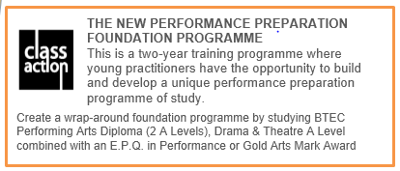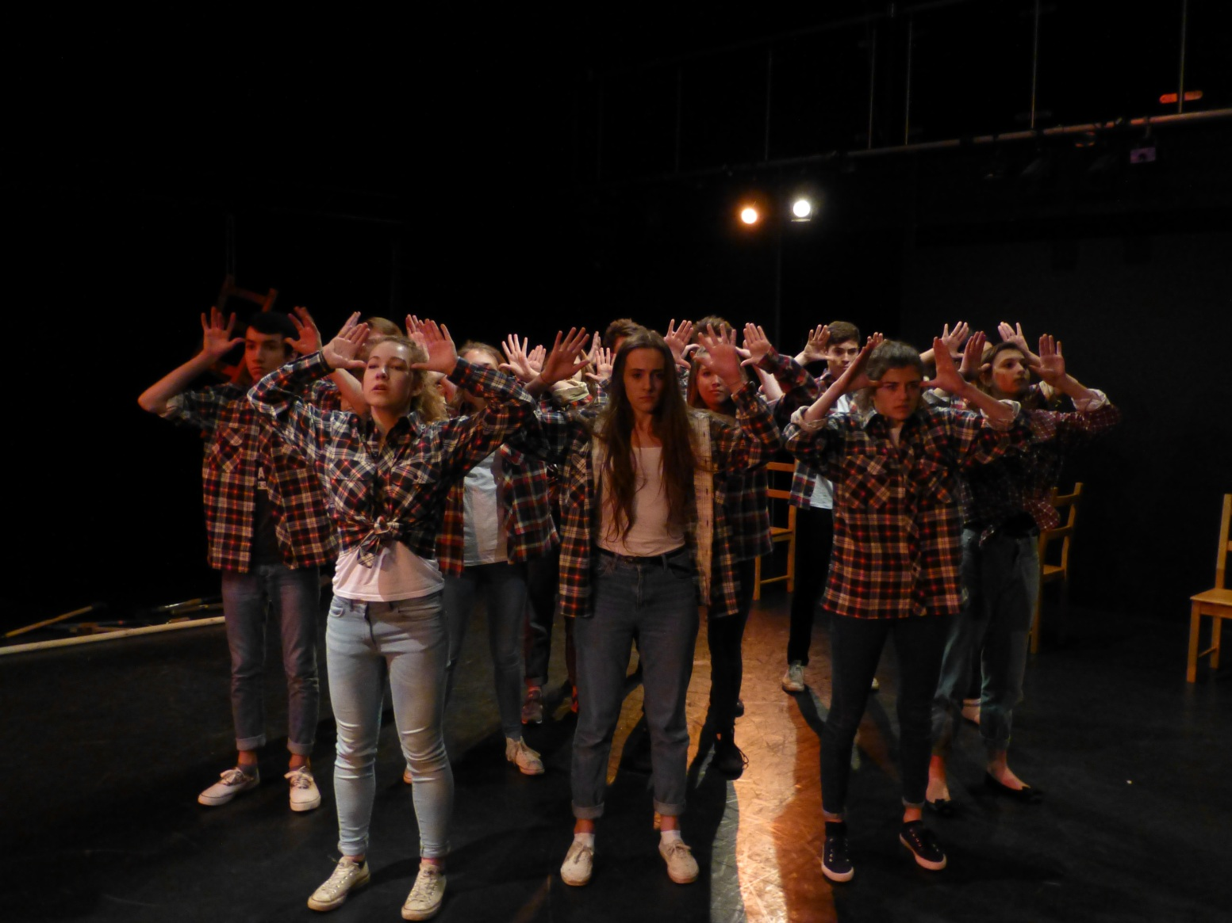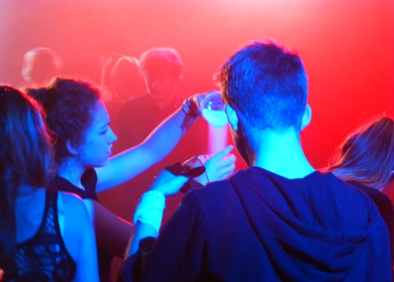

**DRAMA & THEATRE**

AS/A Level

“There is play and adventure within a rigorous learning framework”

**Drama and Theatre**

AS/A Level

“There is play and adventure within a rigorous learning framework”

Tuesley Lane, Godalming

GU7 1RS

T: 01483 423526

E: [college@godalming.ac.uk](mailto:college@godalming.ac.uk)

W: www.godalming.ac.uk

Tuesley Lane

Godalming

Surrey

GU7 1RS

T: 01483

E: [college@godalming.ac.uk](mailto:college@godalming.ac.uk)

W: [www.godalming.ac.uk](http://www.godalming.ac.uk)

What is the course about?

The final draft 2016 specifications have yet to be published

The course demands practical, creative and communication skills in equal measures. You will be expected to extend your ability to create drama and theatre, either in a performing or a production role. You will write about drama and develop your powers of analysis to become an informed critic. The course will involve taking part in productions as well as studying plays, playwrights and theatre practitioners.

What sort of work will I be doing?

A range of approaches will be covered. Performance of text and contemporary devised work will happen in groups; the process is recorded and evaluated. Practical workshops will be used to explore text accompanied by written elements to demonstrate understanding. DVDs, resource packs, podcasts and the college V.L.E. are used extensively to aid your learning. Rehearsal work will be undertaken for performance of text, directed by members of staff or your peers, with opportunity for students to take responsibility to organise their own rehearsal time. The course carries a 40% written exam weighting with 60% practical and coursework assessment.

What are the entry requirements?

A minimum of five GCSE subjects at Grade 4 or above including English, Drama and/or some performance experience. Whilst Drama GCSE is useful it is not compulsory. It is most important to be interested in gaining a greater understanding of how theatre and plays work and to be keen to be involved in performances.

What are the progression routes?

Drama and Theatre complements a wide range of subjects and is useful in building confidence and improving presentation skills in a range of careers.

Drama and Theatre is accepted as an established and rigorous academic subject when applying to Universities.

Increasingly this qualification at Godalming College is leading to a career in the performing arts industries.

As well as students studying the range of performing art subjects at many universities, over the past few years we have had students gain places at prestigious institutes such as RADA, Bristol Old Vic, Royal Central School of Speech and Drama, Lamda, GSA, East 15, Drama Centre, Mountview, Arts Ed, Birds, Performers, LABAN, The Place, Urdang

The futures for our students are bright and exciting and future careers for ClassAction practitioners are rich and diverse as we develop the theatre makers of the future.

What is the department like?

Within the department we aim to create an environment that truthfully reflects that of a professional rehearsal space, based on mutual respect, trust, and a shared passion. Giving equality of time, effort and imagination in line with colleagues and tutors, our students develop from within a strong ensemble group whilst the individual is simultaneously nurtured.

The focus of the department is on you as artists, creators, practitioners, thinkers and learners. We require that you create the best work you can and expect that you will develop and fulfil your artistic and personal potential as well as raising your academic achievements. We want new thinking, we want to push boundaries and above all we want to take risks. You will be challenged to work to professional standards of collaboration. There are high expectations of students on this course, but it also offers the opportunity to perform with the best at the very highest level.

The course aims to develop your understanding and questioning of theatre and drama as product and as powerful tools in the examination of human interaction developing your understanding of the social and historical context of drama and theatre in performance.

We are housed in a well-equipped performance studio within our new Performing Arts Building with a second smaller studio space, rehearsal rooms, scene dock and industry standard control room.

“ClassAction” is Godalming College’s training company that brings together all aspects of this thriving and successful department. We offer a unique performance art programme with the aim of creating a first class performance preparation training course that is underpinned by academic rigour and depth of reflection. ClassAction is supported by an outstanding faculty and a growing network of professional industry contacts, and is dedicated to preparing and inspiring our training practitioners to the highest practical and academic level. There are around 200 students working across the two years in different combinations of programmes. Some follow an academic route on one of our courses. Others combine two of our courses with a performance E.P.Q. in their second year to create a unique performance training package. Everyone will always be encouraged to find their own unique artistic voice as a practitioner.

The teaching is done using a variety of approaches designed to suit different abilities and learning styles. Our staff work closely together and operate a team-teaching approach for practical units to encourage the widest range of creativity.