

**The Expeditions:**

|  |  |
| --- | --- |
| **Silver** | |
| Training | In College throughout the year |
| Practise | The South Downs March 2018 |
| Assessed | New Forest/Brecon Beacons June/October 2018 |
| **Gold** | |
| Training | Dartmoor March 2018 |
| Practise | The Brecon Beacons June 2018 |
| Assessed | Lake District July 2019 |

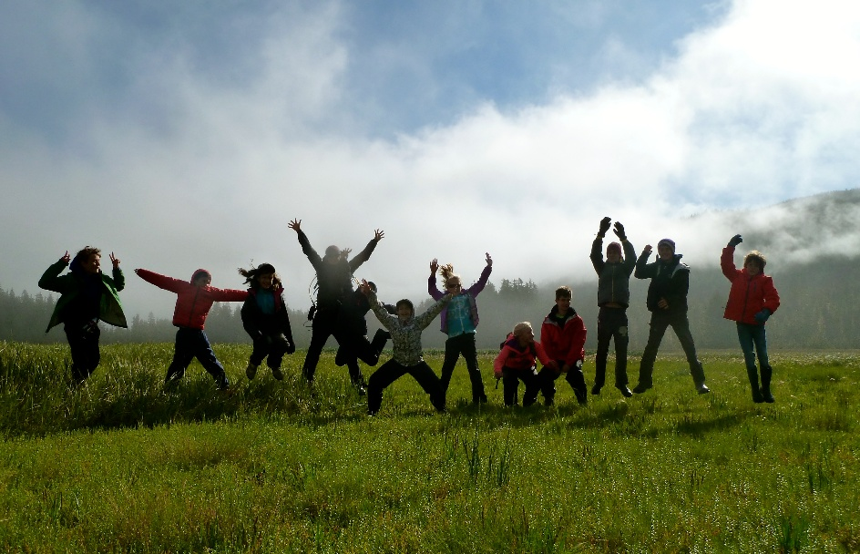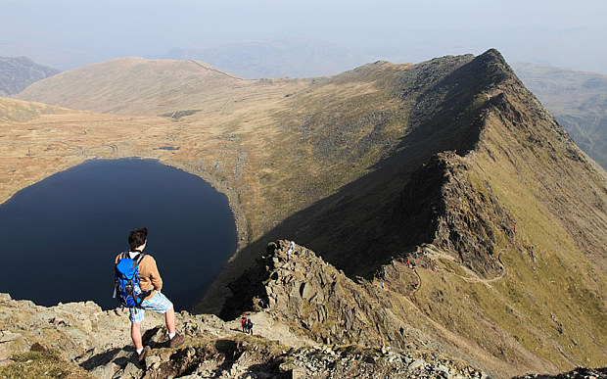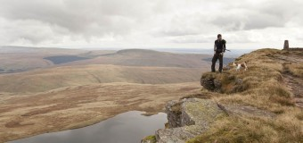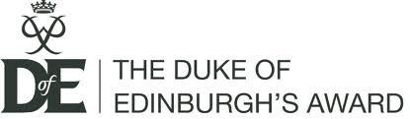

**The Duke of**

**Edinburgh’s Award**

**Gold & Silver**

**The Duke of Edinburgh Award Scheme is a challenging, exciting and life changing programme to be involved in! If you would like to be part of a community that immerses itself in achievement through independent challenge, at the same time as giving you great opportunities learn about yourself, others and the world around you, then this award scheme is for you!**

Please contact the Leader of The Duke of Edinburgh Award’s at Godalming, Belinda Goodman if you have any questions: [BJG@godalming.ac.uk](mailto:BJG@godalming.ac.uk)

Tuesley Lane, Godalming

GU7 1RS

T: 01483 423526

E: [college@godalming.ac.uk](mailto:college@godalming.ac.uk)

W: www.godalming.ac.uk

Tuesley Lane

Godalming

Surrey

GU7 1RS

T: 01483

E: [college@godalming.ac.uk](mailto:college@godalming.ac.uk)

W: [www.godalming.ac.uk](http://www.godalming.ac.uk)

**Will universities and employers like it?**

Yes! Achieving an award will give you skills, confidence and a view on life that employers, colleges and universities will like.

You’ll make a difference to other people’s lives and your community, be fitter and healthier, make new friends and have memories to last you a lifetime.

**What’s the point?**

* Because from the first day to the last it’s a real adventure. Every section gives you something different - that's the fun of it!
* You’ll enjoy loads of new experiences, discover talents you never thought you had, challenge yourself and meet loads of new people.
* And above all, it's fun - the question should really be what isn’t the point!

**How will Godalming College help me to achieve my award?**

* We will help you to find a voluntary work or service placement.
* We will give you ideas for the physical and skill aspects of the course and will monitor your progress.
* We will train you in preparation for all aspects your expedition.

**How can I help myself to achieve?**

* You will need to be proactive in organising all aspects of your course. Whilst we are here to help and advise you, the responsibility of setting up placements lies with you.
* Students who commit themselves to this programme will not only be successful but will also thoroughly enjoy the process. You will get out what you put in!

Young people doing their DofE programme complete four different types of activity at Silver Level and five at Gold Level to achieve the award:

* **Volunteering**: undertake service to individuals or the community. This develops compassion, commitment and the confidence to make a difference.
* **Physical**: improve in an area of sport, dance or fitness activities. This develops fitness, enjoyment and, depending on the activity, teamwork.
* **Skills**: develop practical and social skills and personal interests. This helps young people to realise their unique potential and gain greater self-esteem.
* **Expedition**: plan, train for, and complete an adventurous journey in the UK or abroad. This develops teamwork and leadership, and challenges young people to push themselves beyond their expectations.
* **Residential** (Gold level only): stay and work away from home doing a shared activity. Again this challenges young people, who must work with strangers to achieve a positive goal.

**What is D of E?**