

How will I be assessed?

The syllabus for the full A level is divided into 2 units, both of these being examined at the end of the second year.

The units are:

1. Markets and Market Failure
2. The National and International Economy

An AS Level is also available at the end of the first year. This is divided into 2 units, with a similar breakdown to the full A level above.

What extra work can I do?

Read the economic, financial and business pages of a quality newspaper or magazine. The best Economics students are usually those who have a good grasp of current affairs.

In addition students would benefit from watching newscasts (either ‘live’ or by podcasts) from trusted sources such as the BBC,ITV, Sky or Channel 4.

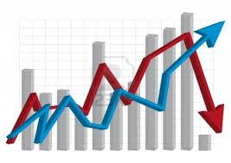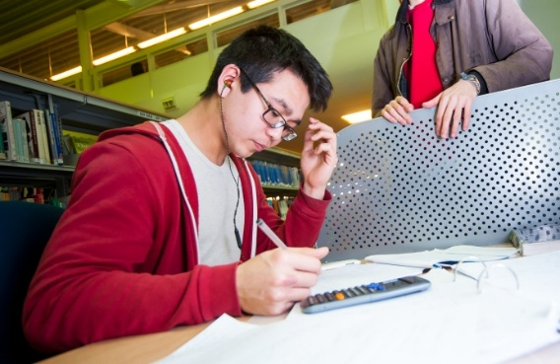

**ECONOMICS** AS/A Level

AQA

Tuesley Lane, Godalming

GU7 1RS

T: 01483 423526

E: [college@godalming.ac.uk](mailto:college@godalming.ac.uk)

W: www.godalming.ac.uk

Tuesley Lane

Godalming

Surrey

GU7 1RS

T: 01483

E: [college@godalming.ac.uk](mailto:college@godalming.ac.uk)

W: [www.godalming.ac.uk](http://www.godalming.ac.uk)

What are the entry requirements?

A minimum of five GCSE subjects at Grade 4 or above, including a Grade 4 in English and a Grade 6 in Mathematics. Much of the course requires an ability to write fluently. Whilst the modern course contains no advanced mathematics in itself, an ability to think logically is important. No previous knowledge of Economics is assumed, but a willingness to take an interest in current affairs is essential.

.

What about educational visits?

There will be an educational trip to New York, open to all economics students. The trip will allow students to visit sites of cultural and economic significance.

Specialist revision conferences will available to 1st year and 2nd year students.

It also looks at the UK economy and our role as a trading nation. This necessitates a discussion of the Economic relations between the UK and other European countries

What is the department like?

The department is accommodated in a new building, with very good IT facilities.

The staff are friendly, approachable and economic specialists.

The department runs regular support sessions throughout the week.

What skills will I develop during this course?

Economics provides the opportunity to contribute to your skills in the areas of numeracy, communication and group work.

Can I do a supplementary course?

An EPQ (Extended Project Qualification) is also offered by the department, which strengthens students University applications.

A number of Economics students also do preparatory work for Oxford and Cambridge entrance. This involves extended reading and work on a recommended text from the library. In addition students will be encouraged to enter the Royal Economic Society essay writing competition.

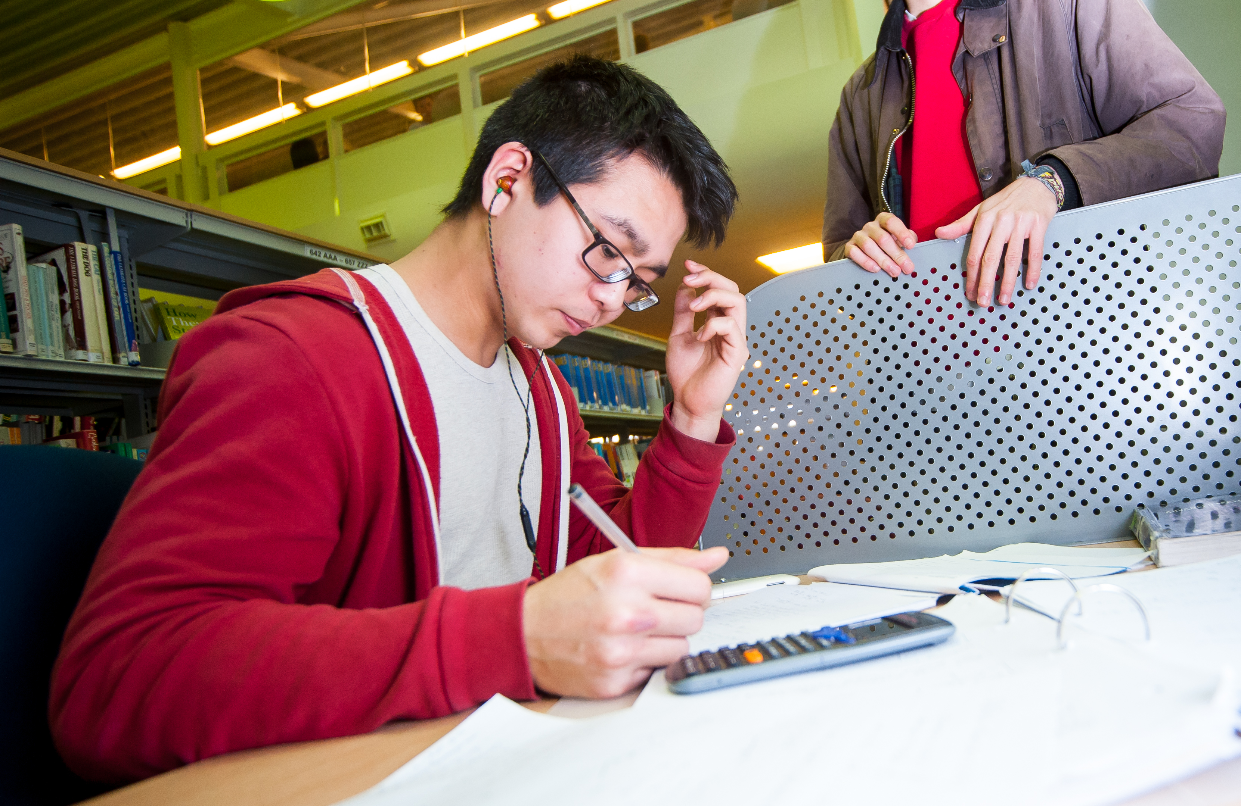

What are the progression routes for this qualification?

Economics is taken by students studying a wide range of other subjects. It complements well the work of students studying predominantly Arts or Sciences.

As a well-respected A level, it is an ideal subject for those aiming at the traditional Universities. Many of our students go on to take Economics degrees.

Typical career destinations here include the Stock Market, International Banking, Insurance and Accountancy.

What sort of work will I be doing?

The course is taught through a variety of methods. In lessons there is a focus on activities, group work and debate.

Furthermore, the course requires some simple mathematical calculations to be performed. However there is no additional content above GCSE mathematics

What is the course about?

Micro-Economics looks at problems as they affect individuals and companies. How are we best to spend our money? What should firms produce? What determines the price of goods in the shops? What determines wage levels? Are students entitled to the Minimum Wage? The course also invites students to discuss just how large a role the government should have in determining economic affairs? Do markets work best when governments leave them alone? Or is active government involvement required to reduce things like inequality in society.

Macro-Economics looks at the big economic issues facing the government of the day. It looks at current debates about unemployment, inflation and Economic growth.