

Tuesley Lane
Godalming
Surrey
GU7 1RS
T: 01483
E: college@godalming.ac.uk
W: www.godalming.ac.uk
ENGLISH GCSE
AQA
Tuesley Lane, Godalming
GU7 1RS
T: 01483 423526
E: college@godalming.ac.uk
W: www.godalming.ac.uk
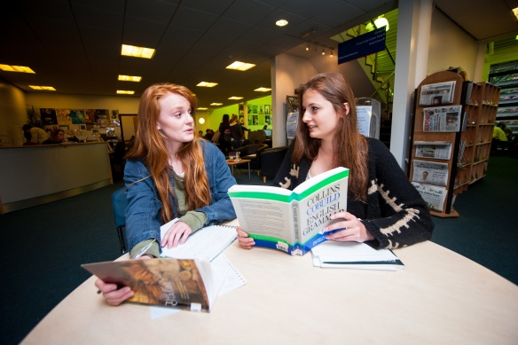
What are the progression routes for this qualification?

GCSE English is generally accepted as a basic requirement for many A Level courses and for most occupations. Accurate written skills are important for any career move you may be considering, and the oral part of the course should develop your confidence for any occupation involving direct contact with the public.

What is the course about?
This one-year course is specifically designed for students in post-16 education. It aims to develop your achievement at Key Stage 4, paying special attention to:

Speaking and listening

Reading
Writing
Spelling and Punctuation
Use of Standard English

Why would I take English?

Employers, apprenticeship schemes and universities look for GCSE English Language on application forms therefore it is an important qualification to gain.

What sort of work will I be doing?

In the English course we use a range of teaching and learning styles, allowing flexibility of approach. These include whole class teaching, videos, small group activities and workshops. Teaching styles aim to foster the development of critical skills and encourage students to participate through discussions and individual presentations. Throughout the course, there will also be time given to practising exam-style exercises.

How will I be assessed?

Speaking and Listening tasks (0%)

You will be involved in a range of activities to demonstrate your ability in presenting, debating and discussing.
Following recent changes by the government, this is now a stand-alone element of the course and, if you have already completed your speaking and listening, you will not have to take this unit again as we will be able to carry it forward.

Examination 100%

You will take two exams which will test your reading ability through the analysis of writers’ decisions and techniques in both fiction and non-fiction. Your writing will be tested through your ability to take a particular viewpoint and write for different audiences and purposes, showing knowledge of form and use of Standard English.

These exams will both be taken in the summer and will be 1 hour 45 minutes each in length.

What extra work can I do?

We encourage as much reading as possible and will be pleased to recommend suitable titles of books but newspapers, magazines and blogs can be just as useful. We will suggest exercises to overcome specific areas of difficulty, either paper-based or on the internet.

