

How will I be assessed?

**A Level:** the examined components test three key areas of study. In paper 1 you analyse and compare two non-fiction texts, including a transcript of live speech; one will be from an anthology of non-fiction texts and one will be unseen. In paper 2 you write about the work of a studied poet, based around a poem printed on the paper; you then answer a question on a modern play, based on a printed extract. In paper 3 you write about a prose text and then produce a fragment of an original story based on a given storyline. There is also a 20% coursework element where you compare the language used in a studied non-fiction text with the language used in a text you choose yourself; you also produce your own piece of non-fiction writing (e.g. a persuasive speech) with a short introduction which lays out what you were trying to achieve.

**AS Level:** this separate qualification has some key elements of the full A level. There are two examined components and no coursework. In paper 1 you compare two texts taken from an anthology of spoken and written texts. In paper 2 you answer a question based on an extract from a novel you have studied and a question comparing two poems from a collection of poetry by a poet such as William Blake.

What extra work can I do?

We encourage you to read widely both before and during your study of English at Godalming College. The department issues a reading list to students in the summer before you join us, and we will recommend extension work to support AS and A2 work in progress. We also have a Higher English group which meets each week during the AS year, designed specifically for those with aspirations to study English at university. We also encourage students to do an Extended Project in English. Here you can write a dissertation on a topic that has caught your interest during the AS year, or develop an extended piece of creative writing.

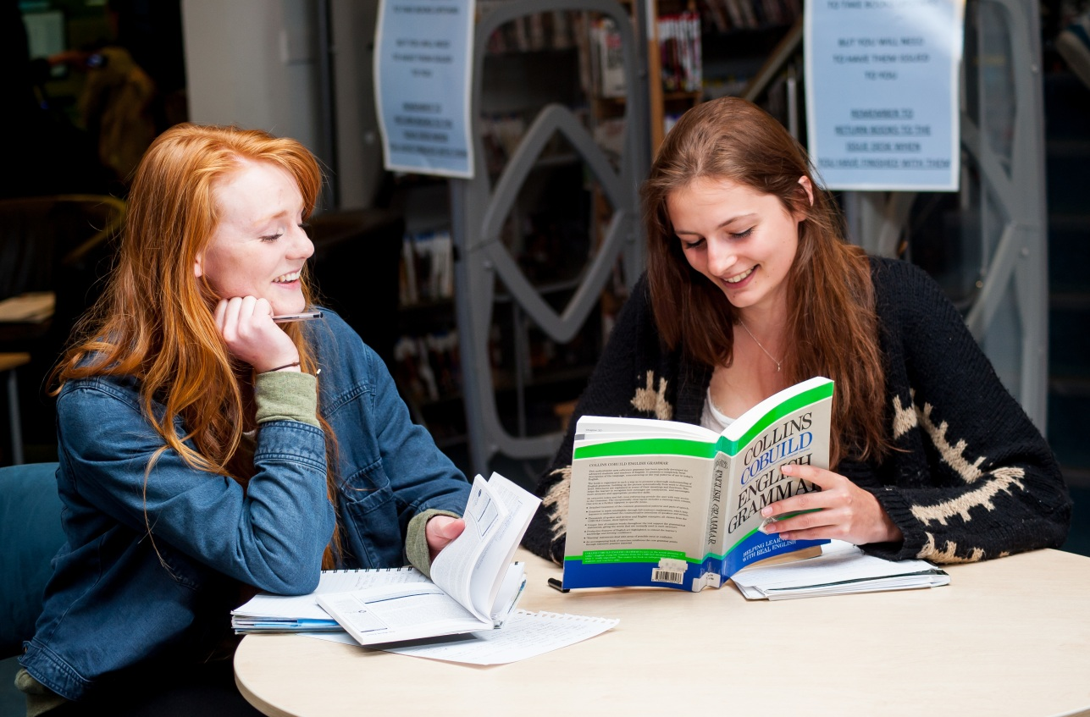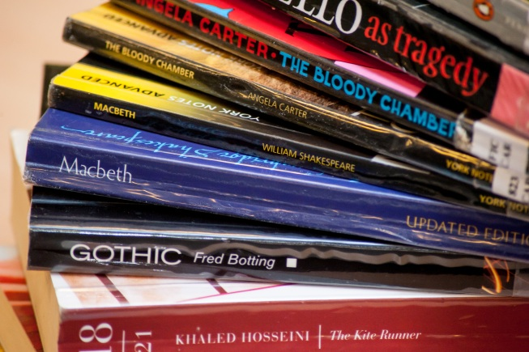

**ENGLISH LANGUAGE AND LITERATURE**

AS/A Level

OCR

Tuesley Lane, Godalming

GU7 1RS

T: 01483 423526

E: [college@godalming.ac.uk](mailto:college@godalming.ac.uk)

W: www.godalming.ac.uk

Tuesley Lane

Godalming

Surrey

GU7 1RS

T: 01483

E: [college@godalming.ac.uk](mailto:college@godalming.ac.uk)

W: [www.godalming.ac.uk](http://www.godalming.ac.uk)

This course requires you to apply literary and linguistic analytical techniques to poetry, plays and novels, as well as to non-literary texts such as transcripts of conversations. As well as writing critically, you will get opportunities to write creative pieces in response to the texts you study.

What sort of work will I be doing?

We set a variety of written exercises, including small-scale tasks, some in preparation for lessons, to be completed within a few days, and more substantial assignments for which two weeks may be allowed to give time for research, planning, consultation and so on. Many of these tasks will be analytical. Some will be creative or transformative (where you take one text and re-write it in a different genre).

Group discussion activities and presentations are an important element of study, helping you to become aware of the complexities of language use in literary and non-literary texts.

One of our main aims will be to equip you with a set of literary and linguistic tools so that you can find patterns in the writing of novels, plays and poetry and, equally, explore the language of non-literary pieces such as speeches and satirical writing.

**Note**: If you are having difficulty choosing which English course to take, please refer to the ‘Deciding Factors Table’, comparing our three different English A levels, available at Open Evening or on request. You *can* do both English Language and English Literature as separate A levels if you wish.

What are the entry requirements?

Five GCSE subjects at grade 4 or above, including English Language and/or English

Literature. Students with a grade 5 or above in English Language or Literature GCSE find the subject more manageable. .

.

Some of these approaches will be familiar to you, for example studying a writer’s choice of vocabulary. Some, such as placing a focus on grammar and syntax or the study of pragmatics (what texts really mean in their context) will be new to you. The course places an emphasis on spoken as well as written texts.

Coursework is an important element at A level only, but throughout the course we aim to encourage and help you to develop self-discipline and eventually take responsibility for organising your own studies.

What is the department like?

We are an enthusiastic team of teachers, keen to share our enjoyment of language and literature with you. Our aim on the combined Language and Literature course is to guide you to becoming independent critical readers, with strong linguistic skills which you can demonstrate in well-written essays and in texts that you create yourself.

We try to provide a variety of learning experiences, both inside and outside the classroom, and continually update our subject knowledge so that you are developing the skills you need in order to do well. We meet regularly and select and share resources that we hope will challenge and stimulate you.

We aim to give careful and constructive feedback on your work. From you, meanwhile, we need intellectual and creative involvement. A love of reading is the best place to start, but we also need a keenness to prepare for class and to work to the best of your ability on all assignments. This kind of engagement will lead to a high grade and for many, we hope, the decision to study English at university. Whatever you achieve, we hope that you will want to pick up challenging and enjoyable books long after you leave college.

What is the course about?

What are the progression routes for this qualification?

Most university English courses, including courses with a strong Literature element, will accept the combined Language and Literature A level in their entry requirements, although you will need to show evidence of extra reading if it is a pure English Literature degree. Students doing a wide variety of other subjects, in Arts, Humanities and Sciences often opt for an English A level and they go on to many different courses and careers. The skills that you learn are a useful starting point for careers in the arts and the media (including journalism), law and business, and in other professions where creativity, a critical approach and good communication skills are needed.