

How will I be assessed?

* **A Level:** the three examined components to the full A level are simply entitled Drama, Prose and Poetry. For the drama paper you will answer questions on a modern tragedy and a play by Shakespeare (supported by a set of critical essays). For the prose paper the question asks you to compare two novels (one pre-1900) under the theme of *Science and Society*. For the poetry paper you will respond to an unseen poem and also answer a question on the work of a key poet from a period or movement. There is also a 20% coursework element, where you will write a 2,500 word essay linking two further texts linked by one of the following: theme, movement, author or period.
* **AS Level:** this separate qualification has elements of the full A level. It is has two examined components and no coursework. In Component 1 you respond to an unseen modern poem and answer a question on a modern tragedy or comedy. There is no Shakespeare play studied at this level. For the shorter prose paper you will answer one question where you link two novels (one pre-1900) under the theme of *childhood*.

What extra work can I do?

We encourage you to read widely to support your study of English Literature at Godalming College. We will issue you with a reading list in the summer before you join us, and we give you a range of texts to read between year one and year two, to prepare for coursework study in the second year. We have a Higher English group, designed specifically for those with aspirations to study English at university and encourage students to do an EPQ in English, where students produce a fully-researched dissertation on any aspect of English Litearture.

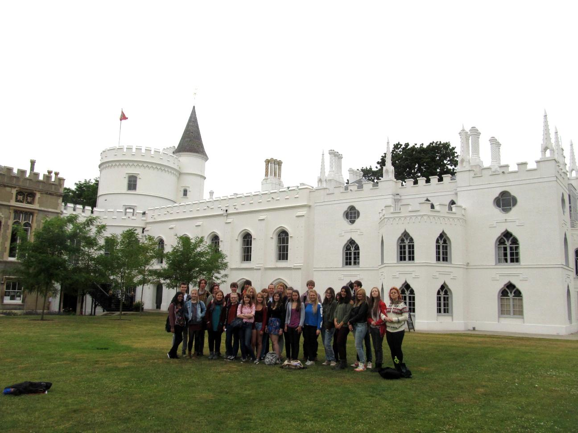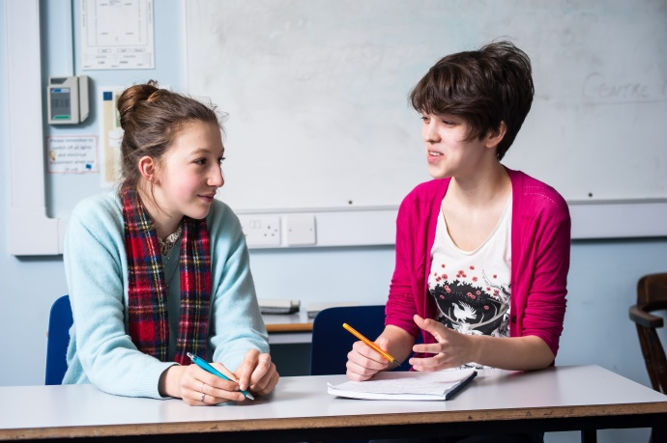

**Note**: If you are having difficulty choosing which English course to take, please refer to the ‘Deciding Factors Table’, comparing our three different English A levels, available on request. You *can* do both English Language and English Literature as separate A levels if you wish.

**ENGLISH LITERATURE** AS/A Level

EDEXCEL

Tuesley Lane, Godalming

GU7 1RS

T: 01483 423526

E: [college@godalming.ac.uk](mailto:college@godalming.ac.uk)

W: www.godalming.ac.uk

Tuesley Lane

Godalming

Surrey

GU7 1RS

T: 01483

E: [college@godalming.ac.uk](mailto:college@godalming.ac.uk)

W: [www.godalming.ac.uk](http://www.godalming.ac.uk)

What sort of work will I be doing?

You will be reading ahead and preparing your texts before the lesson, using materials to support your reading, some of which we will provide for you. You will be involved in lots of classroom discussion, and a range of activities based around discussion of mini-texts, visual images, film clips) designed to build your understanding of how texts are written and why. We set a variety of written exercises, including small-scale tasks, some in preparation for lessons, to be completed within a few days and some within the lesson itself. We will also set more substantial essays for which two weeks may be allowed to give time for research, planning, consultation and so on. Coursework is an important element at A Level. We aim to encourage and help you to develop self-discipline and eventually to take responsibility for organising your own studies.

What are the progression routes for this qualification?

A level English courses are taken by students doing a wide variety of other subjects, in Arts, Humanities and Sciences. They go on to many different courses and careers. English is often a component in degree courses in Humanities as well as being a very popular choice as a single-subject degree. The skills that you learn are a useful starting point for careers in the arts and the media, law and business, and in other professions where creativity, critical awareness and the ability to communicate clearly are needed.

What are the entry requirements?

Five GCSE subjects at grade 4 or above, including English Language and/or English Literature. Students with a grade 5 or higher in one or both of these find the course more manageable.

What is the department like?

We are an enthusiastic team of teachers, keen to share our enjoyment of literature with you. Our aim on the English Literature course is to guide you to becoming independent critical readers, able to demonstrate your skills in well-written essays. We try to provide a variety of learning experiences, both inside and outside the classroom, and continually update our subject knowledge so that you are developing the skills you need in order to do well. We meet regularly and select and share resources that we hope will challenge and stimulate you. We aim to give careful and constructive feedback on your work. From you, meanwhile, we need intellectual and creative involvement. A love of reading is the best place to start, but we also need a keenness to prepare for class and to work to the best of your ability on all assignments. This kind of engagement will lead to a high grade and for many, we hope, the decision to study English at university. Whatever you achieve, we hope that you will want to pick up challenging and enjoyable books long after you leave college.

What is the course about?

You will study, in detail, a variety of texts from different periods and by different authors. In the first year you will concentrate on two ways of studying English literature: firstly, *how writers tell stories*, particularly in novels and narrative poetry; secondly, how we define a *dramatic genre* (e.g. tragedy or comedy) explored via a Shakespeare play and a modern drama text. You will learn about the contexts in which texts are produced as well as being encouraged to develop your powers of judgement and analysis and to form your own opinions about how and why writers write.

In the second year you will develop your understanding of genre and narrative further, adding the skill of comparing texts through an extended coursework essay and learning how to apply critical theory (e.g. feminism or Marxism) to literary texts.

We are great believers in extending your learning beyond the classroom: theatre trips in London, a workshop with the Poet Laureate, a Shakespeare study trip in Stratford, a poetry conference with five living poets and much more besides. The department and the Learning Resources Centre have an excellent collection of films, study guides and other resources, some produced by us, and these are used to support work on the texts.