

How will I be assessed?

If following the AS Film Studies course (one year) you will be assessed through two exams (both 1 hour 30 minutes; - worth 70%) and non-exam assessment (worth 30%).

If taking A-level Film Studies, you will be assessed at the end of two years through two exams (both 2 hours 30 minutes - worth 70%) and non-exam assessment (worth 30%).

Component 1 covers the style, context, and meaning of both classic and independent American film, as well as modern British cinema.

Component 2 looks at the concept of global cinema, as well as documentary film, silent cinema and experimental film movements.

Component 3 comprises of an individual production, within a range of several format choices (short film, digital storyboard or screenplay)

What extra work can I do?

It is expected of all film students that you undertake a substantial amount of work outside normal College hours. This includes:

1. reading: as much of and as varied as you can – and not only books:
2. look out for relevant articles in the press. The College library has an excellent collection of media/film books and magazines
3. research for assignments - books, magazines, newspapers, Internet, etc.
4. production work: if you have your own camera, do as much photography/video work as you can.

The Media Workshop is open until 5.00pm: arrangements can also be made for you to work there until 9.00 p.m. on Mondays and Thursdays.

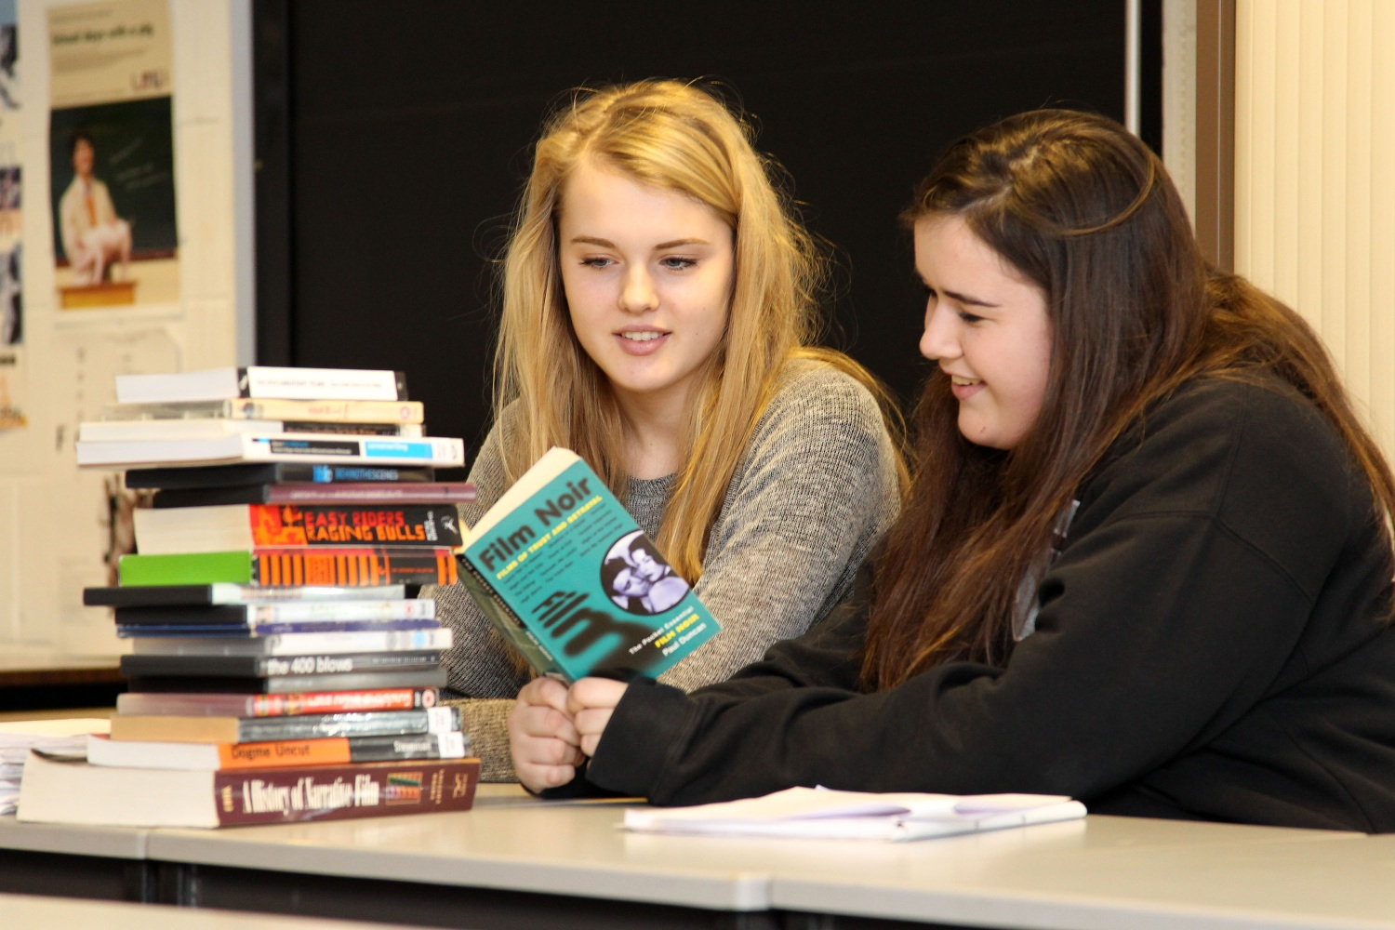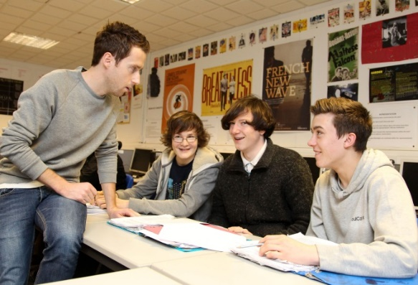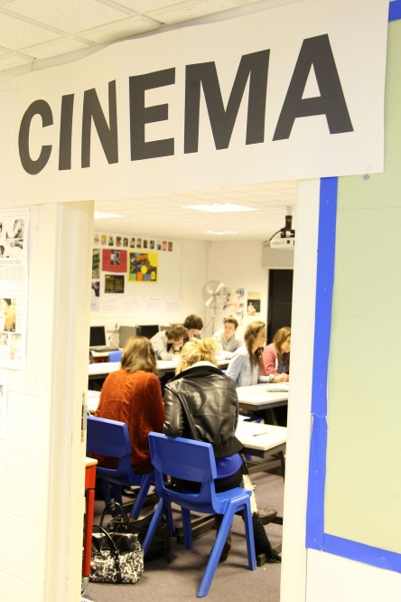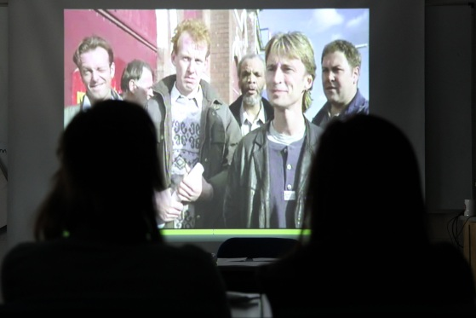

**Film Studies** AS/A Level

WJEC / Eduqas

Tuesley Lane, Godalming

GU7 1RS

T: 01483 423526

E: [college@godalming.ac.uk](mailto:college@godalming.ac.uk)

W: www.godalming.ac.uk

Tuesley Lane

Godalming

Surrey

GU7 1RS

T: 01483

E: [college@godalming.ac.uk](mailto:college@godalming.ac.uk)

W: [www.godalming.ac.uk](http://www.godalming.ac.uk)

What is the department like?

We have a fully equipped Workshop with high quality digital cameras and industry standard editing software. All classrooms are equipped with PCs with desktop publishing software. As part of the course you will learn about the moving image industry and learn the behind the scenes tricks of the trade. The working environment is friendly- one that encourages both intellectual inquisitiveness and creativity.

The staff are enthusiastic about their subject and the college, and enjoy supporting student learning and progression.

There are typically around 300 students in Film and Media Studies across the two year groups. The pass rate is very high and the majority of film and media students achieving grades above the national average.

The teaching incorporates a variety of approaches designed to suit different abilities and learning styles. We try hard to help any student with his / her own learning difficulties such as dyslexia and to stretch those with high academic ability. Visits, trips and speakers are built into the course.

What is the course about?

The specification is designed to introduce learners to a wide variety of films in order to broaden their knowledge and understanding of film and the range of responses films can generate. It offers opportunities to study mainstream American films from the past and the present as well as a range of recent and contemporary British films, American independent films and global films, both non-English language and English language. The historical range of film represented in those films is extended by the study of silent film and significant film movements so that learners can gain a sense of the development of film from its early years to its still emerging digital future. Studies in documentary, experimental and short films also add to the breadth of the learning experience.

What sort of work will I be doing?

There will be a variety of assessment tasks across the two year and one year courses. In both AS and A2 there are options for filmmaking. However, analysing film texts within their production contexts, aesthetics, and cultural significance will make up the majority of your work load, in the form of formal essay writing.

What skills will I develop?

You will develop a range of communication skills, written, verbal and IT based. You will need to be proficient at word processing and using a variety of IT software. Your inter-personal skills will also be developed, as you will be working within small groups in discussions, production work and giving presentations.

What are the entry requirements?

Five GCSE subjects at Grade 4 or above, including English. Previous experience of Media or Film Studies is not required.

.

What are the progression routes for this qualification?

For those interested in pursuing their studies and training in film and the media there are many HND and degree courses. These of are several kinds.

There are courses that are:

* largely practical in nature and are designed for those who want to work in the industry
* wholly theoretical designed for people with an academic interest in the media
* most commonly, those courses that contain a balance of practical and theory.