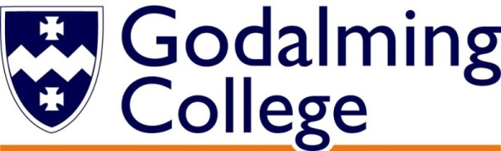

How will I be assessed?

You will take 3 papers for both qualifications, which test the four skills: reading, listening, writing and speaking. In the A level exam a research project is included.

**AS standalone**: AS qualification

**A level (linear, 2 years):**  A level qualification

What skills will I develop during this course?

German will provide the opportunity to develop your skills in communication and information technology as well as improving your study and research skills.

What extra work can I do?

Any additional exposure to the German language will be beneficial. This could be reading German newspapers, magazines and books or watching German films and television programmes. The internet also offers a wide range of opportunities for practising your language proficiency as well as extending your knowledge of German culture and society.

|  |  |  |
| --- | --- | --- |
|  |  |  |

**If you approach the course with enthusiasm and a willingness to participate you will definitely find it stimulating, enjoyable and rewarding.**

**A qualification as an AS standalone or A level German can open all sorts of interesting gateways for you in the future!**

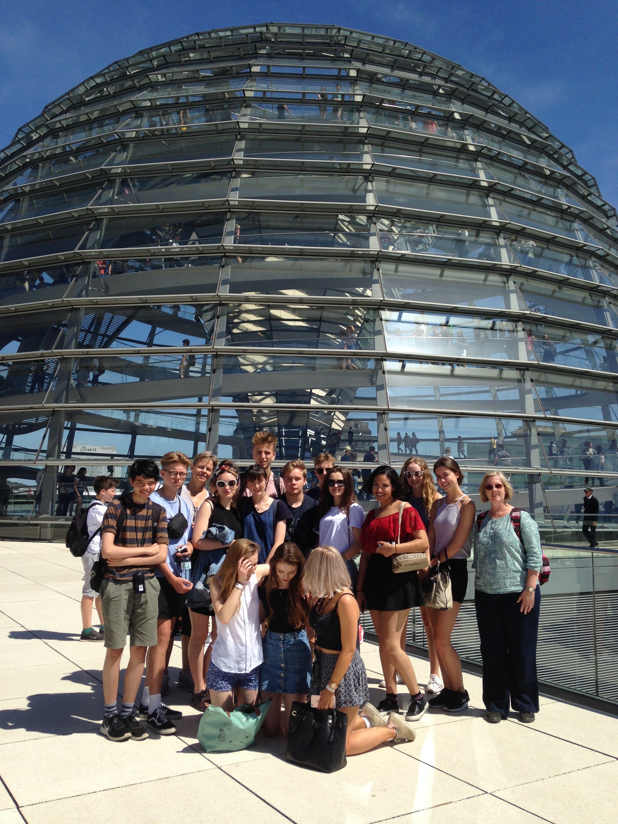

**GERMAN**

AS/A Level

AQA

Tuesley Lane, Godalming

GU7 1RS

T: 01483 423526

E: [college@godalming.ac.uk](mailto:college@godalming.ac.uk)

W: www.godalming.ac.uk

Tuesley Lane

Godalming

Surrey

GU7 1RS

T: 01483

E: [college@godalming.ac.uk](mailto:college@godalming.ac.uk)

W: [www.godalming.ac.uk](http://www.godalming.ac.uk)

What sort of work will I be doing?

You will engage in a wide variety of activities in lessons, ensuring a suitable balance between the different skills. Most tasks will be of a shorter nature, such as speaking exercises, reading, comprehension or listening activities.

What are the entry requirements?

You will be expected to have achieved five GCSE subjects at Grade 4 or above. Normally we would like you to have a Grade 6 or higher in German or an equivalent foreign language qualification. We are always willing to consider each case individually though.

There will also be some written assignments, such as essays and reports, for which more time will be allocated. The atmosphere in classes is relaxed and friendly, encouraging you to participate as much as possible.

The course will develop your proficiency in the areas of speaking, listening, reading and writing, raise your awareness of grammatical structures and extend your command of vocabulary and idioms. We also enable you to broaden your awareness and understanding of contemporary German-speaking societies. Topics include different types of families, music, the digital world, cultural life, art & architecture, the EU & immigration, the German re-unification etc. You will learn to discuss and write about such issues in German. We will study one film in detail (for both courses) and a German novel in the second year of the A level course. These activities will help to develop your sensitivity to the use of language as well as your analytical skills.

You will be taught in a group of about 15 students and classes are conducted almost exclusively in German. Once a week you will also have a one-to-one conversation class (individually or in small groups) with the German Assistant, a German native-speaker.

We also encourage you to visit a German-speaking country during the course so that you might improve your fluency as well as gaining first-hand experience of a different culture. A four day trip to Berlin is offered at the end of the first year. In year two there is an opportunity to participate in a week of work experience.

What is the department like?

We are a well-resourced department within the Modern Languages Department with access to laptops to assist in language learning. The staff are linguists and German native speakers. They enjoy sharing their enthusiasm for language-learning and their interest in German-speaking cultures and societies with you.

There are typically around 30 students of German across the two year groups. In recent years all have been successful in passing the German A level exams, many achieving high grades.

What are the progression routes for this qualification?

A level German can be combined effectively with a range of other A level subjects, broadening your academic base and enhancing your career prospects. With the reunification of Germany and the opening up of Eastern Europe, German is becoming an increasingly important language in numerous fields of commerce, industry and research.

Many of our students continue with the study of German or another foreign language at university. In addition to purely language-based degree courses, it is becoming increasingly popular to combine a language with another subject. Most universities now provide opportunities to combine German with a further subject such as Business Studies, Law, Computing or Engineering. Most of these courses incorporate one year abroad, either at a foreign university or on a work placement and several now offer dual British and German qualifications.

Careers where you could use your skills in German include: interpreting, translating, bilingual secretary, international banking, travel industry, law, teaching, employment in the institutions of the European Union or in commerce and industry. It could even be the stepping-stone to something completely different: some top comedians also studied German at university!

What is the course about?