

How will I be assessed?

You will be assessed on your ability to write essays and use historical sources. For the AS level 100% of the assessment will be by exam. For the A level 80% will be by exam and 20% by coursework.

What are the entry requirements?

Five GCSE subjects at Grade 4 or above including Grade 4 or above in GCSE English and History, if taken. However, newcomers to the subject will also be welcomed, provided that they have gained some good passes in other subjects.

What extra work can I do?

Wide reading and critical reflection on it are vital for success at the highest level. The Department issues a reading list as well as recommending, when appropriate, further reading to support History A level and Extended Project work in progress.

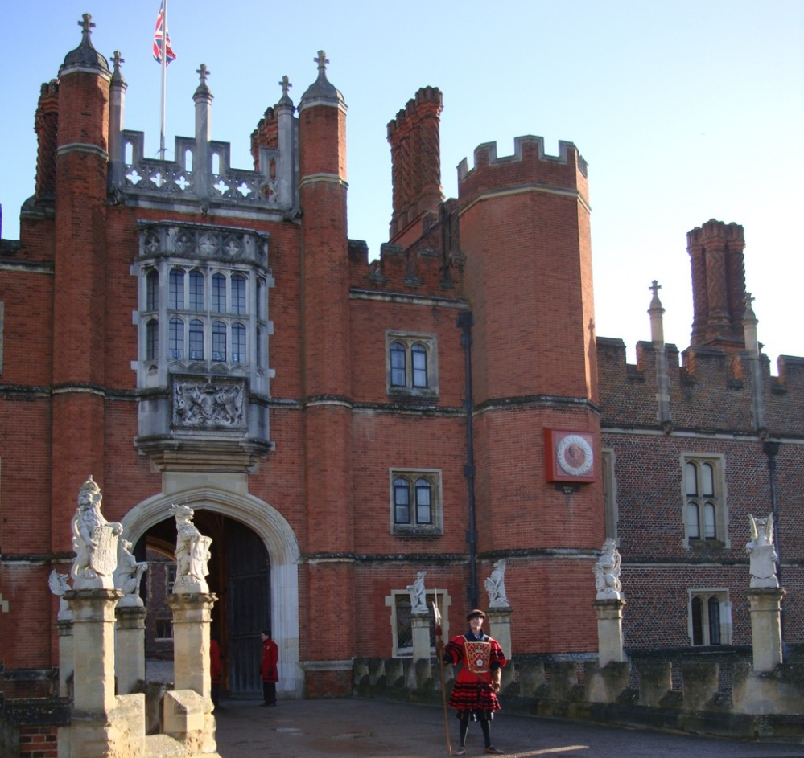

**HISTORY**

AS/A Level

OCR

Tuesley Lane, Godalming

GU7 1RS

T: 01483 423526

E: [college@godalming.ac.uk](mailto:college@godalming.ac.uk)

W: www.godalming.ac.uk

Tuesley Lane

Godalming

Surrey

GU7 1RS

T: 01483

E: [college@godalming.ac.uk](mailto:college@godalming.ac.uk)

W: [www.godalming.ac.uk](http://www.godalming.ac.uk)

We encourage keen Historians to work on an Extended Project in their second year which allows them to pursue an area of particular interest to them whilst still benefiting from supervision within the department. This can stretch students further than the traditional A Level and is a particularly attractive qualification for university admissions tutors for the most competitive courses at the most competitive institutions. As a result of their experience of History at Godalming, many students choose to read the subject at major British universities, including Oxford and Cambridge.

To support learning, a variety of different teaching approaches are adopted. We have an excellent collection of up-to-date material, both in the Department and in the College Library. We also make use of the increasing amount of information technology that is now available to develop learning. Work done in the classroom is supported by other activities, such as day visits to Hampton Court, and lectures in London on relevant issues, delivered by university experts. Cultural and historical enrichment trips abroad to destinations such as Poland and Berlin also broaden and deepen the experience of the History student at Godalming College.

What is the department like?

The History Department is amongst the largest in the College. This year we have over 400 students on our two separate courses across the two year groups. Given the size of the Department, students can choose one of two courses. By a combination of committed and enthusiastic teaching and a responsiveness to the needs and interests of our students we aim both to maintain our high standards of achievement in public examinations and to develop a lasting interest in the subject. Our high standards of achievement are evidenced by consistently strong results and departmental value added scores indicate that the Department adds strong positive value to the progression and attainment of students.

What sort of work will I be doing?

The principal means of assessment at Advanced Level History include the extended answer, or essay based responses, and source analysis responses. The course will prepare students to succeed fully in these areas, both in terms of the content required and the techniques and approaches used to interpret that content in the light of key historical problems. Students should expect to read, write and analyse issues on a frequent basis. The aim is to develop rational, critical, and independent thinkers who are able to handle source material and essay questions with confidence, presenting their insights with persuasion and sophistication.

**The Department offers a choice of two courses.**

**EITHER**

**Rebellion and Revolution**

**First Year**

* England 1445-1509: Lancastrians, Yorkists and Henry Vll
* The French Revolution and the Rule of Napoleon 1774-1815

**Second Year**

* Rebellion and Disorder under the Tudors 1485-1603
* Coursework based on one of the taught units**.**

**OR**

**Dictators And Democracy**

**First Year**

* England 1485-1558: The Early Tudors
* Democracy & Dictatorships in Germany 1919-1963

**Second Year**

* Civil Rights in the USA 1865-1992
* Coursework based on one of the taught units**.**

What is the course about?

What are the progression routes for this qualification?

History is taken by students doing a wide range of other subjects, in both the Arts and Sciences. At this level, History can be a truly complementary subject, extending and balancing a programme of study drawn from any part of the College curriculum. Our students go on to a wide range of courses and careers. A considerable number will take a degree in the subject, or a related field, such as English, Law, Economics, Philosophy, Theology or Politics, where an A-Level in History is certainly an advantage. In addition to a wider angled view of many contemporary events and issues, those trained in History have developed skills of critical analysis and judgement; these are highly valued in many professions, including Law, Management, Finance, Journalism and Politics.