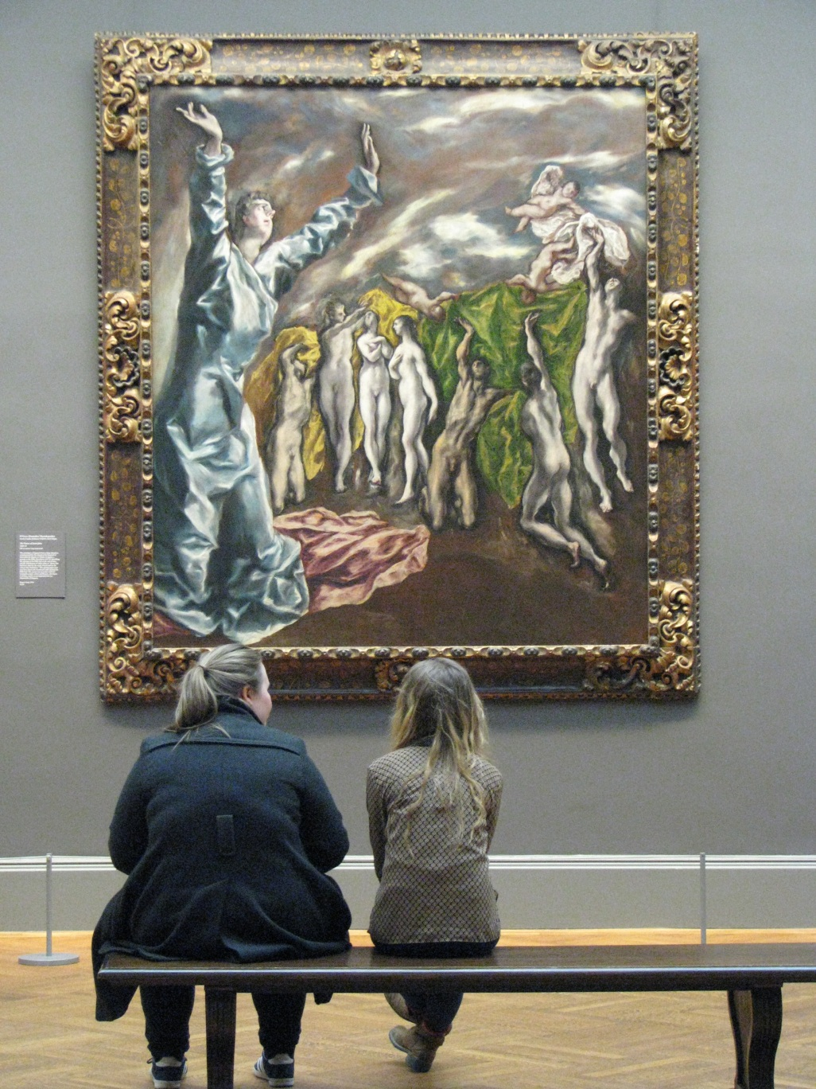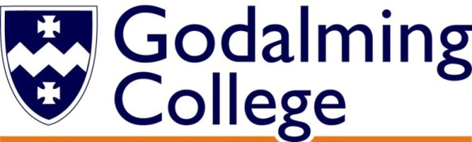

Tuesley Lane, Godalming

GU7 1RS

T: 01483 423526

E: [college@godalming.ac.uk](mailto:college@godalming.ac.uk)

W: www.godalming.ac.uk

**ART HISTORY**

A Level

Pearson Edexcel

How will I be assessed?

Paper 1: Visual Analysis and Themes

This examination requires you to demonstrate your visual literacy on ‘unseen’ examples of painting, sculpture and architecture. The second part tests your knowledge and understanding of the two Themes (‘Identities’ and ‘War’) studied in your first year.

Paper 2: Periods in the History of Art

The two in-depth periods (Baroque Art of the 17th century and British and French Art 1848-99) carry an equal weighting. You will encounter a range of question lengths and types but will be well-prepared for every element of this exciting course and final assessment.

|  |  |  |
| --- | --- | --- |
| **Component** | Weighting | **Assessment Method** |
| Paper 1: Visual Analysis and Themes | 50% of A Level | Written examination  (3 hours) |
| Paper 2: Periods in the History of Art | 50% of A Level | Written examination  (3 hours) |

What extra work can I do?

Open your eyes to the world around you! Look at the buildings you pass, that you work in or visit, and ask yourself questions like: When was it made? Who designed it? Why did they make these choices? How was it paid for? How did the society and ideas of the time have an impact? Go to your local museum, gallery or church and look at the works on display? What is striking about them? Why should they be saved for the future? How and why are they experimental, challenging or provocative?

Spend some happy hours exploring podcasts, films, documentaries on art and artists via the internet. As always, you should be careful and conscious of the sources you are using, but there has never been a better time to learn more about the world around you from the comfort of your own sofa.

Once you start the course, we will give you a weekly ‘Look, listen, learn update’ with suggestions for further reading, good new exhibitions and specific programmes to watch. Don’t worry about spending money on expensive colour books – we have an excellent library at College as well as a well-stocked Art History classroom.

Tuesley Lane

Godalming

Surrey

GU7 1RS

T: 01483

E: [college@godalming.ac.uk](mailto:college@godalming.ac.uk)

W: [www.godalming.ac.uk](http://www.godalming.ac.uk)

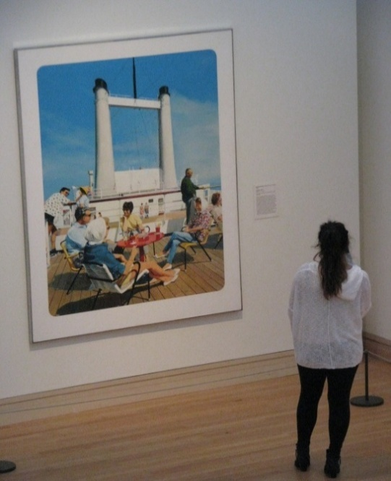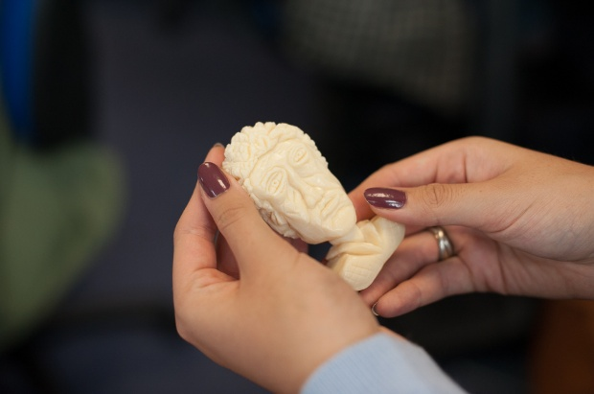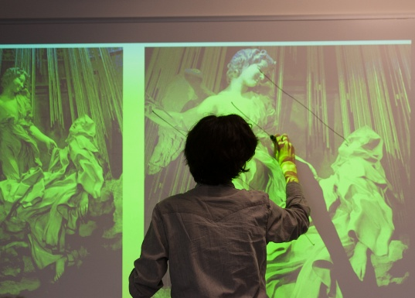

Photographs by Katrina Campbell

What are the entry requirements?

A minimum of five GCSE subjects at Grade 4 or above in English and one other humanities subject. Students who wish to study this course do not have to have any practical artistic skills as it is based on written research and direct observation.

Our main entry requirement is that you have a positive attitude, are prepared to work hard, to listen, learn and contribute to the great team ethos we have in this tight-knit department.

.

What is the course about?

This two year course is about researching and exploring the visual arts, culture and ideas of the world. It is a new and inspiring course which, for the first time ever, allows us to explore the arts of Japan, China and Africa in addition to those of the European tradition.

You will begin with a core course in visual literacy so that you have the skills to analyse any painting, sculpture or building. Then we will explore art and architecture in relation to two themes: Identities and War. Both are highly relevant in the turbulent world in which we live and you will explore the attitudes and solutions of cultures past and present.

We will investigate the history, political context and artistic innovations of key works and artists, making this course relevant for anyone who is interested in the wider world around them. Regular visits to collections in the UK (and the opportunity of an annual international trip) will give you the chance to investigate works at first hand as well as building life-long friendships with your peers.

What sort of work will I be doing?

We know that no one has had the opportunity to study Art History in a school environment before. This gives us the opportunity to introduce you to and inspire you about worlds that you have never encountered. Every lesson will be different as we use a huge range of different teaching methods: we will teach you how to research; to debate; to analyse; to write and to understand influence and significance. Although many students understandably find this course a perfect complement to practical art subjects, you do not need any creative art skills.

In each module of the course, you will explore key topics such as:

* What materials, techniques and processes have been used and why?
* How can you recognise styles in art and architecture and where do these come from?
* How has the time of creation influenced the appearance of the work?
* How have gender/nationality/ethnicity been represented in the work?

In the second year, your studies will move on to an in-depth exploration of two historical modules. At Godalming College, we have selected to study Baroque Art and Architecture of the 17th century and British and French art and architecture between 1848-99. These topics fit neatly with our international study trips to Florence, Rome and Paris and complement the wide breadth of the Theme topics you explore in the first year.

What are the progression routes for this qualification?

Art History A level provides an exciting opportunity to develop a life long interest in some of the most spectacular buildings, painting and sculpture that surrounds us.

It develops critical and analytical thinking, good communication skills and supports the improvement and sophistication of students’ essay work.

These are key skills that will be useful to any university degree and future professional role.

There are a wide number of excellent universities who offer Art History for study at degree level – either as a stand alone subject, or in combination with another subject – for example a language or English/History.