

How will I be assessed?

You will be assessed through 50% portfolio/coursework,

25% exam and 25% exam board set controlled assessments. Each unit is awarded points, which are translated into an overall grade (Pass, Merit or Distinction) by the assessors at the end of the course. Assignment tasks will be in the form of

a variety of observed practical tasks, reports, presentations

and activities.

What sort of work will I be doing?

You will encounter a wide variety of approaches, tasks and exercises. You’ll get your basic knowledge and understanding through combinations of class notes, articles, research, videos, and practical exercises. You’ll learn to apply this knowledge, to explain, analyse and evaluate each individual unit of study, culminating in you organising your own College based event (for your final assessment). Educational visits, work experience and guest speakers form an integral part of the course in making the learning experience interesting, thought provoking and real. You will assessed delivering customer service at various College events, giving you the chance to demonstrate many of the skills that you learn This course is hard work but with motivation, dedication and application all students benefit greatly from its broad approach and achieve excellent results at the end.

What extra work can I do?

College expects that for every hour in lessons you should be doing one hour of private study. This is the case for all subjects. In private study time for this subject you will be completing coursework, reading about the subject in newspapers and magazines, attending events with a critical eye and not just for pleasure, researching statistics on the Internet and keeping abreast of current issues impacting on the hospitality industry. The industry is always looking for keen and enthusiastic employees – a part time job in the industry can be massively beneficial to your understanding of many topics we cover (as well as being a useful resource on which to base some of your assessments).

[](http://www.google.com/url?sa=i&rct=j&q=&esrc=s&frm=1&source=images&cd=&cad=rja&docid=okV_uKAXSm82hM&tbnid=jSgrg6vCn3WTHM:&ved=0CAUQjRw&url=http://essemmevents.com/what-we-do/&ei=RxLLUdKAMe6y0AWEk4AI&bvm=bv.48340889,d.d2k&psig=AFQjCNH57Fct5uJrp65IKwiDENB1oUqYyg&ust=1372349340236399)[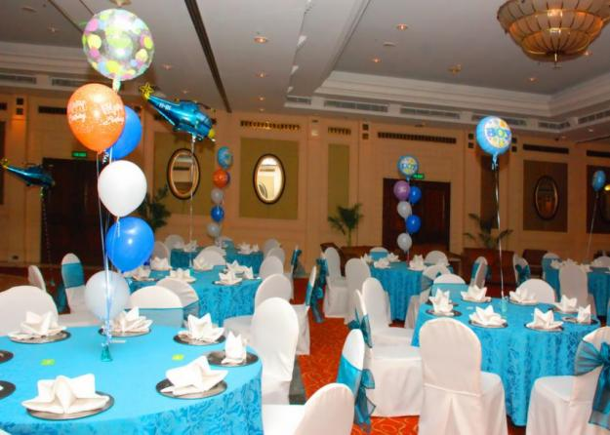](http://www.google.com/url?sa=i&rct=j&q=&esrc=s&frm=1&source=images&cd=&cad=rja&docid=Zkp5Ta5hZ_XXkM&tbnid=FzS5hwG_eMnWxM:&ved=0CAUQjRw&url=http://newdelhi.olx.in/global-india-event-management-company-in-delhi-iid-178877783&ei=lxLLUbGPEMPR0QWKlYGwBg&bvm=bv.48340889,d.d2k&psig=AFQjCNH57Fct5uJrp65IKwiDENB1oUqYyg&ust=1372349340236399)[](http://www.google.com/imgres?biw=1294&bih=737&tbm=isch&tbnid=wuCC62WwC8YvfM:&imgrefurl=http://www.grey-hare.co.uk/portfolio/event-management/&docid=sfEmfLdPUqRzZM&imgurl=http://www.grey-hare.co.uk/wp-content/uploads/2012/09/Event-management.png&w=940&h=627&ei=GxLLUZTQM62Q0QXd6oHQDg&zoom=1&ved=1t:3588,r:37,s:0,i:211&iact=rc&page=3&tbnh=174&tbnw=211&start=29&ndsp=20&tx=142&ty=99)

**HOSPITALITY AND EVENT MANAGEMENT**

BTEC Level 3 National Extended Certificate

Pearson/EDEXCEL

Tuesley Lane, Godalming

GU7 1RS

T: 01483 423526

E: [college@godalming.ac.uk](mailto:college@godalming.ac.uk)

W: www.godalming.ac.uk

Tuesley Lane

Godalming

Surrey

GU7 1RS

T: 01483

E: [college@godalming.ac.uk](mailto:college@godalming.ac.uk)

W: [www.godalming.ac.uk](http://www.godalming.ac.uk)

What are the progression routes for this qualification?

Higher education or employment in a variety of areas within the industry. Many Universities offer well established Events Management courses, which a number of our 2nd year students have already secured places on.

This course offers a huge variety of future opportunities in the hospitality and events industry either at home or abroad and at many different levels.

What skills will I learn?

Your course has been designed to allow you to develop transferable independent and team-working skills in planning, communication, presentation, research, and information technology. There is a big focus on developing your customer service skills, to help prepare you for working in the industry

What is the course about?

The hospitality industry is hugely diverse and offers the potential

for exciting and unique future career opportunities all over the world.

As well as hotel and catering businesses, more recently managing

events of all different themes of sizes has become a key part of the industry.

On this course, Students will examine the structure of the hospitality industry and gain a knowledge and understanding of the necessary

customer service and planning procedures for a variety of events. Different aspects of the industry are explored by visiting organisations and inviting speakers into college. The course also involves students planning, managing and marketing events in college.

You will study the following units during the course (we are awaiting

confirmation from BTEC on exact unit titles/content):

Unit 1: (TBC) The Hospitality Industry (written exam).

Unit 2: (TBC) Managing Hospitality Teams (controlled assessment).

Unit 3: (TBC) Customer Service in Hospitality (coursework).

Unit 4: (TBC) Planning and Running Events (coursework).

The BTEC Level 3 National Extended Certificate in Hospitality and

Events is the equivalent of 1 A level and allows students to earn the

same number of UCAS points. This is a two year course and should be taken as part of a full College programme alongside

other A level and BTEC National qualifications.

What are the entry requirements?

A minimum of five GCSE subjects at Grade 4 or above (including English Language) or a merit grade in BTEC level 2 First Diploma in Hospitality.