john

What to expect

The teaching staff are friendly and enthusiastic about digital & creative technology. They adopt a variety of teaching methods designed to match

a variety of learning style which maximises student participation

within all lessons. Within each unit of study each student is asked to

undergo a learning styles/skills assessment. This assessment is aimed

at the department being able to provide a personalised learning

programme. These programmes are designed to meet the needs of a wide range of IT backgrounds and abilities and allow the student to develop their own independent learning skills. Four specialist pathways are offered to

each student. These pathways are aimed at matching ability and prospects.

We are extremely fortunate to be able to involve many local, national and international businesses in the delivery and assessment of the course. Students are able to become involved in a number of trips, to question

visiting speakers and join team building activities. All of these sessions

aim to reinforce the material delivered during normal lessons.

What sort of work will I be doing?

The work will consist of producing a ‘**portfolio’** of work. This consists

of assignments that demonstrate your knowledge and skills and form

the basis for the assessment of your grades. You will encounter a

wide variety of approaches, tasks and exercises. Additional (home) work

is essential to enhance your technology knowledge & understanding.

Watching television, listening to the radio and reading some of the many Computing/IT publications are some of the activities that will help you

become more aware of the ever-changing and exciting field of IT.

How will I be assessed?

The mode of assessment is through 3 externally & 1 internally assessed mandatory units; and 1 additional internally assessed portfolio assignment (coursework) option. The external assessments are carried out by the

OCR examination board. Each students’ unit submission is assessed

against criteria and awarded points, which translate into an overall grade (Pass, Merit or Distinction). At the end of the course an overall grade of

Pass, Merit, Distinction or Distinction* (equivalent to A* at A level) is

available for the Introductory Diploma in IT. Resources supporting each assignment are provided electronically via our VLE (Godalming Online).

All students’ work is electronically submitted, in line with strict deadlines.

The teachers provide prompt and target-driven electronic feedback via Godalming Online – leading to a virtually paper-free department.

What skills will I develop during this course?

The Cambridge Technical Level 3 IT Introductory Diploma will provide opportunities to develop your employability and communication skills and

IT, as well as improving your study, presentation and research skills.



INFORMATION TECHNOLOGY

CTEC (Level 3)

Introductory Diploma

OCR

Tuesley Lane, Godalming

GU7 1RS

T: 01483 423526

E: [college@godalming.ac.uk](mailto:college@godalming.ac.uk)

W: www.godalming.ac.uk

Tuesley Lane

Godalming

Surrey

GU7 1RS

T: 01483

E: [college@godalming.ac.uk](mailto:college@godalming.ac.uk)

W: [www.godalming.ac.uk](http://www.godalming.ac.uk)

**What skills**

What is the department like?

.

What is the course about?

Units 1, 2 and 3 are **mandatory, externally assessed** core units which

provide an essential grounding in IT. A student is then matched to an

individual pathway (Emerging Digital Technology Practitioner; IT

Infrastructure Technician; Data Analyst; Application Developer) with

**one more mandatory unit** and a wide variety of ‘specialist’ units available

to make up the FIVE required units. See the diagram below:

Two dedicated, fully equipped computing rooms, a workshop and office within the College main building form the Digital & Creative Technology (DCT) department. The department boasts spacious and extremely well resourced classrooms - interactive whiteboard, games and animation technologies, fully equipped with modern personal computers loaded with up-to-date business and creative design computer programs. The computers are all connected to the College network, which provides access to the Internet, and Virtual Learning Environment (Godalming Online). The contents of each room are monitored and maintained by a team of College computer technicians. The department boasts its own (ex-student) IT trainee technician ready to loan/help students; a wide variety of equipment such as VR computer and headset, email-scanners, colour laser printers, DVDRWs, digital cameras, graphics tablets and web cams. Students are provided with their own secure IT storage and email account. We recommend you bring along your own memory device as an additional safeguard for your work.

The DCT workshop is available throughout the course. It particularly supports one of the core units – Fundamentals of IT. In this unit students identify, maintain and upgrade software and hardware, before finally benchmark assessing the effects on performance.

During Year 1 you will be involved in a week of work experience.

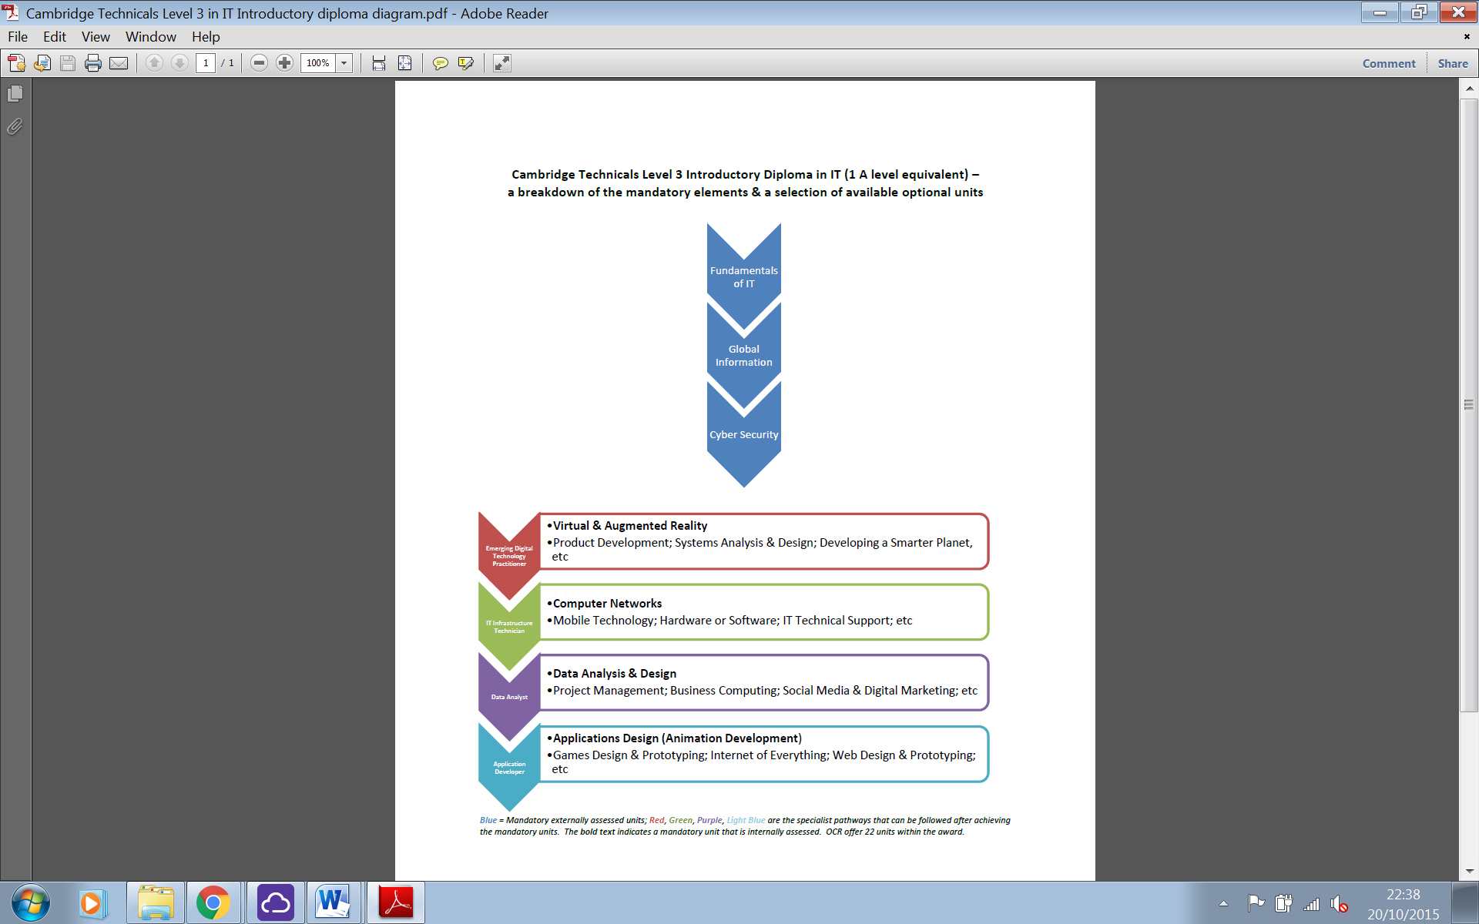

NB. The Cambridge Technicals Level 3

Information Technology

Introductory Diploma

course is the equivalent of

ONE A level. It is

important to note that this course is enrolled as a

2-year course, but does

have a part qualification

at the end of year 1 (Cambridge Technicals

Level 3 Certificate in IT).

What are the entry requirements?

A minimum of five GCSE subjects at Grade 4 or above, including

English and Mathematics.

Although some students might have achieved a GCSE in IT (or Level 2

equivalent), the course does not assume or expect that an IT qualification has previously been achieved.

What are the progression routes for this qualification?

Demand for ICT

personnel is increasing;

consequently job

opportunities for well-

qualified individuals

are high. An

ever-increasing number

of degree related courses

and apprenticeships

are now available to

extend your understanding

and operation of ICT. In

many cases IT degree

courses are combined

with another subject to

take advantage of the specialised industries that exploit the use of ICT.