

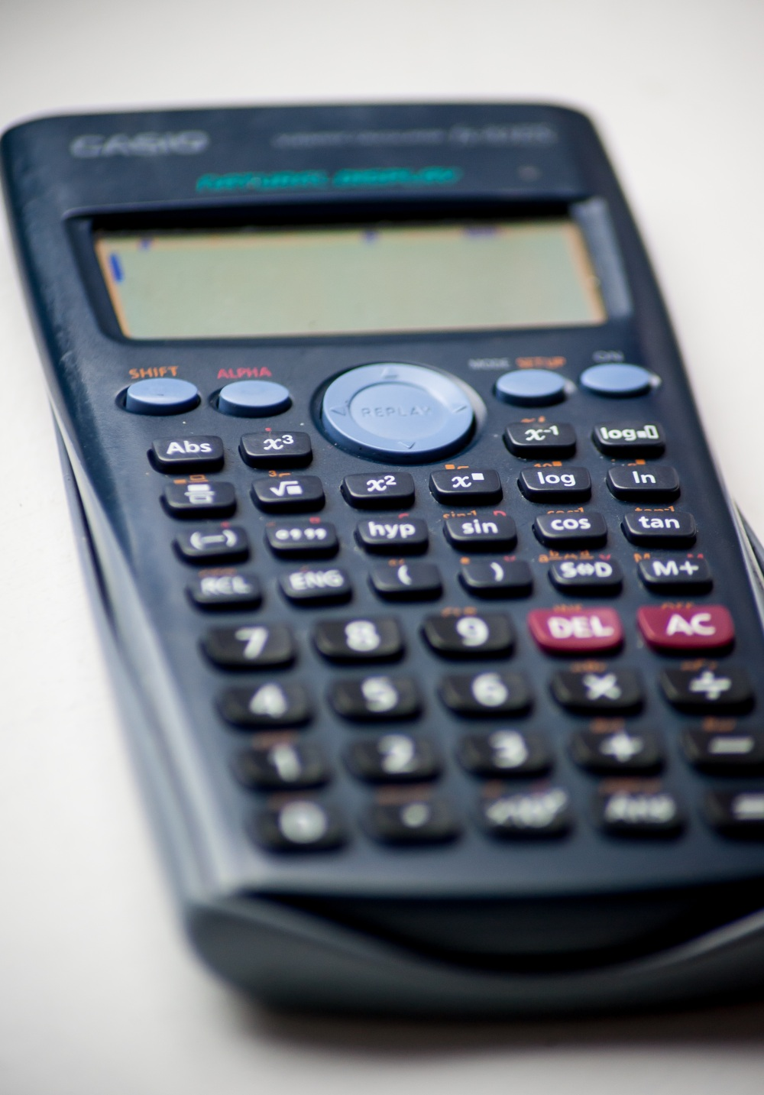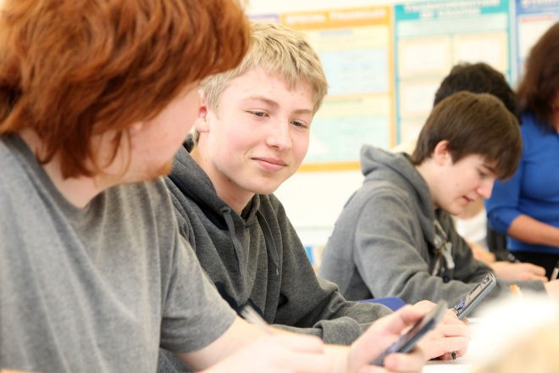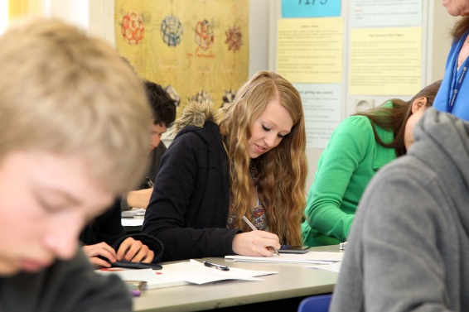

**MATHEMATICS** GCSE

EDEXCEL

Tuesley Lane, Godalming

GU7 1RS

T: 01483 423526

E: [college@godalming.ac.uk](mailto:college@godalming.ac.uk)

W: www.godalming.ac.uk

Tuesley Lane

Godalming

Surrey

GU7 1RS

T: 01483

E: [college@godalming.ac.uk](mailto:college@godalming.ac.uk)

W: [www.godalming.ac.uk](http://www.godalming.ac.uk)

What are the entry requirements?

Students who have previously received a Grade 3 or 4 in GCSE Mathematics will take the course in one year, aiming to achieve a 4 or 5.

Students who have achieved a Grade 2 or below will be on a two year course, in the first year they will study towards an alternative Mathematics qualification and success on this will enable them to sit the GCSE in their second year.

Students with higher than a Grade 4 who need to boost their grades to between 6 and 9 may be able to take a higher tier course, subject to demand.

How will I be assessed?

GCSE Mathematics will be assessed via three external exams, candidates will have the opportunity to sit these in November and in the summer.

.

What is the department like?

Staff in the Department are well-qualified, enthusiastic, hard-working, caring and sympathetic to students when they have difficulties with mathematical problems. They support students and encourage them to succeed. The Department has specialist rooms with computer facilities, practical apparatus, textbooks and videos.

There are two opportunities to sit the GCSE Maths exams, in November and in the summer. They will be assessed with three exams, one non-calculator and two calculator papers.

The focus between September and November is revising key topics to help all students improve their grade. After November we go through the material in more depth, and regularly assess student’s progress in all areas of the curriculum. The course is split into six broad areas: Number, Algebra, Ratio and Proportion, Geometry and Measures, Probability, and Statistics.

Those students sitting the course in two years will study an alternative Mathematics qualification in their first year. This course will provide a strong grounding for the key skills required to pass the GCSE, and to put these skills in real life contexts to help our students apply their numerical skills. By the end of the year they should be well practiced in all areas of numeracy required for the GCSE, as well as having encountered items such as bank statements, invoices, monetary calculations, timetables and interpreting information from charts and tables. Following this, their second year will follow the same format as the one-year students.

What sort of work will I be doing?

We provide you with booklets to work through in lessons and as homework. As well as whole class teaching there will be some individual study required, since students will have different strengths and weaknesses based on their previous studies. The course will make some use of computer software and internet sites to help reinforce and practise skills.

What skills will I develop during this course?

GCSE Mathematics provides the opportunity to develop numerical skills with and without a calculator.

What extra work can I do?

The more Mathematics you can do the better your chance of gaining success. Some students already own a Revision Guide and continuing to work through this in addition to following our course will be beneficial.

Websites such as MyMaths, Hegarty Maths and BBC Bitesize have helped many students.

What is the course about?