

How will I be assessed?

* AS Maths and AS Further Maths are each assessed by two exams at the end of one year.
* A level Maths is assessed by three exams at the end of two years.
* A level Further Maths is assessed by four exams at the end of two years.

What extra work can I do?

There are many ways in which you can improve your mathematical skills beyond the confines of the syllabus; for example, a graphical calculator will enable you to visualise functions. You could develop programs for various tasks and by so doing improve your powers of reasoning and logic. You may develop an interest in computer-generated fractals and explore the patterns and mathematical applications involved. You may enjoy recreational maths, including puzzles, using a wide variety of sources from books by Martin Gardner and Ian Stewart amongst others. The history of mathematical ideas can provide an insight into topics being studied and an excellent book on this subject is Fermat’s Last Theorem by Simon Singh. There are plenty of good websites to stretch you beyond the A-level syllabus. For example, www.plus.maths.org. An internet magazine of articles and puzzles for 6th form students.

Can I do any supplementary courses?

It is possible for Maths A Level students to take Further Maths AS in their second year. If you are contemplating reading Maths at Oxford or Cambridge, then you will be given appropriate tuition for your own particular examination requirements.

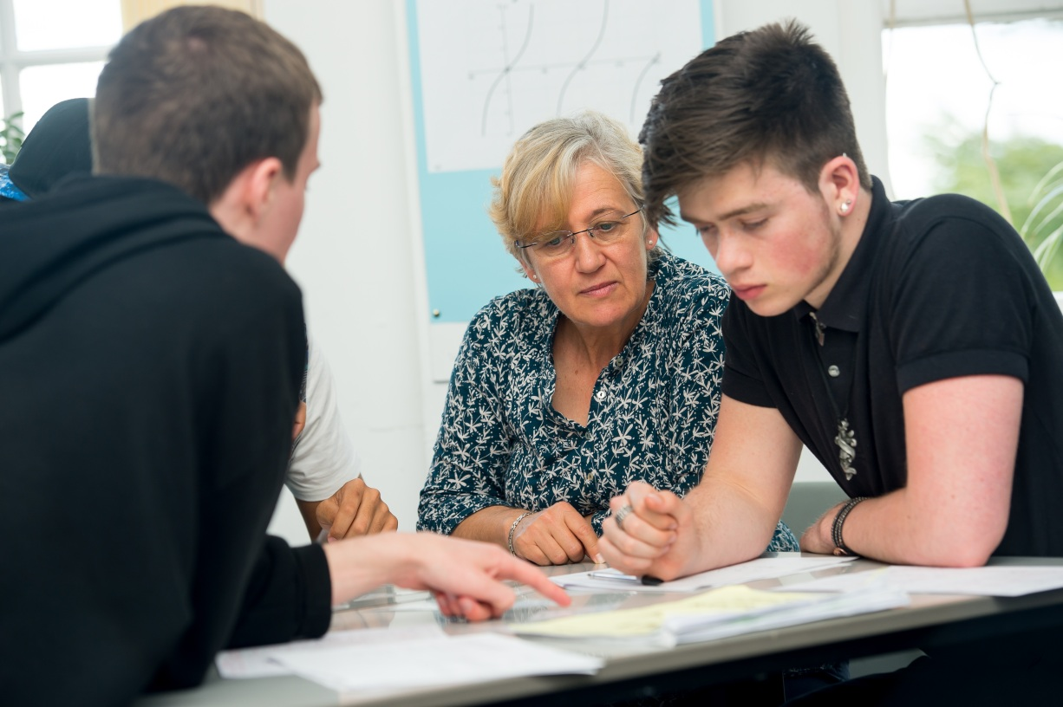

**MATHS AND FURTHER MATHS** AS/A Level

EDEXCEL

Tuesley Lane, Godalming

GU7 1RS

T: 01483 423526

E: [college@godalming.ac.uk](mailto:college@godalming.ac.uk)

W: www.godalming.ac.uk

Tuesley Lane

Godalming

Surrey

GU7 1RS

T: 01483

E: [college@godalming.ac.uk](mailto:college@godalming.ac.uk)

W: [www.godalming.ac.uk](http://www.godalming.ac.uk)

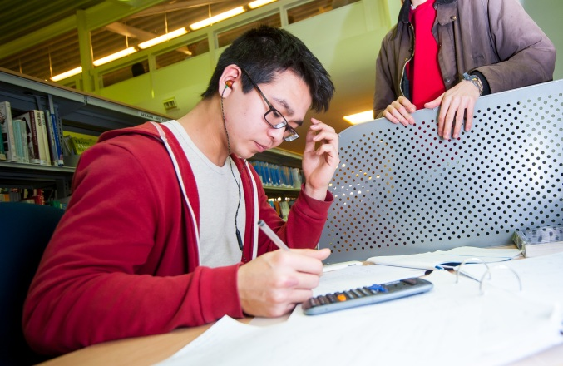

What sort of work will I be doing?

You will be learning new techniques and applying them to problems. Some problems will be textbook-style whilst others may be of a more practical nature. Graphical ideas will be explored using the software packages Autograph or Desmos. You will be encouraged to see how Maths informs and describes real world situations and you will become aware of both its power and its limitations in achieving these aims.

What is the course about?

What are the progression routes for this qualification?

Maths is a subject with many applications as well as providing a basis for further study in its own right. It will be a requirement for a variety of university courses, ranging from sciences and engineering to economics and aspects of computing. It will also be an advantage for many other university courses which have components of Maths or Statistics within them, for example Geography, Psychology, Sociology, Architecture and Design Technology. Research shows that those workers with qualifications in Maths earn more than those without. With increasing use of data analysis in many fields of work the opportunities for mathematically competent and confident employees will grow. Keep your options open: choose Maths as a subject for further study at either A or AS Level!

In all courses you will study Pure Maths, Statistics and Mechanics. The Pure Maths extends the GCSE work on algebra, co-ordinate geometry, vectors and trigonometry and introduces you to exponential and logarithmic functions and calculus. Mechanics and Statistics both involve the modelling of real world situations using appropriate techniques; Mechanics relating to the physical world and Statistics to the presentation and handling of data.

Further Maths A-level can be studied with Maths A-level. You are strongly advised to take this course if you wish to study Maths at university. Further Maths contains further work on Pure Maths, Mechanics and Statistics. Complex numbers, matrices, hyperbolic functions and differential equations are studied and vectors and calculus are considered in more depth.

How can I best prepare myself for A-level Maths?

If you are good at Algebra and problem solving then you will succeed on this course. If not then we strongly advise you to work on these areas before you start college! There are plenty of workbooks available which help to bridge the gap between GCSE and A-level Maths. It is essential to start with a solid foundation!

What is the department like?

There are typically over 500 students in Maths across the two year groups, including about 70 who are also doing some form of Further Maths. Staff in the Department are well-qualified, enthusiastic, hard-working, caring and sympathetic to students when they have difficulties with mathematical problems. Individual members of the department will support their students and encourage them to succeed. We also run lunch time and after college support sessions every day. In addition to these, we supply a wealth of resources on our Godalming Online pages. These include directed notes, videos, exemplar exam questions and exercise sheets. We also organise trips to lectures and take part in the Surrey Schools Maths Challenge at Surrey University.

What are the entry requirements?

For Maths AS or A level, a grade 6 in GCSE Maths is required. However, this is the absolute minimum recommendation and students are more likely to be successful with a grade 7 or above.

For Further Maths, a grade 7 at GCSE is required, but an 8 or 9 is strongly recommended. In order to study Further Maths you must also study Maths. A love of the subject is also essential! You will be learning new material at a fast pace and covering twice as much content as a single mathematician.

.

