

How will I be assessed?

Coursework forms the main basis for assessment, and there are 2 externally assessed assignments and 8 internally assessed Major Projects.

**Compulsory Units:**

Digital Media Skills

Media Enterprise

Responding to a commission

Film Production

**Possible specialist/optional units:**

Storyboarding for Digital Media

Scriptwriting

Single Camera Techniques

Film Editing

Stop Motion Animation

Sound Editing

What extra work can I do?

It is expected of all media students that they undertake a substantial amount of work outside normal College hours. This includes:

1. reading: as much of and as varied as you can – and not only books
2. look out for relevant articles in the press. The College library has an excellent collection of media/film books and magazines
3. research for assignments - books, magazines, newspapers, Internet, etc.
4. production work: if you have your own camera, do as much photography/video work as you can

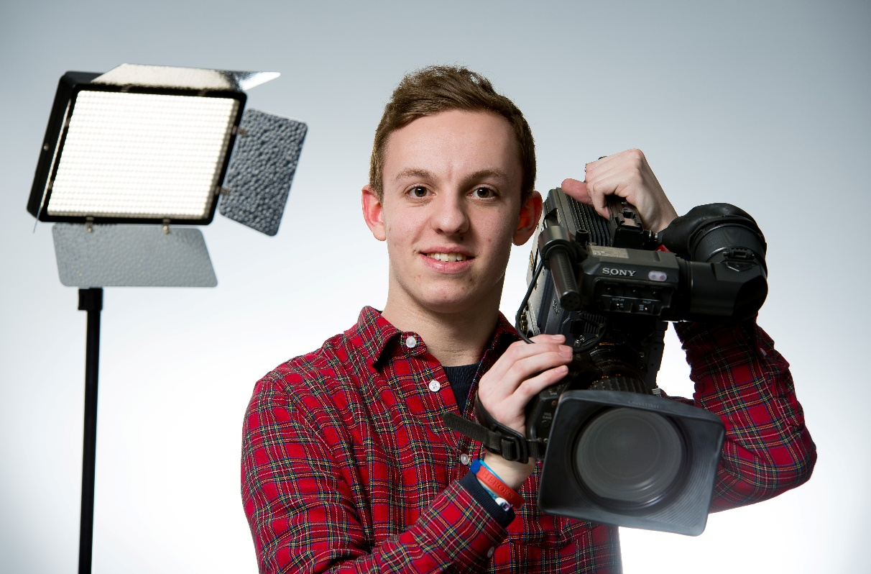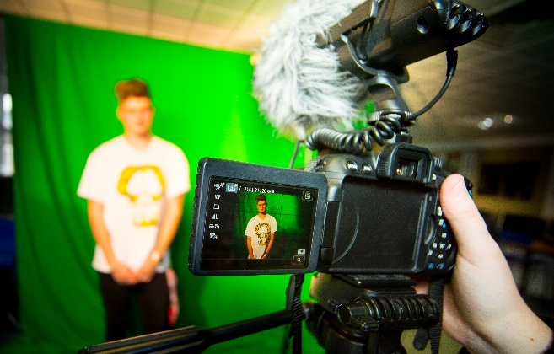

**MEDIA: CREATIVE MEDIA PRODUCTION**

BTEC LEVEL 3 NATIONAL DIPLOMA (Film & Television)

EDEXCEL

Tuesley Lane, Godalming

GU7 1RS

T: 01483 423526

E: [college@godalming.ac.uk](mailto:college@godalming.ac.uk)

W: www.godalming.ac.uk

Tuesley Lane

Godalming

Surrey

GU7 1RS

T: 01483

E: [college@godalming.ac.uk](mailto:college@godalming.ac.uk)

W: [www.godalming.ac.uk](http://www.godalming.ac.uk)

What are the entry requirements?

Five GCSE subjects at Grade 4 or above, including English, or a merit at BTEC First.

Previous experience of Media Studies is not required, however an enthusiasm for and commitment to the subject is a necessity.

.

What sort of work will I be doing?

The emphasis is on professional practice through a series of planned assignments. You will carry out research projects on different areas of the Film and Television industries; regulation, music video, single camera productions and screenwriting and your research will lead to practical tasks which are designed to recreate industry practices. All of the assignments offer you opportunities to develop your research, pre-production and practical production skills.

What skills will I develop during this course?

You will develop a range of communication skills, written, verbal and IT based, as well as video camera and digital editing skills. You will need to be proficient at word processing and using a variety of IT software packages. Your inter-personal skills will also be developed, as you will be working within small groups in discussions, production work and pitching ideas and presentations.

What are the progression routes for this qualification?

For those interested in pursuing their studies and training in the media there are many HND and degree courses. These are of several kinds.

There are courses that are:

1. largely practical in nature and are designed for those who want to work in the industry
2. wholly theoretical, designed for people with an academic interest in the media
3. most commonly, those that contain a balance of practical and theory.

The BTEC Level 3 National Diploma is a qualification which can extend a learner’s programme of study by providing a vocational emphasis. The course offers you the chance to develop practical media production skills focussing on the areas of Television and Film. It aims to prepare you for work in both industries exploring the behind the scenes structure and the different jobs that are available, through to developing film making and script-writing skills. The course is the equivalent of 2 A levels and aims to provide you with a broad base of production and pre-production skills which will enable you to produce your own media products, usually as part of a small production team.

What is the department like?

We have a fully equipped Media workshop with high quality digital cameras and industry standard editing software. All classrooms are equipped with PCs with desk top publishing software. As part of the course you will learn about the moving image industry and learn the behind the scenes tricks of the trade. The working environment is friendly and one that encourages both intellectual inquisitiveness and creativity.

The staff are enthusiastic about their subject and the college, and enjoy supporting student learning and progression.

There are typically around 300 students in Media and Film Studies across the two-year groups. The pass rate is very high and the majority of film and media students achieving good grades.

The teaching incorporates a variety of approaches designed to suit different abilities and learning styles. We try hard to help any student with his/her own learning difficulties such as dyslexia and to stretch those with high academic ability. Visits, trips and speakers are built into the course.

What is the course about?