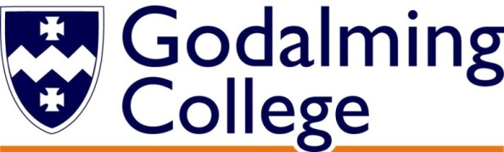

How will I be assessed?

If following the AS Media Studies course (one year) you will be assessed through two exams (1 hour 30 minutes; and 2 hours - worth 70%) and non-exam assessment (worth 30%).

If taking A-level Media Studies, you will be assessed at the end of two years through two exams (2 hours 15 minutes; and 2 hours 30 minutes - worth 70%) and non-exam assessment (worth 30%).

Component 1 looks at media language, representation, media industries (including advertising, marketing, film, newspapers, radio and video games), audiences and media historical contexts.

Component 2 involves an in-depth study of set texts including: television programmes, magazines (mainstream and alternative) and online media.

Component 3 comprises of individual cross-media productions (one product for AS or two for A-level) in response to a choice of briefs set by the exam board.

What extra work can I do?

It is expected that media students undertake a substantial amount of work outside normal College hours. This should include:

1. reading: as much and as varied media as you can
2. look for relevant articles in the press. The college library has an excellent collection of media/film books and magazines
3. engagement with the media in everyday life: radio, newspapers, online, television, magazines
4. research for assignments – from books, magazines, newspapers, internet etc.
5. filming and photography (when working on the non-exam assessment project)

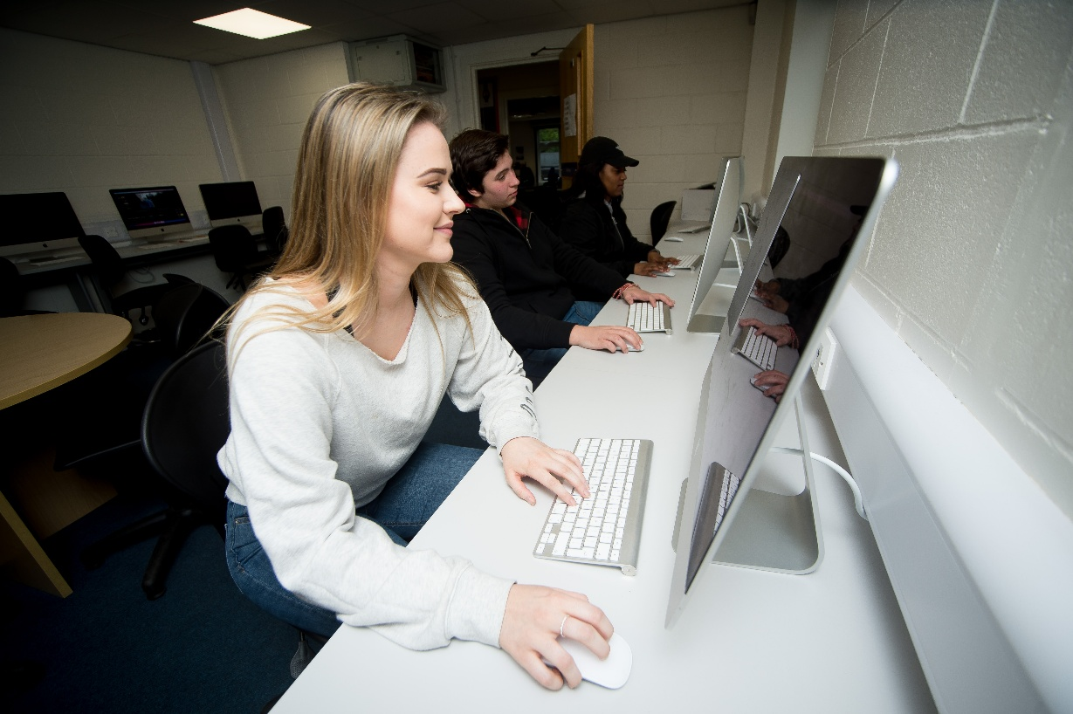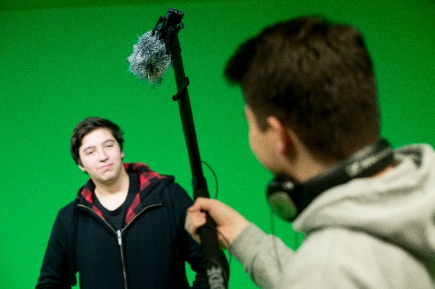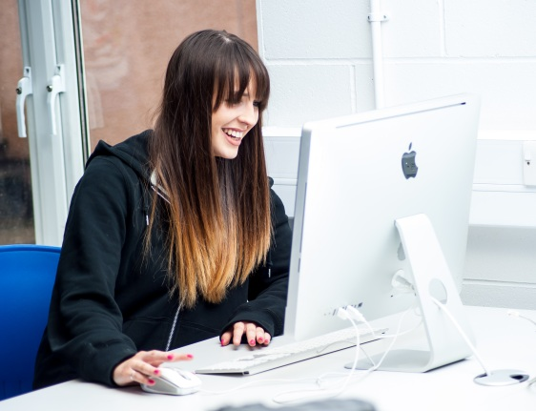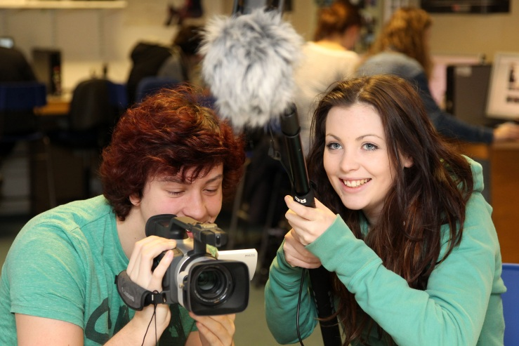

**MEDIA** STUDIES

AS/A Level

WJEC Eduqas

Tuesley Lane, Godalming

GU7 1RS

T: 01483 423526

E: [college@godalming.ac.uk](mailto:college@godalming.ac.uk)

W: www.godalming.ac.uk

Tuesley Lane

Godalming

Surrey

GU7 1RS

T: 01483

E: [college@godalming.ac.uk](mailto:college@godalming.ac.uk)

W: [www.godalming.ac.uk](http://www.godalming.ac.uk)

What are the entry requirements?

A minimum of five GCSE subjects at Grade 4 or above, including English or Media. Previous experience of Media Studies is not required.

.

What sort of work will I be doing?

A variety of work is undertaken on this course, both practical and written. Lessons will include working as a whole class, in small groups and individually. The non-exam assessment allows the opportunity to produce audio-visual or print based work using digital cameras and editing software.

What skills will I develop during this course?

You will develop a range of communication skills: written, verbal and IT based. Research skills will also be enhanced. You will also become proficient at word processing and using a variety of IT software. Your inter-personal skills will also be developed, as you will be working within small groups in discussions, production work and giving presentations.

What are the progression routes for this qualification?

For those interested in pursuing their studies, many students move on to degrees in Media Studies or TV/Film Production.

There are courses that are:

1. largely practical in nature and are designed for those who want to work in the industry
2. wholly theoretical designed for people with an academic interest in the media
3. most commonly, there are courses that contain a balance of practical and theory.

What is the department like?

We have a new media workshop, TV studio and recording booth with a range of high quality digital cameras and editing equipment. We are housed in well-equipped classrooms and the working environment is friendly and one that encourages both intellectual inquisitiveness and creativity.

The staff are enthusiastic about their subject and the college, and actively support student learning and progression.

There are typically around 300 students in Media and Film Studies across the two-year groups. The pass rate is very high and the majority of film and media students achieve good grades.

Teaching incorporates a variety of approaches designed to suit different abilities and learning styles. We try hard to help any student with his/her own learning needs, and to stretch those with high academic ability. Visits, trips and speakers are built into the course.

We work hard and enjoy what we do - we hope that you will too.

The course is concerned with cultivating an understanding of the mass media (television, the press, advertising, video games and online) and their role in society. It looks at how the media represents people and issues based on a close and extensive study of a range of media products. We also consider how audiences are targeted and why audiences engage with particular media texts. The course also endeavours to develop your communication and critical skills across a variety of media.

What is the course about?