

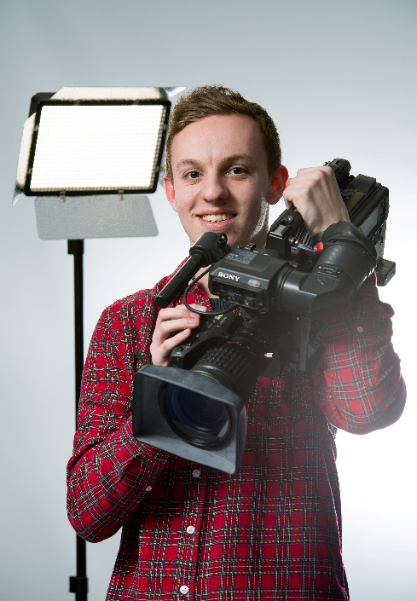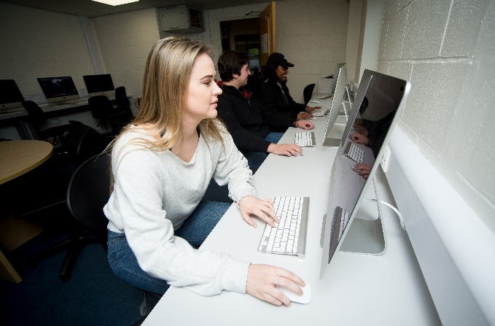 

**MEDIA STUDIES**

GCSE (Double Award)

AQA

Tuesley Lane, Godalming

GU7 1RS

T: 01483 423526

E: [college@godalming.ac.uk](mailto:college@godalming.ac.uk)

W: www.godalming.ac.uk

Tuesley Lane

Godalming

Surrey

GU7 1RS

T: 01483

E: [college@godalming.ac.uk](mailto:college@godalming.ac.uk)

W: [www.godalming.ac.uk](http://www.godalming.ac.uk)

What skills will I develop during this course?

- Critical thinking and decision-making skills through the study of media texts, audiences and institutions

- Practical skills through opportunities for personal engagement and creativity

- Understanding how to use media key concepts to analyse media texts and their contexts.

.

What sort of work will I be doing?

Unit 1 – Investigating the Media: An externally assessed exam featuring a pre-production media scenario for a specific genre. Past examples have included, TV Crime shows and Sci-Fi. (20%)

Unit 2 – Understanding the Media: Coursework consisting of three assignments – an introduction to media conventions; moving image and print products; and producing a moving image product. (30%)

Unit 3 – Exploring Media Industries: An externally assessed exam concentrating on contemporary media industry trends. (20%)

Unit 4 – Responding to a Media Brief: Coursework requiring students to present a professional pitch and produce a fully-realised production. (30%)

This course is designed to encourage students to be inspired, moved and challenged by media issues by gaining an insight into a broad range of media.

It also aims to prepare candidates to make informed decisions about further learning opportunities and career choices.

What is the department like?

We are housed in classrooms equipped with PCs with desk top publishing and radio editing software. In addition there is a media workshop, equipped with high quality digital cameras and editing facilities. There are typically around 300 students studying media or film courses. The pass rates are good and the majority of film and media students achieve a good grade.

The teaching incorporates a variety of approaches designed to suit different abilities and learning styles and we endeavor to arrange visits, trips and speakers to enrich the learning experience.

How will I be assessed?

Two Units of internally assessed coursework – responding to a brief (30%) and a production portfolio (30%).

Two Units of externally assessed exams (20% and 20%).

.

What is the course about?

What are the progression routes for this qualification?

Students on this course can progress to the wide range of As and A level courses offered at the college, and the BTEC Level 3 courses may be of particular interest.