

**How will I be assessed?**

|  |  |  |
| --- | --- | --- |
| **AS Level Music** | | |
| **Unit 1**  Performing | You will perform a recital of at least **6 minutes** of continuous performance that will be recorded. Minimum standard of playing should be **Grade 6.** | 30%  Coursework |
| **Unit 2**  Composing | You will compose **two compositions** – one from a choice of set briefs and the other can be a free composition or another choice from the set briefs. Total length of both compositions must be at least **4.5 minutes.** | 30%  Coursework |
| **Unit 3**  Appraising | You will study the following types of music: vocal, instrumental, film, pop and jazz, fusions and new directions. The exam will contain listening tests and essays on the set works and associated music. | 40%  1.5 hour exam |
| **A Level Music** | | |
| **Unit 1**  Performing | You will perform a recital of at least **8 minutes** of continuous performance that will be recorded. Minimum standard of playing should be **Grade 7**. | 30%  Coursework |
| **Unit 2**  Composing | You will complete one composition. This can be a free choice or chosen from a list of briefs. You will also complete one technical study from a choice of Bach Chorale, 2 part counterpoint, an arrangement or a remix. Combined, these compositions must total at least **6 minutes.** | 30%  Coursework |
| **Unit 3**  Appraising | You will study the following types of music: vocal, instrumental, film, pop and jazz, fusions and new directions. The exam will contain listening tests and essays on the set works and associated music. | 40%  2 hour exam |

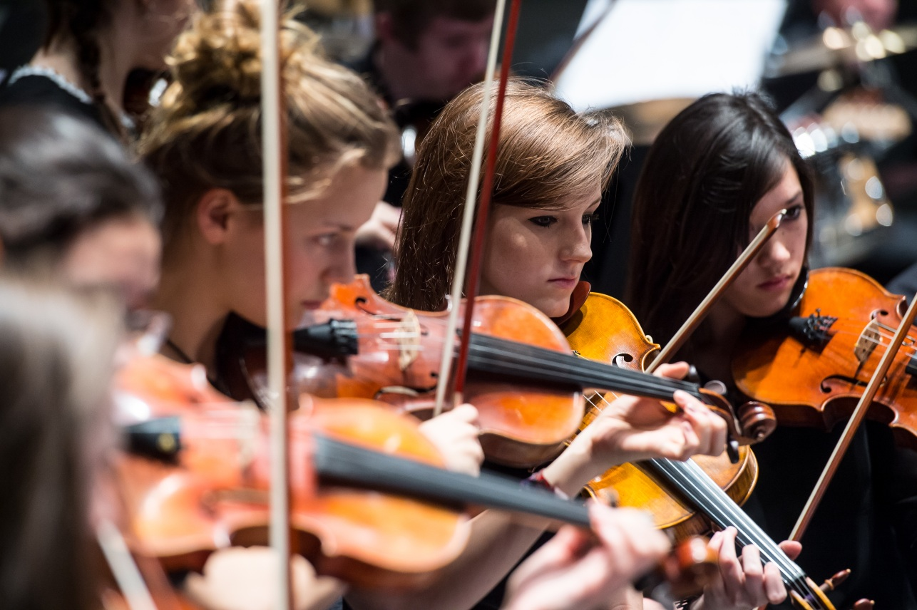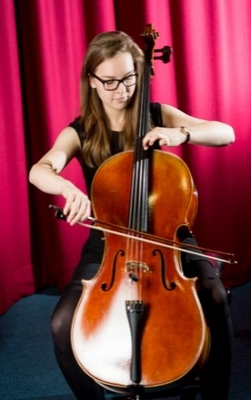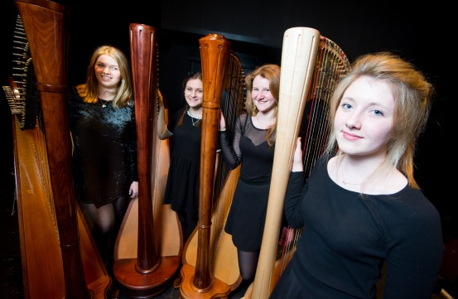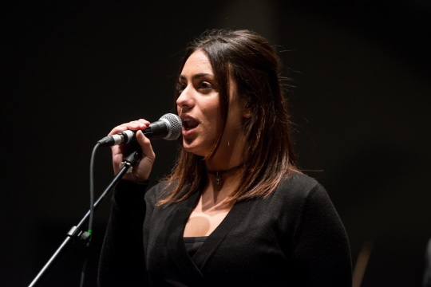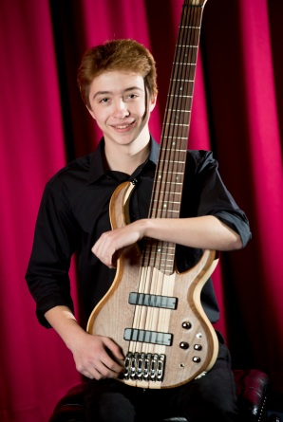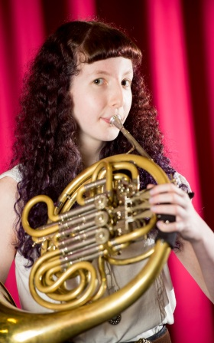

**TOP RESULTS!**

A2 Music 2014: 75% A*-B grades (against a sixth form college average of 42%)

A2 Music 2015: 65% A*-B grades (against a sixth form college average of 42%)

A2 Music 2016: 83% A*-B grades (against a sixth form college average of 45%)

The College Music Department is an extremely busy and fun place to be! If you would like to be part of a community that immerses itself in creating and enjoying music, at the same time as giving you a high quality education, then the Music course is definitely for you!

Please contact Head of Music, Ceilidh Botfield if you have any questions about our Music course or the department CHB@godalming.ac.uk

**MUSIC** AS/A Level

EDEXCEL

Tuesley Lane, Godalming

GU7 1RS

T: 01483 423526

E: [college@godalming.ac.uk](mailto:college@godalming.ac.uk)

W: www.godalming.ac.uk

Tuesley Lane

Godalming

Surrey

GU7 1RS

T: 01483

E: [college@godalming.ac.uk](mailto:college@godalming.ac.uk)

W: [www.godalming.ac.uk](http://www.godalming.ac.uk)

**Recent university offers:** University of Oxford, University of Birmingham, University of Durham, University of Manchester and University of Southampton

**Recent conservatoire offers:** Birmingham Conservatoire, Royal Academy of Music, Royal College of Music and RWCMD.

**What are the entry requirements?**

* You should have five GCSE subjects at Grade 4 or above and a 4 in English.
* **Music performance standard of at the least Grade 6** **is required**. Exam does not have to have been taken.
* Students should also have an understanding of **Music** **Theory to Grade 5 level**. Private theory lessons are available through the college and will need to be taken if ability is slightly below this level at enrolment.
* Music GCSE can be beneficial but is not essential.

.

**What extra work can I do?**

It is important to complete extra listening outside of the course to develop listening skills and strengthen knowledge. It is important to listen to Music of all styles to become a well-rounded musician. It is also hoped that, where appropriate, students will look for opportunities to perform externally to College, for example in the county’s youth orchestras and choirs.

**What are the progression routes for this qualification?**

Music A Level is a comprehensive qualification that offers you the development of a wide range of skills including analysis, criticism, creative expression, verbal, written and musical communication, discipline, initiative, team work and the application of ICT.

Few other subjects cover such a range of disciplines, so Music is recognised as excellent preparation not only for music-related careers but also for progression into other fields.

Music can be studied for single honours at university or at conservatoire, but there are also many joint honours courses.

**The majority of our Music students progress to studying Music at Russell Group universities or conservatoires, some receiving scholarships.**

The Music course introduces you to some of the disciplines involved in an academic study of the subject. It develops the skills, knowledge and understanding needed to communicate through music and to take part in music-making, whether as a composer, a performer or a listener.

**What sort of work will I be doing?**

**Aural awareness** is encouraged through singing activities, dictation and listening exercises, both in and out of the classroom. Your study of **harmony** and **compositional techniques** involves weekly exercises, which can be completed with the aid of a keyboard instrument, as well as longer **composition assignments**, which involve the use of computer software. In **analysis**, you are given short written tasks, arising from class work, or as preparation for lessons. You should expect to write a short essay most weeks. **Performing** skills are developed throughout the course. Students regularly perform in the classroom or in College concerts.

**Instrumental, vocal and theory lessons**

You should take specialist lessons in your main instrument or voice in order to prepare for performance assessments. The College can provide private tuition through our peripatetic teachers; however students are welcome to continue with an external teacher. Private Music Theory lessons are also available for students who want to achieve Grade 5 or continue to study to higher grades.

**What is the department like?**

**Facilities:** Two Yamaha grand pianos and a baby grand, four acoustic drum kits, one electric drum kit, six practice rooms each with an upright piano, an 80 seat recital room, two well-equipped recording studios, a mastering suite, two computer suites, each with 16 networked PCs and iMacs offering a variety of music software including Sibelius and Logic, and independent workstations for composing and performing.

**Performing:** In addition to academic work, Music students would be involved in solo and ensemble performing and contribute to some of the department’s ensembles which include Concert Orchestra, Jazz Band, Contemporary Rock Choir, Chamber Choir, String Ensemble and various chamber ensembles (such as harp quartet, flute choir, string quartet). Music students are expected to perform in regular internal and external college concerts and at local music festivals.

**What is the course about?**