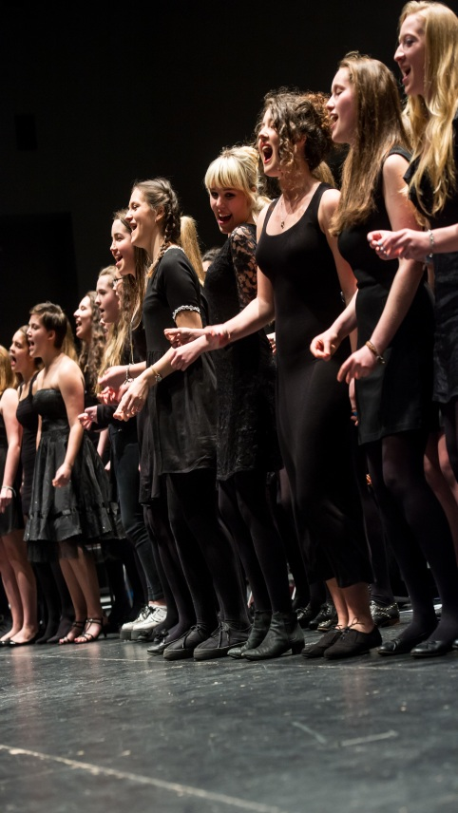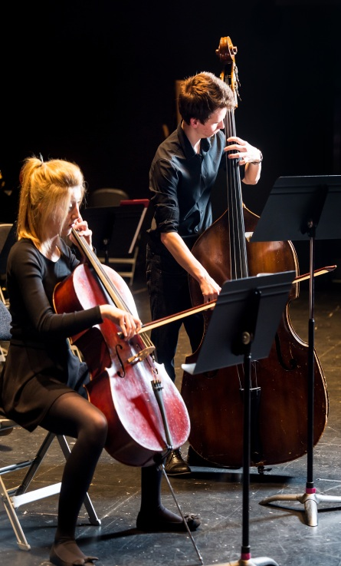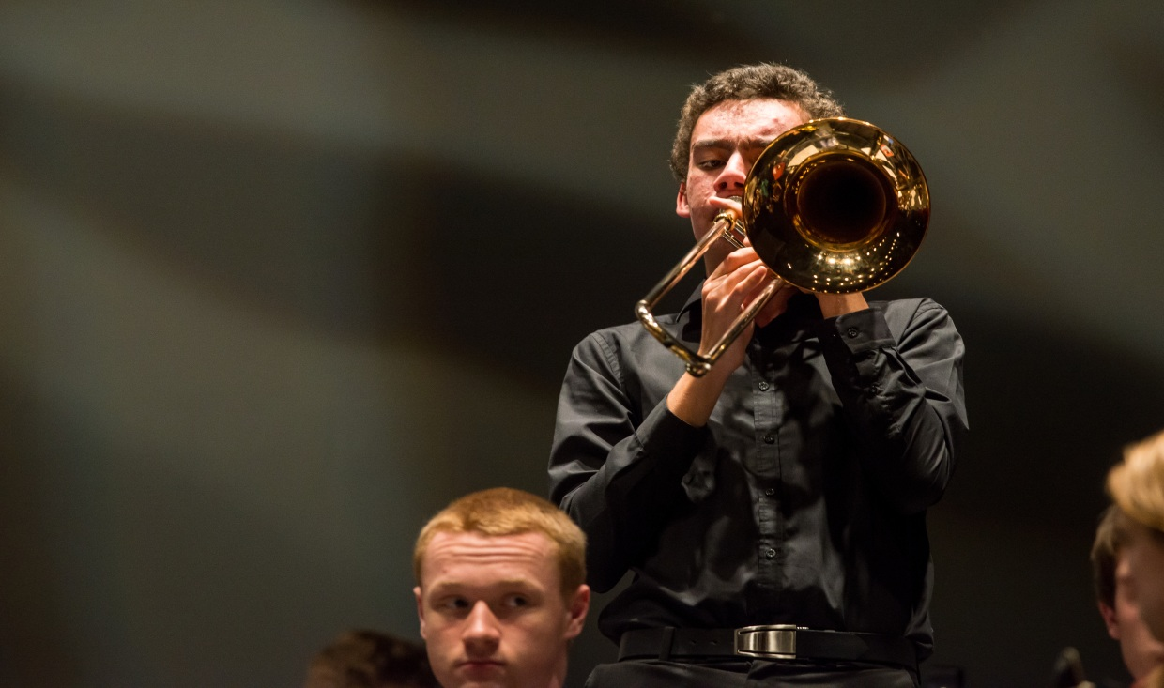

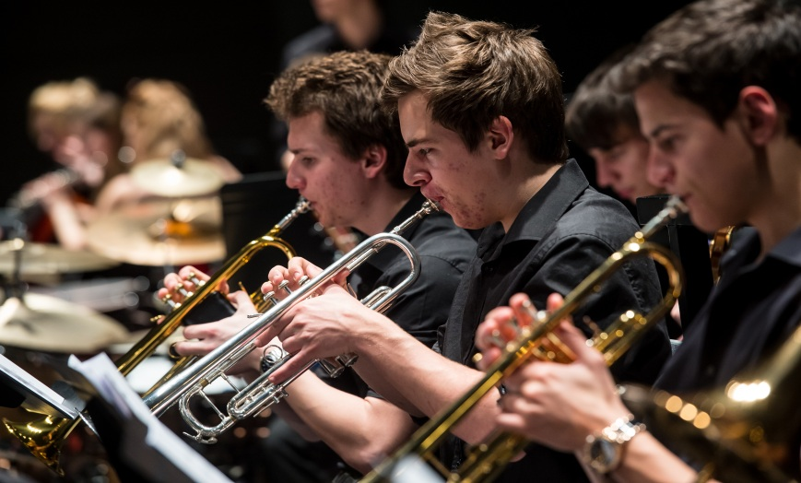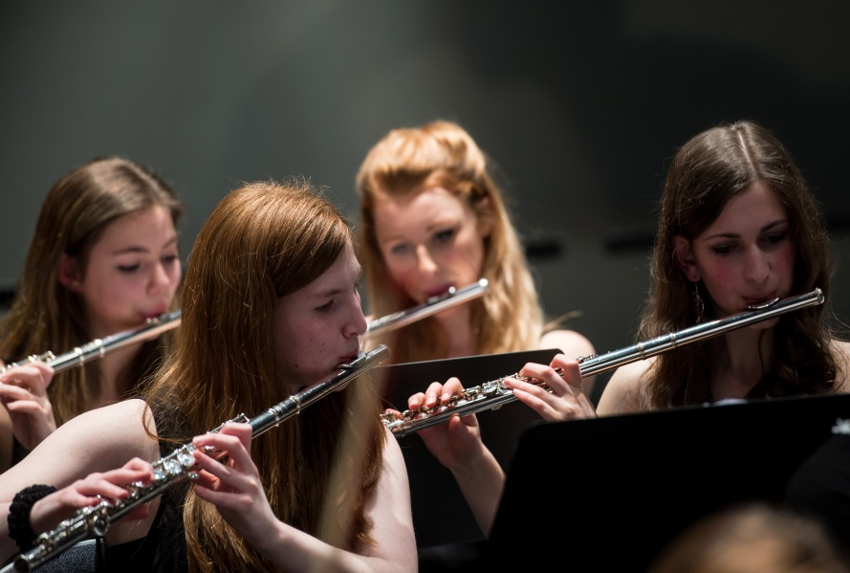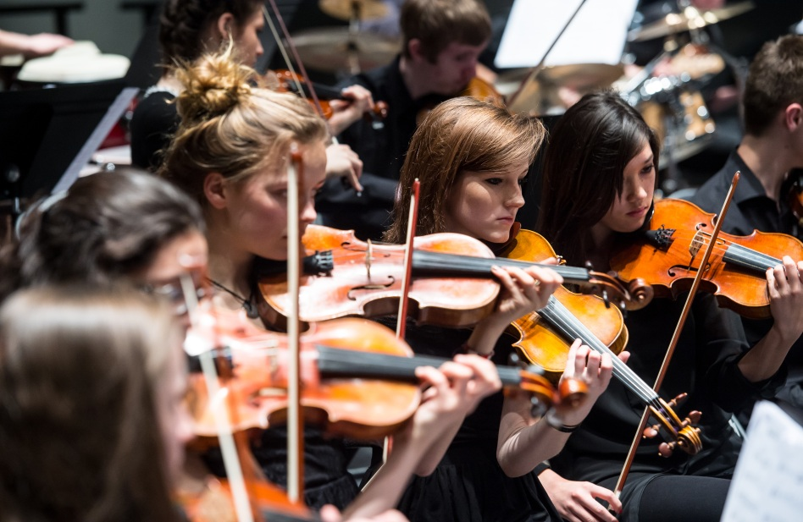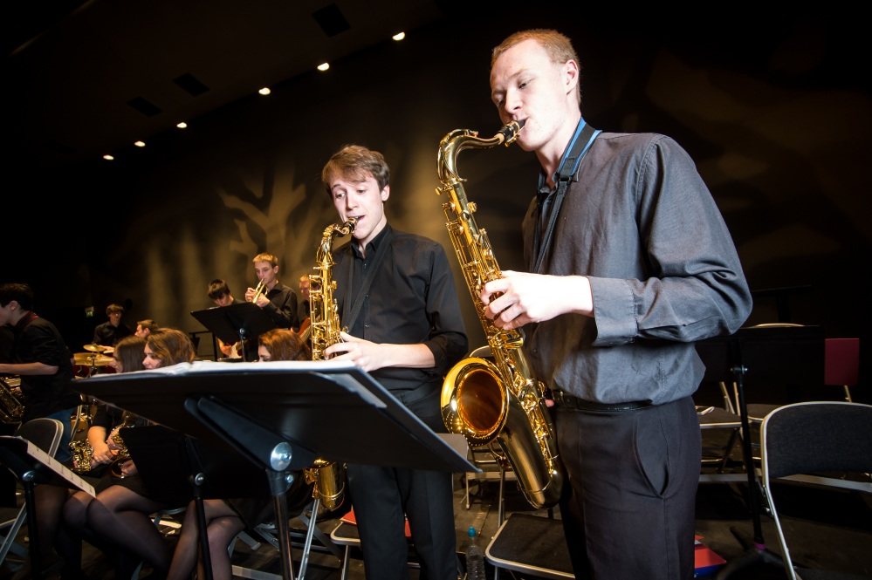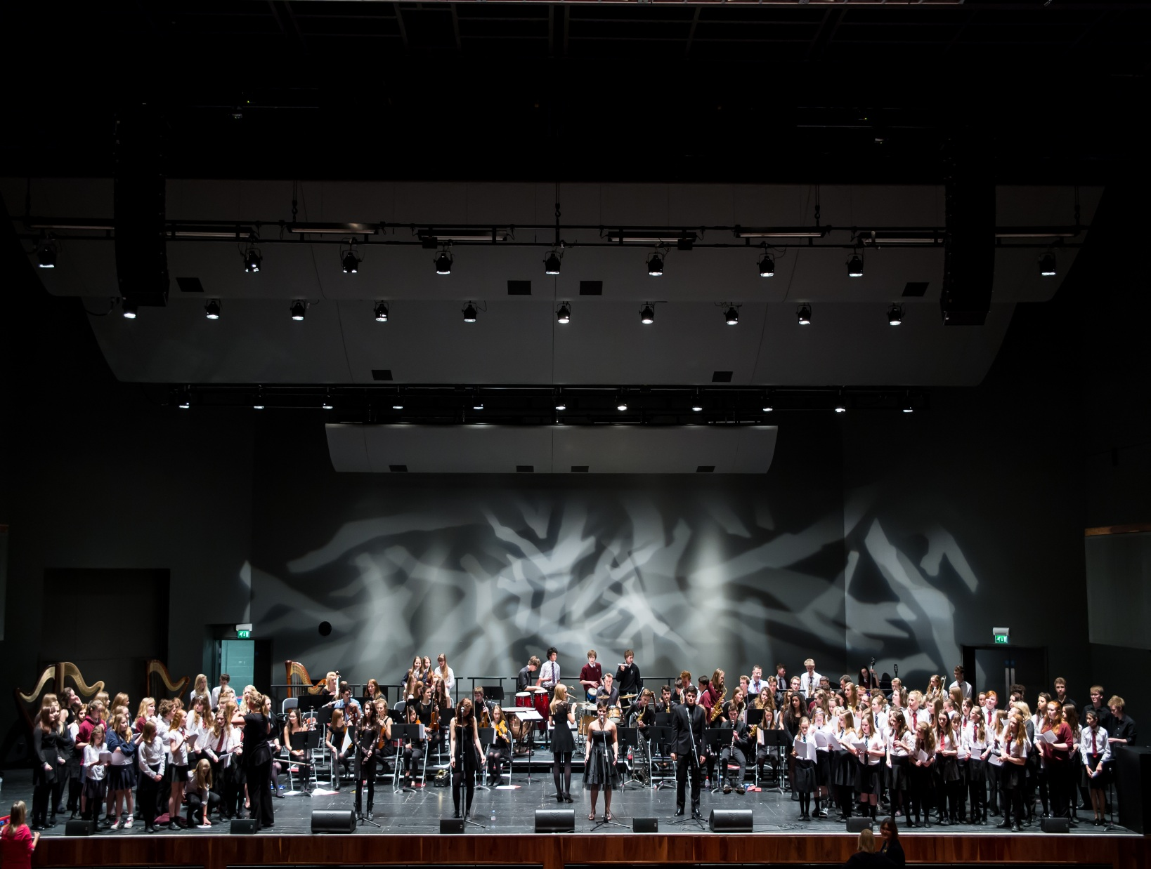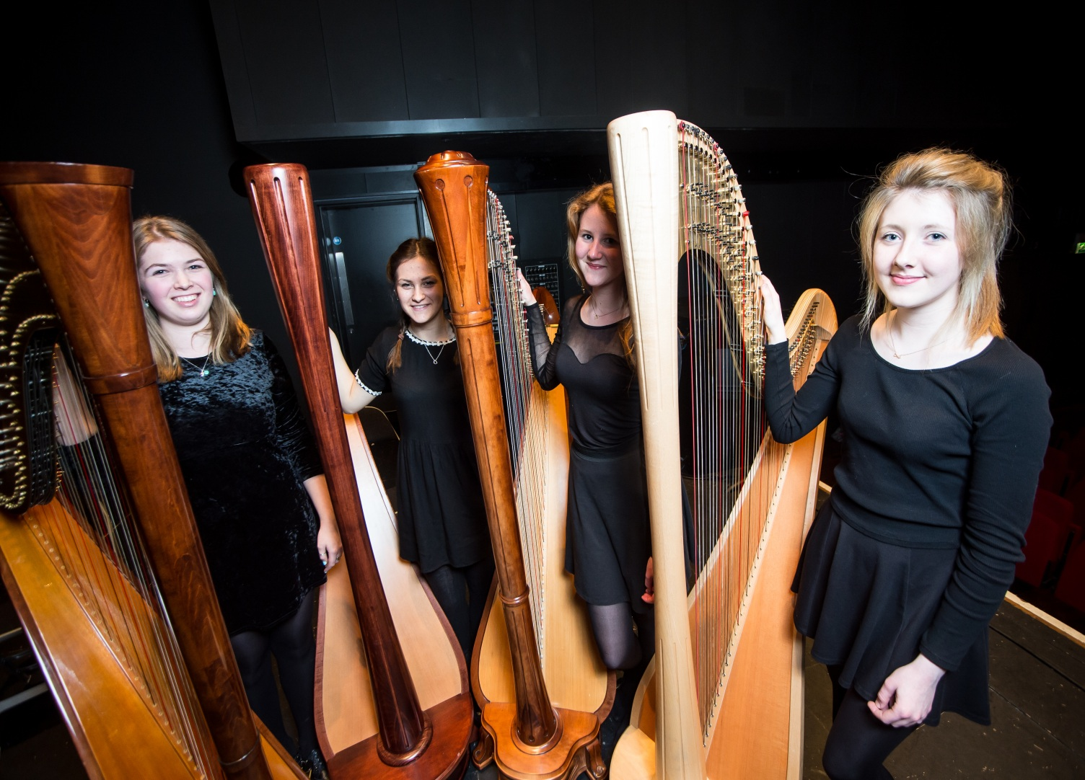

GODALMING COLLEGE AT G LIVE

Tuesley Lane

Godalming

Surrey

GU7 1RS

T: 01483

E: [college@godalming.ac.uk](mailto:college@godalming.ac.uk)

W: [www.godalming.ac.uk](http://www.godalming.ac.uk)

**MUSIC ACTIVITIES**

**PERFORMANCE OPPORTUNITIES**

Each term there is at least one main concert where all ensembles and soloists perform. This could be in college or at an external venue. There are also smaller performance opportunities throughout the year.

Recent performance opportunities have included:

Recital Evenings

Christmas Concert

G Live Concert

Godalming Bandstand Concert

Electric Theatre Concert

College Arts Festival

End of year concert

Participation at local music festivals

Class concerts

(Music A level students)

**MUSIC ACTIVITIES**

**CHAMBER ENSEMBLES**

We run a variety of chamber ensembles each year depending on the combination of musicians we have at the time. Chamber ensembles we currently have include string quartet, saxophone quartet, harp quartet and barbershop quartet. Ensembles that we have had in the past include flute choir, clarinet group and wind band.

**WHO CAN JOIN IN?**

Anyone! We do not hold auditions. Students of any standard are able to participate. You do not need to be taking Music A level to be involved.

Students are encouraged to also form their own ensembles and perform works which they have prepared themselves.

We want music activities to be enjoyed by students as well as develop their performing skills. It is common for students to write arrangements for ensembles to perform and to suggest repertoire which could be performed.

There are also opportunities for students to direct ensembles.

**WHEN ARE REHEARSALS?**

Ensemble rehearsals are normally integrated into student timetables, happen at lunch times or occasionally after college.

**CONCERT ORCHESTRA**

An ensemble of around 70 students developing large ensemble skills. Current repertoire includes Riverdance, Pirates of the Caribbean, English Folk Song Suite by Vaughan Williams, Themes for The Incredibles and Schindler’s List. Repertoire with vocal solos include I Dreamed A Dream from Les Miserables and You Can’t Stop The Beat from Hairspray.

**JAZZ BAND**

Opportunities for instrumentalists and vocalists to perform jazz classics and develop improvisation skills. Current repertoire includes Fly Me To The Moon, Spain, Chameleon and Watermelon Man.

**STRING ENSEMBLE**

An ensemble for all string players to participate in. Recent performances include Palladio by Karl Jenkins and Folk Tune Air by Safford.

**GODALMING COLLEGE SINGERS**

A large choir of around 80 students performing lively modern contemporary hits including pieces such as Little Lion Man, Don’t Worry, Be Happy, Tears In Heaven and Heroes.

**CHAMBER CHOIR**

An opportunity to sing traditional 4 part harmony vocal works including Requiem by Rutter, Seal Lullaby by Whitacre and Ave Verum Corpus by Mozart.

**INSTRUMENTAL, SINGING & MUSIC THEORY LESSONS**

We can provide private tuition for most instruments and for voice. Costs vary each year and according to the teacher. We also offer private individual and group Music Theory lessons.

Opportunities to take graded performance and theory exams are given each term.