

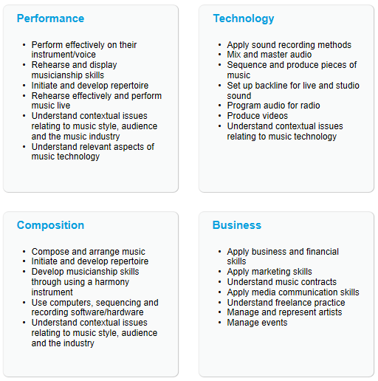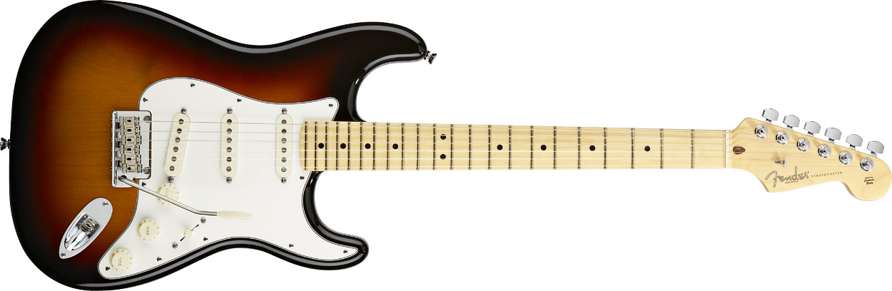

If you would like a course that will develop your interests in popular music or sound engineering and you would like to be involved in making music in a stimulating and vibrant environment, then the Music Practitioners Qualification is definitely for you!

**What sort of work will I be doing?**

Performance pathway: A large amount of your time will be spent rehearsing in bands. You will also need to spend time choosing and arranging songs to perform.

Technology pathway: Your time will be spent working with bands during their rehearsals to plan the sound set ups for concerts. You will then be responsible for setting up the sound equipment and operating it during performances.

**Time commitment**

1x 90 minute lesson a week (during the normal college day) with occasional evening/lunchtime performances

**How will I be assessed?**

Mostly through practical performance and video assessment. Your work will be awarded a pass, merit, distinction or distinction* grade.

**Entry Requirements:**

Performance pathway: You should be able to play an instrument or sing to a reasonable level (approx. grade 2/3). You do not need to have taken any music exams of any form and do not have to read music.

Technology pathway: Some previous knowledge of sound systems would be an advantage.

**MUSIC PRACTITIONERS**

**QUALIFICATION**

Level 3 Extended Certificate

ROCKSCHOOL

Tuesley Lane, Godalming

GU7 1RS

T: 01483 423526

E: [college@godalming.ac.uk](mailto:college@godalming.ac.uk)

W: www.godalming.ac.uk

Tuesley Lane

Godalming

Surrey

GU7 1RS

T: 01483

E: [college@godalming.ac.uk](mailto:college@godalming.ac.uk)

W: [www.godalming.ac.uk](http://www.godalming.ac.uk)

**One year course**

**What are the progression routes**

**for this qualification?**

You can gain between

**8-28 UCAS** **points**

for this qualification.

This qualification is considered suitable for entry into Music institutions such as

ACM & BIMM

The **Music Practitioners Qualification** is for learners who want to develop their skills in the core elements of the Music Industry.   
  
The qualification is developed with [Access to Music](http://www.accesstomusic.co.uk/) ([www.accesstomusic.co.uk](http://www.accesstomusic.co.uk)) and industry professionals so that they are relevant to the current dynamics of the Music Industry.   
  
With pathways in Performance and Technology, learners can gain the full 360° skills required to make it in the Music Industry.

Learners choose **one pathway** from the two below. For non-instrumentalists the Technology pathway provides a route in to the production, engineering and business sides of the industry.

**What is the course about?**