

**How will I be assessed?**

|  |  |  |
| --- | --- | --- |
| **AS Level Music Technology** | | |
| **Unit 1: Recording** | You produce a multi-track recording lasting 2-2.5 minutes. Recordings must include vocals, acoustic guitar and bass guitar, plus other instruments of your choice. Recordings are produced in out studios and mixed and mastered on Logic X. | 20% coursework |
| **Unit 2: Technology-based composition** | Using samples provided by Edexcel, you are to produce a piece in a style of your choice lasting 2.5 minutes. You will learn how to create, edit & manipulate sounds through synthesis and sampling in Logic X. | 20% coursework |
| **Unit 3: Listening & analysing** | You will sit an exam listening to unstudied commercial recordings. Questions will test your knowledge of recording & production techniques, principles of sound technology and the development of recording & production technologies. | 25%  Exam |
| **Unit 4: Producing & analysing** | You will sit an exam which contains practical elements and written questions. Using audio material provided by the exam board you will have to produce a track following given instructions. | 35%  Exam |
| **A Level Music Technology** | | |
| **Unit 1: Recording** | You produce a multi-track recording lasting 3-3.5 minutes. Recordings must include vocals, acoustic guitar, bass guitar & drums plus other instruments of your choice. Recordings are produced in out studios and mixed and mastered on Logic X. | 20% coursework |
| **Unit 2: Technology-based composition** | Using samples provided by Edexcel, you are to produce a piece in a style of your choice lasting 3 minutes. You will learn how to create, edit & manipulate sounds through synthesis and sampling in Logic X. | 20% coursework |
| **Unit 3: Listening & analysing** | You will sit an exam listening to unstudied commercial recordings. Questions will test your knowledge of recording & production techniques, principles of sound technology and the development of recording & production technologies. | 25%  Exam |
| **Unit 4: Producing & analysing** | You will sit an exam which contains practical elements and written questions. Using audio material provided by the exam board you will have to produce a track following given instructions. | 35%  Exam |

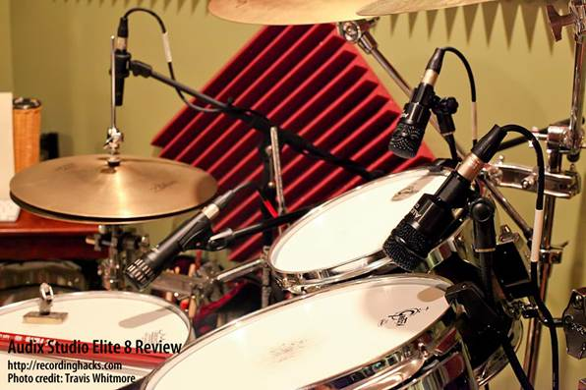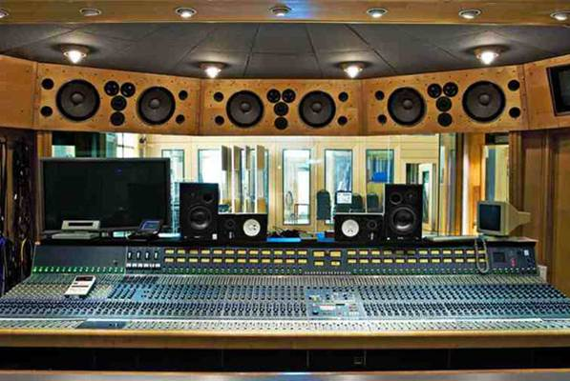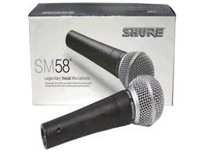

**TOP RESULTS!** We started running this course in September 2016 so there are currently no exam results, however both teachers have taught this qualification at other institutions and have achieved excellent results, including having students attain the A* grade. The Music Department is well known for its outstanding results in Music Technology BTEC and Music A level.

Please contact Head of Music, Ceilidh Botfield ([CHB@godalming.ac.uk](mailto:CHB@godalming.ac.uk)) if you have any questions about our Music Technology A level course

The College Music Department is an extremely busy and fun place to be! If you would like to be part of a community that immerses itself in creating and enjoying music, at the same time as giving you a high quality education, then the Music Technology course is definitely for you!

**MUSIC TECHNOLOGY** AS/A Level

EDEXCEL

Tuesley Lane, Godalming

GU7 1RS

T: 01483 423526

E: [college@godalming.ac.uk](mailto:college@godalming.ac.uk)

W: www.godalming.ac.uk

Tuesley Lane

Godalming

Surrey

GU7 1RS

T: 01483

E: [college@godalming.ac.uk](mailto:college@godalming.ac.uk)

W: [www.godalming.ac.uk](http://www.godalming.ac.uk)

**What are the entry requirements?**

* You should have five GCSE subjects at Grade 4 or above, including English and Maths.
* Music GCSE (grade 6) OR grade 3 instrumental/vocal ability is required
* Basic ability to play the keyboard and notation reading skills would be beneficial as would some previous experience of using music production software
* An enthusiasm for studying the science of sound as well as music production

.

**What extra work can I do?**

It is important to complete extra listening outside of the course to develop listening skills and strengthen knowledge. It is important to listen to Music of all styles and genres from 1910 onwards to become a well-rounded music technologist. It is also hoped that, where appropriate, students will explore music technology through their own personal involvement with music technology software for example Logic X, Pro Tools, Ableton and FL Studios.

**Instrumental, vocal and theory lessons**

Students are encouraged to develop instrumental skills to enhance their musical ability and understanding. The College can provide private tuition through our peripatetic teachers; however students are welcome to continue with an external teacher. Private Music Theory lessons are also available for students who want to achieve Grade 5.

**Ex-student**

**JESSICA SAUNDERS receives BAFTA BREAKTHROUGH BRIT for Games Sound Design 2015**

Picture supplied by BAFTA

**What are the progression routes for this qualification?**

Music Technology A level combines well with many other subjects including Maths, Physics, Music and Media.

Students who take Music Technology A level can progress to degree courses such as the Tonmeister degree at the University of Surrey, Music Production at Leeds College of Music, Music Production at Huddersfield University, Live Sound Engineering at ACM and Music Technology at Birmingham Conservatoire.

Career opportunities include:

* sound engineering
* music production
* teaching
* composing for film and media
* music journalism
* music software development

**What is the department like?**

**Facilities:** Two Yamaha grand pianos and a baby grand, four acoustic drum kits, one electric drum kit, six practice rooms each with an upright piano, an 80 seat recital room, two well-equipped recording studios, a mastering suite, two computer suites, one with 16 networked PCs, the other with 18 networked iMacs offering a variety of music software including Sibelius 7 and Logic X, and independent workstations for composing and performing.

**Extra-Curricular:** Music Technology students are welcome and expected to use the studios outside of lesson time to develop skills, complete recording tasks, mix and master their work. In addition to academic work, Music Technology students can be involved in solo and ensemble performing and contribute to some of the department’s ensembles which include Concert Orchestra, Jazz Band, Godalming College Singers, Chamber Choir, String Group and various other ensembles.

The Music Technology A level course introduces you to some of the disciplines involved in the academic study of the subject. It develops the skills, knowledge and understanding needed to compose, sequence, record, analyse and produce music.

**What sort of work will I be doing?**

Taught by experienced teachers, the key focus of the course is mastery of the different disciplines within Music Technology. Students spend time understanding the science behind sound and applying their understanding through professional standard multi-track recordings made in the studio. Students go on to develop musical listening and appraising skills through the study of the history of music and apply their knowledge through composing in particular styles or to set briefs. Students also learn advanced Logic X editing and manipulation skills and processes which are applied through sequencing and composition work, as well as through the mixing and mastering process of the multi-track recording.

**What is the course about?**