

**Unit content**

Across 2 years, learners will complete **some** of the following units:

1. Studio Recording Techniques Learners will learn about different types of recording equipment, the setting-up of audio equipment for a recording session and the capturing of multitrack recordings
2. Digital Audio Workstation ProductionLearners will develop an understanding of how a digital audio workstation (DAW) can be used creatively to produce music, manipulate audio and mix music.
3. Live SoundLearners will learn about the equipment requirements for a range of venues and progress to set-up, test and operate equipment for a range of contrasting material including rock gigs, concerts and drama productions.
4. Working & Developing as a Production Team Learners will develop an understanding of the collaborative process by which a music recording project is carried out. Students will create portfolio CD containing recordings which they have engineered, mastered and produced.
5. Music & Sound for Media Learners explore the production of the music, sound and effects that are used for media products

such as games, films and apps.

1. Remixing & Reworking Learners will explore and carry out the skills required to create effective remixes and reworks of existing musical material.
2. Creative Synthesis & Sampling Learners will explore the creative functions of synthesisers and samplers in making music and sound design.
3. Mixing & Mastering Techniques This unit aims to give learners the skills to mix and master a DAW project to a professional standard.

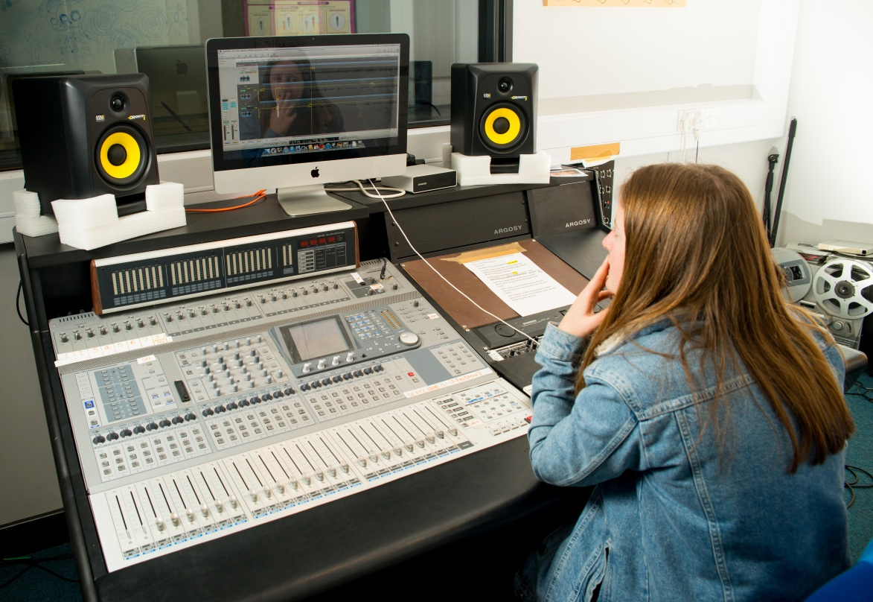[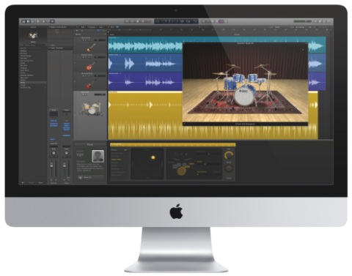](http://9to5mac.com/2013/07/16/apple-releases-major-logic-pro-x-mainstage-3-updates-in-mac-app-store/logic-pro-x-01/)

Please contact Head of Music, Ceilidh Botfield ([CHB@godalming.ac.uk](mailto:CHB@godalming.ac.uk)) if you would like more information on this course

If you would like a course that will develop your interests in popular music and creative music production in a vibrant environment, then this is the course for you!

**TOP RESULTS!** (BTEC Subsidiary Diploma - previous equivalent qualification)

**2014:** 79% of students were awarded a distinction/distinction star grade

**2015:** 90% of students were awarded a distinction/distinction star grade

**2016:** 88% of students were awarded a distinction/distinction star grade

**MUSIC TECHNOLOGY** BTEC National

Certificate/Extended Certificate

EDEXCEL

Tuesley Lane, Godalming

GU7 1RS

T: 01483 423526

E: [college@godalming.ac.uk](mailto:college@godalming.ac.uk)

W: www.godalming.ac.uk

Tuesley Lane

Godalming

Surrey

GU7 1RS

T: 01483

E: [college@godalming.ac.uk](mailto:college@godalming.ac.uk)

W: [www.godalming.ac.uk](http://www.godalming.ac.uk)

**Qualification Type**

This course is equivalent to 1 A level with the BTEC Extended Certificate qualification awarded at the end of students’ second year at college.

**What is the department like?**

We run a stimulating, lively, energetic department in which experienced and enthusiastic staff set high standards both in examination achievements and in music-making activities.

**Facilities**

Two Yamaha grand pianos and a baby grand, four acoustic drum kits, one electric drum kit, six practice rooms each with an upright piano, an 80 seat recital room, two well-equipped recording studios, a mastering suite, two computer suites, one with 16 networked PCs, the other with 18 networked iMacs offering a variety of music software including Sibelius 7 and Logic X, and independent workstations for composing and performing.

**What are the entry requirements?**

Students should have five GCSE subjects at Grade 4 or above, including a 4 in English Language. It is expected that students will be proficient on at least one instrument and/or vocals.

.

**What is the course about?**

Picture supplied by BAFTA

**Ex-student**

**JESSICA SAUNDERS receives BAFTA BREAKTHROUGH BRIT for Games Sound Design 2015**

Most of our students progress to top universities or conservatoires to continue their study of Music Technology. Our BTEC students have been awarded offers on the **Tonmeister course** at **Surrey University**. This prestigious course is widely considered to be the best sound engineering course in the world.

**What are the progression routes for this qualification?**

Music Technology combines well with many subjects, such as Maths, Media Studies, Physics and performing arts subjects. It is also ideal as a subject to be taken alongside Music.

There are a vast number of degree courses specialising in different aspects of Music Technology, including courses in composition for film, TV and video games, computer software and music production, recording, sound manipulation and the management of music businesses. Most of these courses lead directly into specialised careers.

**What extra work can I do?**

It is expected that students will actively engage in listening, reading and performance activities. It is particularly important that students of a music based course explore as wide a range of musical styles as possible in order to become well informed and more experienced as the course develops. It is hoped that students will look for opportunities to become involved in music-making in and out of College. You may also take specialist lessons in your main instrument or voice.

The BTEC Music Technology course introduces students to some of the skills and techniques required by the studio musician, whether as a composer, a performer, a producer or a sound engineer. The course centers on the use of recording equipment and music software and is a very practical course compared to A-Levels. Students are encouraged to gain an understanding of the historical impact of Music Technology on recording, and to listen to a range of contemporary music, recognising and assessing how musicians use music technology in the world of today. The course is also supported by visiting performers, workshops and external visits.

**How will I be assessed?**

BTECs are coursework based qualifications. Coursework briefs are based on real-life work-based case studies, scenarios and projects. Most of this course is assessed internally, with 2 units being assessed externally. Pass, merit or distinction grades can be achieved for each unit. The final qualification grade will be based on the average performance in each unit.