

How will I be assessed?

You will be encouraged to demonstrate your skills and talent by being assessed in practical ways. You will be assessed through portfolio, written work and performance by your subject tutors.  
Your work will be moderated by a visiting moderator. Each unit is

awarded points, which are translated into an overall grade by

the examiners at the end of the course.

For The Diploma (equivalent to two A-Levels) students will complete 8 modules over 2 years.

What extra work can I do?

Wider reading is always advisable as is seeing plenty of live dance to broaden your experience. Most theatres have student standby arrangements with very good rates. Keep up-to-date with the dance world by reading dance magazines and the Arts section of local and Sunday newspapers. Look for opportunities to take part in work run by professional companies.

What is special about studying with ClassAction?

High Achievement and progression rates  
Regular performance assessment showcasing work to the public  
A purpose built Dance Studio  
Taught by professionals who are working/have worked professionally in the industry  
You will learn how to work as part of a performance ensemble – to lead and take the initiative in group work.  
  
ClassAction believe that performance art training should be a challenging, inspiring, life affirming and ultimately life changing experience. We will: develop a nurturing and supportive environment in which every single student is valued as an individual.

|  |
| --- |
| **Follow us on Twitter @ ClassAction01** |
| **YouTube channel – ClassAction Theatre** |

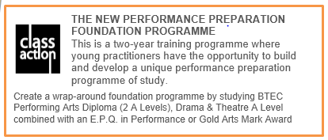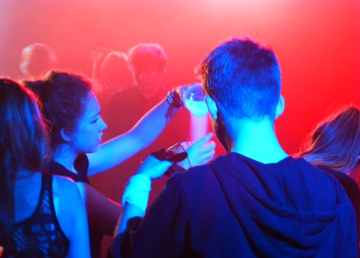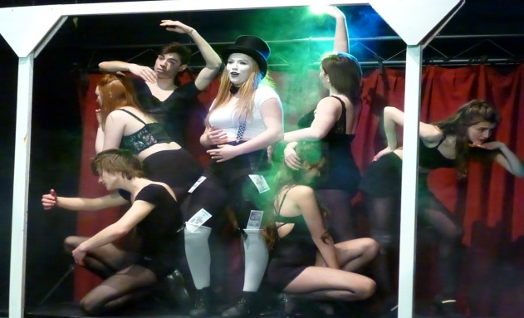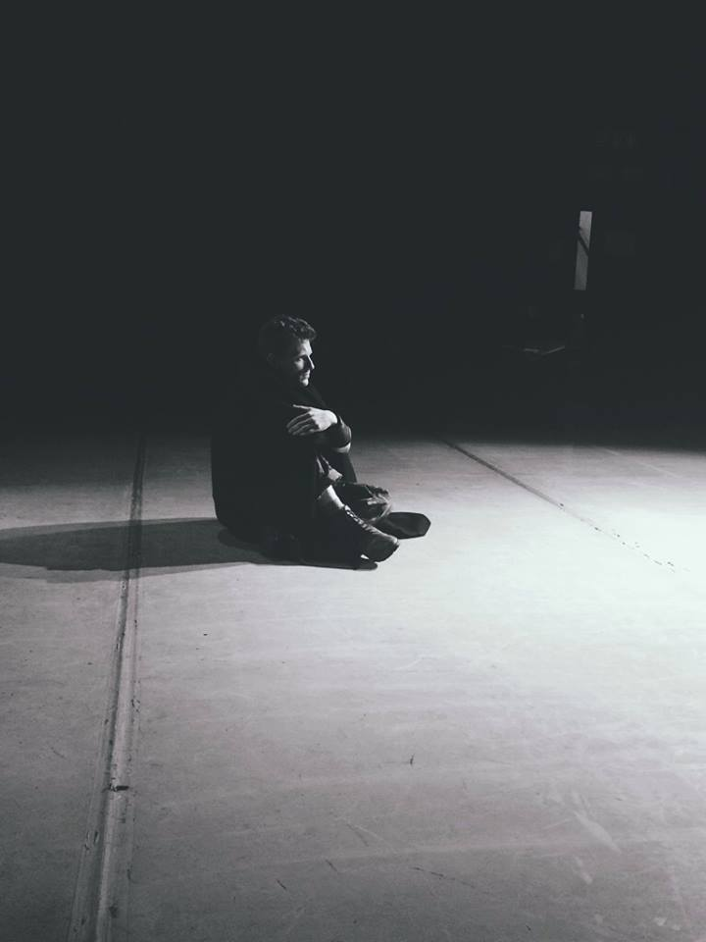+

**PERFORMING ARTS**

BTEC Diploma

(2 A Level Equivalent)

EDEXCEL

Building your unique Foundation Study Programme

Tuesley Lane, Godalming

GU7 1RS

T: 01483 423526

E: [college@godalming.ac.uk](mailto:college@godalming.ac.uk)

W: www.godalming.ac.uk

Tuesley Lane

Godalming

Surrey

GU7 1RS

T: 01483

E: [college@godalming.ac.uk](mailto:college@godalming.ac.uk)

W: [www.godalming.ac.uk](http://www.godalming.ac.uk)

Within the department we aim to create an environment that truthfully reflects that of a professional rehearsal space, based on mutual respect, trust, and a shared passion. Giving equality of time, effort and imagination in line with colleagues and tutors, our students develop from within a strong ensemble group whilst the individual is

simultaneously nurtured.

This course covers a range of Acting/Movement skills and techniques. With our dedicated team of professionals guiding and supporting you, you will explore different acting styles and approaches and look at the work of different playwrights and practitioners.   
  
  
  
You will develop your acting and vocal skills, prepare audition material, and develop your rehearsal and performance skills. You will explore ensemble, create and devise material through rehearsal and learn to refine your work before performing to a public audiences. The advanced training requires a high level of self-discipline and commitment, and will require you to attend rehearsals and performances throughout the two years.  
  
  
  
  
  
What are the entry requirements?  
  
The Diploma is a demanding and intensive training course offering a comprehensive performing arts training. Prospective practitioners must have talent, self-belief, motivation, commitment, dedication,   
self-discipline and an open attitude. Actors must be able to take responsibility for their own development, have good time management skills and a passion for their craft. There is an academic requirement of 5 GCSE’s at GRADE 4 or above (must include English).

What is the department like?

“ClassAction” is Godalming College’s training company that brings together all aspects of this thriving and successful department. We offer a unique performance art programme with the aim of creating a first class performance preparation training course that is underpinned by academic rigour and depth of reflection.   
  
ClassAction is supported by an outstanding faculty and a growing network of professional industry contacts, and is dedicated to preparing and inspiring our training practitioners to the highest practical and academic level. There are around 200 students working across the two years in different combinations of programmes. Some follow an academic route on one of our courses. Others combine two of our courses with a performance E.P.Q. in their second year to create a unique performance training package. Everyone will always be encouraged to find their own unique artistic voice as a practitioner.

ClassAction has an absolute commitment to nurture and guide each actor to discover and develop their individual and unique talents and skills to the fullest possible extent.

The demands are real and the success of our training can be seen in the high achievements of our practitioners and their progression into higher level training.

What sort of work will I be doing?  
This Level 3 Performing Arts Diploma is a unique two-year training programme where young practitioners learn to work as professionals in a modern, industry-relevant environment. Here you have the opportunity to develop your own **FOUNDATION STUDY programme by taking this alongside a Drama & Theatre A Level to build a unique performance preparation programme of study.**  
  
  
You will work as part of a theatre company whilst developing your own skills in voice and movement and using them to create believable and fully rounded characters for the stage.  
  
  
ClassAction aims to produce performers who are both dynamic and interesting and who can draw on their own, often varied and wide ranging life experiences, to produce work that is truthful and engaging.

The course includes written work based around research and personal development, and requires you to keep reflective journals of your work and to evaluate yourself both during and after rehearsal and performance.

What are the progression routes for this qualification?

BTEC Dance can lead

to degree courses in Dance, Performing Arts and Education, professional performance work, community work and therapy courses.

This course gives students a wide choice of progression options.

As well as students studying the range of performing art subjects at many universities, over the past few years we have had students gain places at institutes such as RADA, Bristol Old Vic, Royal Central School of Speech and Drama, Lamda, GSA, East 15, Drama Centre, Mountview, Arts Ed, Birds, Performers, LABAN, London Contemporary Dance School, Urdang.

The futures for our students are bright and exciting and future careers for ClassAction practitioners are rich and diverse as we develop the dance makers of the future.

What is the course about?