

How will I be assessed?

You will be encouraged to demonstrate your skills and talent by being assessed in practical ways. You will be assessed through portfolio, written work and performance by your subject tutors.  
Your work will be moderated by a visiting moderator. Each unit   
is awarded points, which are translated into an overall grade by

the examiners at the end of the course.

For a National Extended Certificate (equivalent to one A-Level) students will complete 4 modules over 2 years. **There is an opportunity to take this as a one year option. The qualification then becomes the BTEC National Certificate which comprises of 2 modules.**

This exciting and varied course is often changed and tailored to the practitioners we have in any one year group. Topics can include: performance workshops, performing arts business, historical context of performance, rehearsing for performance, performing to an audience, devising plays, classical theatre performance, musical theatre, developing voice for the actor, principles of acting, applying acting styles, drama, storytelling as performance, singing skills, developing physical theatre.

What is special about studying with ClassAction?

High Achievement and progression rates  
Regular performance assessment showcasing work to the public  
A purpose built Dance Studio  
Taught by professionals who are working/have worked professionally in the industry  
You will learn how to work as part of a performance ensemble – to lead and take the initiative in group work.  
  
ClassAction believe that performance art training should be a challenging, inspiring, life affirming and ultimately life changing experience. We will: develop a nurturing and supportive environment in which every single student is valued as an individual.

|  |
| --- |
| **Follow us on Twitter @ ClassAction01** |
| **YouTube channel – ClassAction Theatre** |

**FOLLOW US @ClassAction01 | YouTube Channel – ClassAction Theatre**

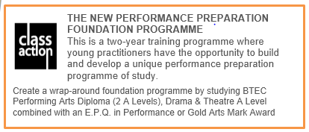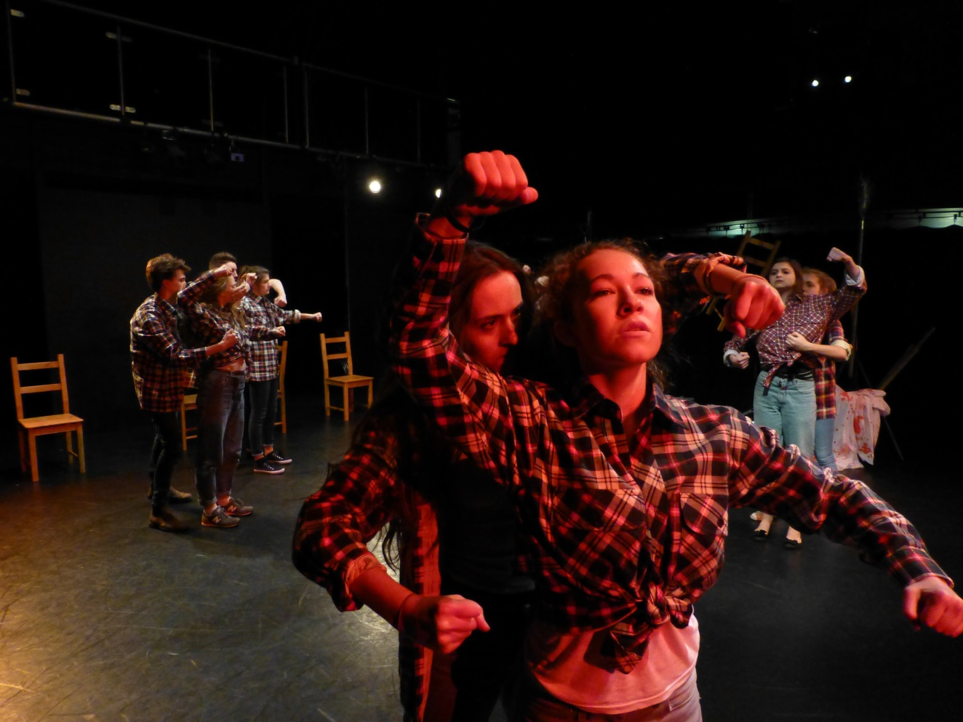

**PERFORMING ARTS**

BTEC National

Extended Certificate

EDEXCEL

“There is play and adventure within a rigorous learning framework”

Tuesley Lane, Godalming

GU7 1RS

T: 01483 423526

E: [college@godalming.ac.uk](mailto:college@godalming.ac.uk)

W: www.godalming.ac.uk

Tuesley Lane

Godalming

Surrey

GU7 1RS

T: 01483

E: [college@godalming.ac.uk](mailto:college@godalming.ac.uk)

W: [www.godalming.ac.uk](http://www.godalming.ac.uk)

**NB. Whilst there is the opportunity to explore Musical Theatre in performance, this is not a musical theatre course.**

What are the progression routes for this qualification?

The BTEC Level 3 Extended Certificate in Performing Arts is   
widely accepted and   
accredited by the great majority of universities

as an excellent

foundation for degree study. It also provides

an invaluable foundation for vocational study.

As well as students studying the range of performing art subjects at many universities, over the past few years we have had students gain places at prestigious institutes such as RADA, Bristol Old Vic, Royal Central School of Speech and Drama, Lamda, GSA, East 15, Drama Centre, Mountview, Arts Ed, Birds, Performers, LABAN and London Contemporary Dance School

The futures for our students are bright and exciting and future careers for ClassAction practitioners are rich and diverse as we develop the theatre makers of the future. ear course students are well equipped or further study at university or drama school.

What are the entry requirements?

Whilst Dance/Drama/Performing Arts GCSE or dance grades are useful they are not compulsory. It is most important that you are interested in gaining a greater understanding of how the performing arts industry works and to be keen to be involved in performance work. You will need passion and dedication to achieve on this course; you will need to commit to the high level of ongoing written reflective work through-out the year. Also required; minimum of five GCSE subjects at Grade 4 or above including English.

.

Assessment.

BTECs are coursework based qualifications. Students undertake real-life work-based case studies and complete projects and assessments which contribute to each unit studied. In order to complete each unit, students must achieve against a set of outcomes. The assessment process is ongoing and the projects that students undertake form the basis of their unit results which are graded as a Pass, a Merit or a Distinction.

The course demands practical, creative and communication skills in equal measures.

You will enjoy this course if you wish to develop your own skills, with an opportunity to specialise in different performance genres wand you want to develop;

* Understanding of all aspects of performing arts
* An insight into the nature of the performing arts industry
* Understanding of employment opportunities, constraints and the issues

facing professionals working within the sector

* A knowledge of the working methods used by professionals: as an individual in teams, with clients, commissioners and audiences.

You will develop skills that allow you to stage your own production events, whilst also learning to record development and progress in order to reflect upon your own professional practice.

What is the course about?

*Collaboration, Creation, Innovation*

Our Performing Arts course gives you an understanding of all aspects of performing arts and combines it with the opportunity to make specialist choices during your study. This vocational qualification offers a genuinely practical approach. As a part of the ‘ClassAction Company’ you will be challenged to work to professional standards of creative collaboration. There are high expectations of students on this course, but it also offers the opportunity to perform with the best at the very highest level.

What is the department like?

We are housed in a well-equipped performance studio within our Performing Arts Building with a second smaller studio space, rehearsal rooms, scene dock and industry standard control room. We also have a purpose built dance studio with sprung floors, mirrors and barre. These provide a comfortable working atmosphere with easy access to technical equipment needed for the course.

“ClassAction” is Godalming College’s training company that brings together all aspects of this thriving and successful department. We offer a unique performance art programme with the aim of creating a first class performance preparation training course that is underpinned by academic rigour and depth of reflection. ClassAction is supported by an outstanding faculty and a growing network of professional industry contacts, and is dedicated to preparing and inspiring our training practitioners to the highest practical and academic level. There are around 200 students working across the two years in different combinations of programmes. Some follow an academic route on one of our courses. Others combine two of our courses with a performance E.P.Q. in their second year to create a unique performance training package. Everyone will always be encouraged to find their own unique artistic voice as a practitioner.

Prospective practitioners must have talent, self-belief, motivation, commitment, dedication, self-discipline and an open attitude. You should have good time management skills and a passion for your craft.