

How will I be assessed?

By examination only: the AQA AS-level qualification consists of one examination of three hours duration; the Cambridge Pre-U qualification consists of three examinations, one of two hours and 15 minutes duration and two of two hours duration, all at a level equivalent to A-level and taken at the end of two years.

What skills will I develop during this course?

Philosophy develops skills of communication, evaluation and analysis. You will learn to interpret philosophical concepts, analyse philosophical arguments and develop your own reasoning skills.

**Philosophy is for you if –**

1. You like to think about issues, even if they seem difficult at first
2. You are willing to work hard at learning new ways to think
3. You enjoy discussing your ideas with others, and are prepared to listen to other people’s ideas.

## You won’t enjoy Philosophy if –

1. You don’t like to read about ideas, or the reasons for them
2. You don’t like it when there isn’t a straightforward answer to your questions
3. You want a quick and easy way of getting a qualification!

**If you would like to know more about philosophy, here are some books which you may find in your library:**

Stephen Law, *The Philosophy Files*, (Orion Books). This is an easy to read book for children (and grown-ups who like silly cartoons!) discussing some well-known philosophical questions.

Bryan Magee, *The Story of Philosophy,* (Dorling Kindersley): a beautifully illustrated, accessible history of philosophy.

Nigel Warburton, *Philosophy – The Basics*, (Routledge). Philosophy in a nutshell - read about all of it in 150 pages!

[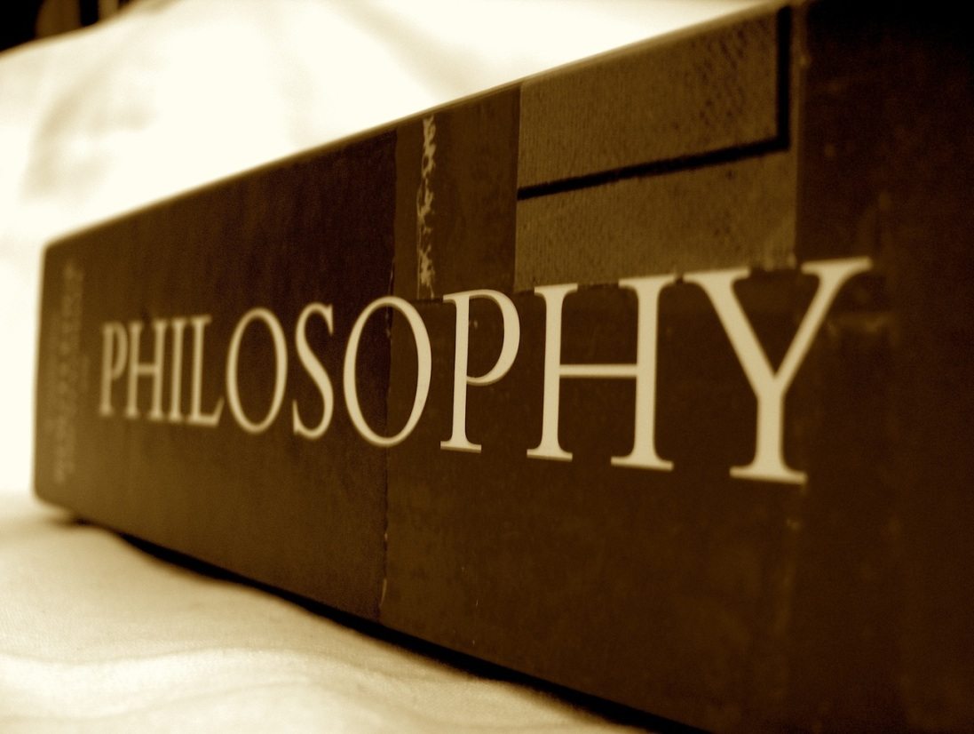](http://www.google.com/url?sa=i&rct=j&q=&esrc=s&frm=1&source=images&cd=&cad=rja&docid=lcbBaCY0FkFl2M&tbnid=NcPlECe9PLzK0M:&ved=0CAUQjRw&url=http://philosophy.uchicago.edu/prospective/&ei=BeDSUaSZL-mV0AXB1YDwCw&bvm=bv.48572450,d.d2k&psig=AFQjCNEI1bsH4ciiNdfRPVoNZuREJ2sSRw&ust=1372860734949677)

**PHILOSOPHY**

AS Level: (AQA).

A Level: (Cambridge Pre-U)

Tuesley Lane, Godalming

GU7 1RS

T: 01483 423526

E: [college@godalming.ac.uk](mailto:college@godalming.ac.uk)

W: www.godalming.ac.uk

Tuesley Lane

Godalming

Surrey

GU7 1RS

T: 01483

E: [college@godalming.ac.uk](mailto:college@godalming.ac.uk)

W: [www.godalming.ac.uk](http://www.godalming.ac.uk)

Philosophy asks questions about fundamental aspects of human existence. There are many branches of philosophy; for almost every area of thought there is a ‘philosophy’ that reflects on the underlying issues relevant to it.

**The one-year course: AQA AS Level.**

**Epistemology.** Can knowledge be defined? Which is more important to the beliefs that we form and knowledge that we have: our capacity to reason or our sensory experience of the world? Are all of the ideas or concepts that we possess derived from our experience of the world or is it necessary to possess certain concepts in order to experience anything at all? Can we know what 'reality' is like if there are no differences between real and virtual experiences?

**Ethics.** Are there any moral imperatives – actions that we should always do or refrain from doing – such as never kill or always tell the truth? Is the right thing to do dependent upon whether it increases happiness or reduces pain and suffering? Alternatively, is morality about character – how we should be in order to live a good life? Practical issues include whether animals have rights and whether war can be justified. Do moral judgements describe objective moral facts or do they simply state our own feelings or preferences?

**The two-year course: Cambridge Pre-U**

Paper 1 of the Cambridge Pre-U involves the study of a number of **foundational debates in philosophy**. These are: Plato and Aristotle; Empiricism and Rationalism; Moral Absolutism and Moral Relativism; Conscience, Free Will and Determinism.

Papers 2 and 3 include a number of options for study. At present the preferred options are:

**Epistemology**. What is knowledge? What, if anything, can be said to be known for certain? How can it be known? The role of philosophical doubt: Descartes’ search for knowledge that cannot be doubted. The relationship between knowledge, belief and justification. Theories of how we might justify the beliefs that we hold, including foundationalism, reliabilism and coherentism. The relationship between our sense experience and reality: theories of perception, including naïve realism, representative realism, idealism and phenomenalism

**Philosophy of Mind.** This philosophical theme concerns the nature of consciousness. Is the mind physical – e.g. is the mind the brain – or do mental states possess properties that brain states do not? Is it possible that you are the only minded being and that everyone else is a zombie with no real feelings or attitudes? If mental states are physical do they have to be brain states or could some artificially intelligent systems possess them?

What are the entry requirements?

The minimum requirements are five GCSE subjects at grade 4 or above, with a 6 in English Language. However, philosophy is a demanding subject; the real qualification that will help you to succeed is the ability to think through an issue, willingness to work hard and being open to new ideas.

.

What sort of work will I be doing?

When studying philosophy, we don’t invent our own theories from scratch. We learn what great philosophers have said about these issues in the past and discuss their importance for our present thinking. So there is a variety of work. Studying texts and theories involves reading, reflection and discussion; you may be set short tests, but also substantial essays requiring some research.

What is the department like?

We are a growing department, housed in a new teaching block. The tutors are enthusiastic about their subject and are keen to introduce newcomers to their field. We realise that it is a new and difficult subject for most students, and we like to use a variety of ways to introduce and illustrate philosophical issues. There are around 150 students in Philosophy across the two year groups, and most of our students achieve high grades.

Teaching uses a variety of approaches designed to suit different abilities and learning styles. We try hard to help any student with his or her own learning difficulties such as dyslexia and to stretch those with high academic ability.

What are the progression routes for this qualification?

Philosophy combines well with most subjects, whether they are natural or social sciences or humanities subjects, and will provide evidence of important competencies for UCAS and employment applications. Because you acquire important thinking skills as well as subject knowledge, an A level in philosophy is an excellent preparation for any degree course. Philosophy is taught at many British universities and can be combined with a wide variety of other subjects. Graduates enter a wide variety of careers particularly those requiring analytical, evaluative and problem solving skills.

What is the course about?