

How will I be assessed?

|  |  |
| --- | --- |
| AS Physical Education | |
| Paper 1: Factors affecting participation in physical activity and sport Written exam: 2 hours  Total: 84 marks  70% of AS  Section A – Applied physiology (28 marks)  Section B – Skill acquisition and sports psychology  (28 marks)  Section C – Sport and society and technology in sport (28 marks) | **Practical performance in physical activity and sport.**  Internal assessment, external moderation  Total: 90 marks  30% of AS  Students are assessed as a player/performer or coach in the full sided version of one activity (15%)  plus  Written/verbal analysis and evaluation of performance  (15%) |

|  |  |  |
| --- | --- | --- |
| A2 Physical Education | | |
| **Paper 1: Factors affecting participation in physical activity and sport**  Written exam:  2 hours  Total: 105 marks  35% of A-level  Section A  Applied anatomy and physiology  (35 marks)  Section B  Skill acquisition  (35 marks)  Section C  Sport and society (35 marks) | **Paper 2: Factors affecting optimal performance in physical activity and sport**  Written exam:  2 hours  Total: 105 marks  35% of A-level  Section A  Exercise physiology and biomechanics (35 marks)  Section B  Sports psychology  (35 marks)  Section C  Sport and society and technology in sport (35 marks) | **Practical performance in physical activity and sport**  Internal assessment, external moderation  Total: 90 marks  30% of AS  Students are assessed as a player/performer or coach in the full sided version of one activity (15%)  plus  Written/verbal analysis and evaluation of performance  (15%) |

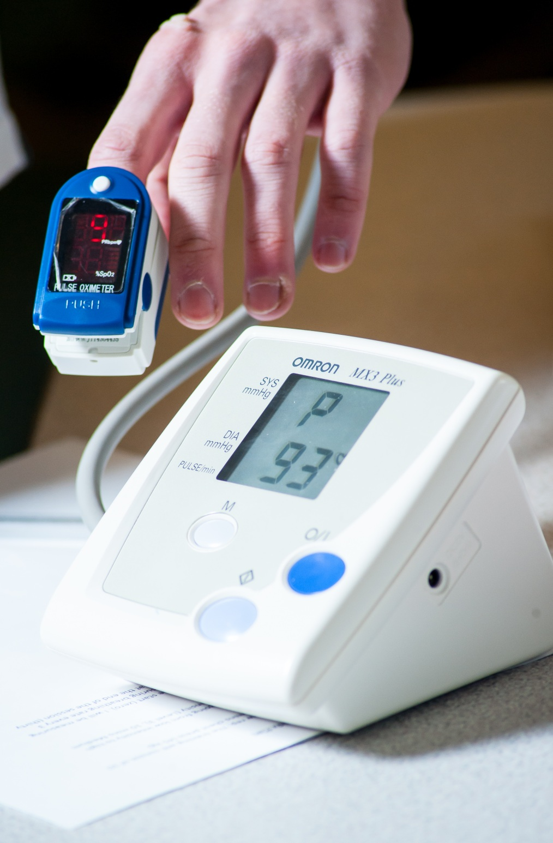

**PHYSICAL EDUCATION**

AS/A Level

AQA

Tuesley Lane, Godalming

GU7 1RS

T: 01483 423526

E: [college@godalming.ac.uk](mailto:college@godalming.ac.uk)

W: www.godalming.ac.uk

Tuesley Lane

Godalming

Surrey

GU7 1RS

T: 01483

E: [college@godalming.ac.uk](mailto:college@godalming.ac.uk)

W: [www.godalming.ac.uk](http://www.godalming.ac.uk)

What are the entry requirements?

A minimum of five GCSE subjects at Grade 4 or above, including English and Double Science or Biology. Not all students will have done GCSE Physical Education and it is **not necessary** to have done so in order to take Physical Education at AS/A Level.

A genuine interest in sport is required as your performance in your sport is a major part of your assessment. The standard required for these assessments is very high.

.

What sort of work will I be doing?

The theory work will generally be delivered in a classroom environment but a wide range of techniques will be used. Discussion, experiments, practical demonstrations, video, student presentations and good old-fashioned board work will be used to provide a varied approach to learning.

Practical lessons will be used to reinforce the concepts used and studied in the classroom. Practical assessments are completed in training times and during assessment week sessions.

What skills will I develop during this course?

As well as an excellent knowledge base, you will develop your abilities to analyse situations and apply theoretical concepts to practical situations. This is a very necessary skill for any future career. You will develop both your communication skills to help you become an effective team member and your leadership qualities. Opportunities will be available for you to achieve the Community Sports Leader Award through your PE course.

What are the progression routes for this qualification?

Physical Education is now seen as any other academic qualification. Previous students have been accepted on higher education courses to study sports science, teaching, leisure management, coaching studies and so on. Recently, a large number of our students have gone on to study physiotherapy. Nearly all universities accept physical education for their courses and many like the enhanced communication and leadership skills that physical education students develop. Physical education is also a sensible qualification for people considering work in the leisure or health and fitness industry.

The PE course combines all the major elements of any study of sport. You will study three theory areas that cover the physiological, psychological and sociological aspects of sport and complete about two hours of practical work a week. This will allow you to use a wide range of knowledge to explain how physical education can affect the mind, body and spirit of the performer. The physiological aspects cover the anatomy and exercise physiology areas that will help us understand how our bodies move and what we can do to improve performance. The psychological areas help us understand how we learn and how we can improve our teaching and coaching skills and the sociological areas help us understand the role of PE and sport in society and how it has become so important.

What is the course about?

What is the department like?

The Physical Education Department is one of the liveliest departments in the college. Students who have completed courses in our department enjoy both the positive staff-student relationships and the varied approaches to study.

The department has superb new facilities on site including a sports hall ready for top level badminton, basketball, netball, volleyball, 5 – aside, indoor hockey, trampolining and cricket. A state of the art fitness club with highly qualified instructors, two football pitches, one rugby pitch, two netball courts and three tennis courts. We also make use of other specialist facilities such as Charterhouse astroturf, athletics track and pool. Our classrooms are right in the heart of the sports centre and we have access to all the latest audio-visual equipment.

As well as excellent teaching, the department offers a range of activities to enhance your time at Godalming. We run successful teams in basketball (male), football (male and female), netball (female), rugby (male), swimming (male & female) and cross country (male and female) and we also have recreational classes for badminton, cricket and trampolining. We have used residential visits to well-known sports resorts such as Club La Santa, Lanzarote and have attended revision conferences delivered by the senior examining staff.

Godalming College PE Department welcomes people with a genuine interest in sport and many top international level performers study here alongside those who just enjoy playing.