

How will I be assessed?

All aspects of the main qualifications are assessed by written test papers. At both levels, these will include papers to test your knowledge and application of the theory content and your understanding of experimental procedures, including data analysis.

At the end of the full A level, the examinations will cover all aspects of the 2 year course including your selected option topic.

There will also be a separate endorsement of practical skills at A level, but there are **no** major course-work projects in either AS or A level Physics.

What extra work can I do?

You will be given guidance on what you need to do to support your class work and regular homework will be set, including practical report writing and numerical problems. However, Physics is a demanding subject and you will need to support your work with background reading.

If you are keen to do some preliminary reading, we can recommend some suitable textbooks. In particular, ‘Oxford’ and ‘Hodder’ publish a series of books specifically for AQA courses.

You are also recommended to read scientific articles in books, newspapers and magazines, the Internet, and to watch scientific television programmes.

**Physics is both challenging and fun! It can be your passport to an exciting future.**

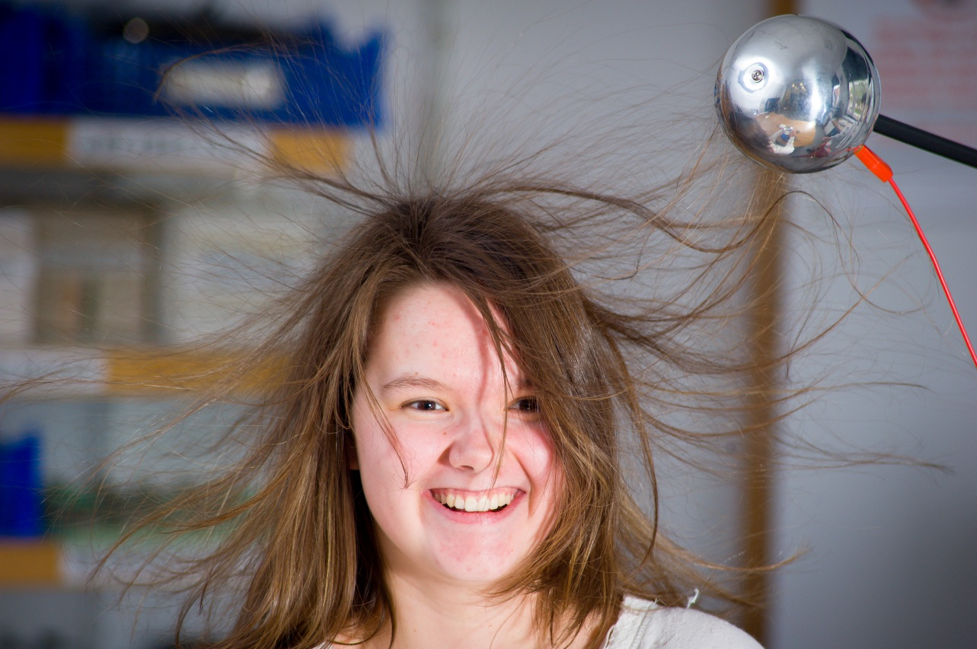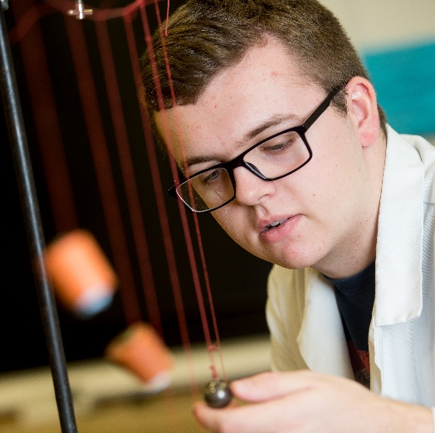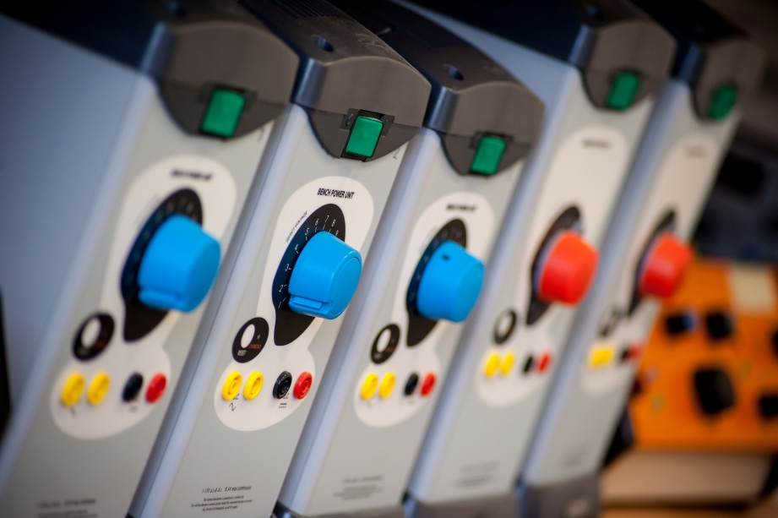

**PHYSICS** AS/A Level

AQA

Tuesley Lane, Godalming

GU7 1RS

T: 01483 423526

E: [college@godalming.ac.uk](mailto:college@godalming.ac.uk)

W: www.godalming.ac.uk

Tuesley Lane

Godalming

Surrey

GU7 1RS

T: 01483

E: [college@godalming.ac.uk](mailto:college@godalming.ac.uk)

W: [www.godalming.ac.uk](http://www.godalming.ac.uk)

What is the department like?

The Physics Department consists of three enthusiastic and well-qualified teachers. We are housed in a suite of well-equipped rooms in the main College building. There is a large laboratory with computing facilities and a range of modern equipment, and a classroom with an electronic whiteboard.

Over 150 students study Physics across the two year groups. The Department has enjoyed excellent results in recent years, with many of our students achieving top grade passes.

The department places a strong emphasis on experimental work, both to reinforce the theory and to develop practical and problem solving skills. We hope you will derive enjoyment and satisfaction from the study of Physics.

What sort of work will I be doing?

The course is delivered through theory lessons, practical sessions and individual or group tutorials. Theory lessons exist primarily for explaining the principles of the subject, and you will need to make notes for your own use. The lessons will be a mixture of formal tuition, class demonstration, problem solving and smaller practical exercises.

Each group has two teachers for theory classes, and one of these will also supervise the main weekly practical session. You will usually work individually in the laboratory and choose from a wide range of experiments. Some exist to support your understanding of Physics topics, others to introduce a particular experimental skill, and there are some exercises that introduce you to the use of the departmental IT facilities.

What is the course about?

What are the entry requirements?

The entry recommendations are five GCSE subjects at Grade C (or 4) or above including Grade 6 in Mathematics and 6 in Physics or 6-6 in Combined Science.

You do not need to have done separate sciences - we have students joining us from a wide range of schools, and many of these do not offer separate sciences.

You are also strongly recommended to take AS Mathematics alongside Physics. If you are not studying Maths, we will ask you to join a one period per week support course provided by the department.

.

You will study and learn about various aspects of matter and energy. The AS year includes some topics that follow on from GCSE studies, including **Mechanics, Electricity** and **Waves**.

You will also be introduced to some new areas of Physics including **Particle Physics** and **Quantum Physics**.

The A2 work covers **Fields and Further Mechanics, Nuclear Physics and Thermal Physics**. The A2 course also includes the study of an **Option Topic**. There is a choice from **Medical Physics**, an interesting and worthwhile application of Physics in the real world, **Astrophysics,** a popular topic in modern Physics, **Engineering Physics, Electronics** or **Turning Points in Physics**.

What are the progression routes for this qualification?

Physics is recommended for many Scientific, Engineering and Caring professions. Physics is essential for degree courses in Astronomy, Computer Technology, Engineering, Geophysics, Meteorology and Physics itself.

You are strongly recommended to combine the subject with Mathematics to at least AS level. For a Science career, research has shown that the combination Maths, Physics and Chemistry is the most versatile.

It is also possible to take Physics as a complementary course with other Arts and Humanities subjects, however you should ideally still take Maths to keep your career options open.