

What are the entry requirements?

Five GCSE subjects at Grade 4 or above including Grade 4 or above in GCSE English Language. A good grade in History would also be an advantage but it is anticipated that all who choose the subject will be newcomers to it.

How will I be assessed?

|  |  |  |  |
| --- | --- | --- | --- |
| **Module** | **Method** | **Length** | **Contribution** |
| Unit 1 | Written Exam | 2hr (A level)  1hr 30 (AS) | 33.3% (A level)  50% (AS) |
| Unit 2 | Written Exam | 2hr (A level)  1hr 30 (AS) | 33.3% (A level)  50% (AS) |
| Unit 3 | Written Exam |  | 33.3% (A level) |

All written papers will comprise of short answer questions, stimulus questions and essay questions. There is no coursework element.

What extra work can I do?

Wide reading is helpful and encouraged. Students will be expected to make use of the extensive materials relevant to Politics in the library. These include academic textbooks, in addition to regular compulsory reading of a quality daily newspaper and a quality political periodical. Frequent visits to the BBC website are also advised.

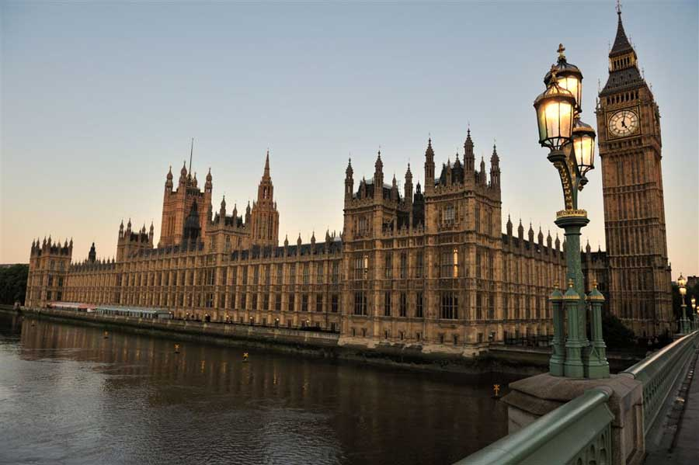

**POLITICS** AS/A Level

EDEXCEL

Tuesley Lane, Godalming

GU7 1RS

T: 01483 423526

E: [college@godalming.ac.uk](mailto:college@godalming.ac.uk)

W: www.godalming.ac.uk

Tuesley Lane

Godalming

Surrey

GU7 1RS

T: 01483

E: [college@godalming.ac.uk](mailto:college@godalming.ac.uk)

W: [www.godalming.ac.uk](http://www.godalming.ac.uk)

**Unit 1: UK Politics & Key Political Ideas**

This Unit introduces students to the key channels of communication between government and the governed in the UK. Topics studied include Parties, Democracy, Voting Behaviour and Elections. Students are encouraged to evaluate the adequacy of existing arrangements for ensuring strong lines of representative democracy and high levels of political participation.

**A level only**: Students will also look at the three key political ideologies, of Liberalism, Conservatism and Socialism. This topic introduces an overview of what the ideologies stand for, as well as some of the key thinkers of the ideology. Students also consider how they can apply the ideology to current political situations.

**Unit 2: UK Government & Additional Political Ideas**

This Unit introduces students to the key institutions that wield power in the UK and the concepts that underpin and drive them. Topics include the Executive, Parliament and the Constitution. This unit encourages students to develop a critical understanding of their role and effectiveness and of their inter-relationship.

**A level only**: Students will also look at one of Nationalism or Feminism. This topic introduces an overview of what the ideology stands for, as well as some of the key thinkers of the ideology. Students also consider how they can apply the ideology to current political situations.

**Unit 3: Global Politics (A Level only):**

This unit gives students an opportunity to develop an understanding of international topics such as the Globalisation, Human Rights and Terrorism, alongside looking at institutions such as the UN and the EU. Students will gain understanding of abstract political concepts through grounding them in contemporary real world examples and case studies that will develop an international awareness and knowledge of multiple perspectives.

What is the Department like?

Almost 200 students study Politics at Godalming College across the two years. Guiding the students through the course are staff with high levels of expertise, enthusiasm and experience in the field. Classes are invariably vibrant and interesting and fuelled by the hot political issues of the day. Our high standards of achievement were evidenced again this year by a very strong set of results at both AS and the more demanding A2, where over 50% attained an A or B grade. Departmental value added scores indicate that the Department adds strong positive value to the progression and attainment of students. We aim to develop a critical awareness of the nature of politics and the relationship between political ideas, institutions and processes. We prepare our students to be active and knowledgeable members of our society and also to develop the skills required to argue a case with relevance and coherence. As a result of their experience of Politics at Godalming, many students choose to read the subject at major British universities, including Oxford and Cambridge.

To support learning, a variety of different teaching approaches are adopted. We have an excellent collection of up-to-date material, both in the Department and in the College Library and host a lively facebook forum which provides a space for student debate. Work done in the classroom is supported by other activities, such as attending Conferences in London delivered by politicians, political journalists and academics. In recent years we have had visits from Members of the European Parliament, Jeremy Hunt, MP for Surrey South West and Baroness Parminter. Election candidates are invariably invited to campaign in College during election periods, submitting their policies and proposals to the scrutiny of the student body. Political enrichment trips to destinations such as the Houses of Parliament and also to New York and Geneva to help broaden and deepen the experience of the Politics student at Godalming College.

What is the course about?

What are the progression routes for this qualification?

Politics is taken by students doing a wide range of other subjects, in both the Arts and Sciences. At this level, Politics can be a truly complementary subject, extending and balancing a programme of study drawn from any part of the College curriculum. Our students go on to a wide range of courses and careers. A considerable number will take a degree in the subject, or a related field, such as History, English, Law, Economics, Philosophy, or Theology In addition to a wider angled view of many contemporary events and issues, those trained in Politics have developed skills of critical analysis and judgement; these are highly valued in many professions, including Law, Management, Finance, Diplomacy, Journalism and, of course, Politics.