

How will I be assessed? ⚫ 100% coursework

This is an entirely coursework assessed AS and A level subject. There are no written exams instead you are required to demonstrate your knowledge, understanding, and capabilities through you practical and design work.

At the end of your first year you will be submitting a design book, a range of A3 design sheets, and a series of models, prototypes and working design solutions.

In your first year your design book will contain evidence of the techniques we have taught you through the set exercises and short projects; evidence of your own extended project (to include research, analysis, designing, and making); preliminary design work for the exam board-set project; and final 3D design prototypes.

In your second year you will submit a personal study of the work of a designer or design movement as well as a series of projects of your choice.

|  |  |  |  |
| --- | --- | --- | --- |
| **Component** | | **Method** | **%AS** |
| **1** | Coursework | Coursework set by teacher  Portfolio of techniques, and projects. | **50** |
| **2** | **Externally Set Assignment** | Externally set Component  Own choice | **50** |
|  |  |  |  |
| **Component** | | **Method** | **%A2** |
| **1** | **Coursework** | Coursework Component  Own Projects, Personal Study | **60** |
| **2** | **Externally Set Assignment** | External set Component  Own project choice | **40** |

For both your coursework and the exam project you will be assessed on your ability to record your research and ideas; analyse and evaluate; develop ideas; realise your designs.

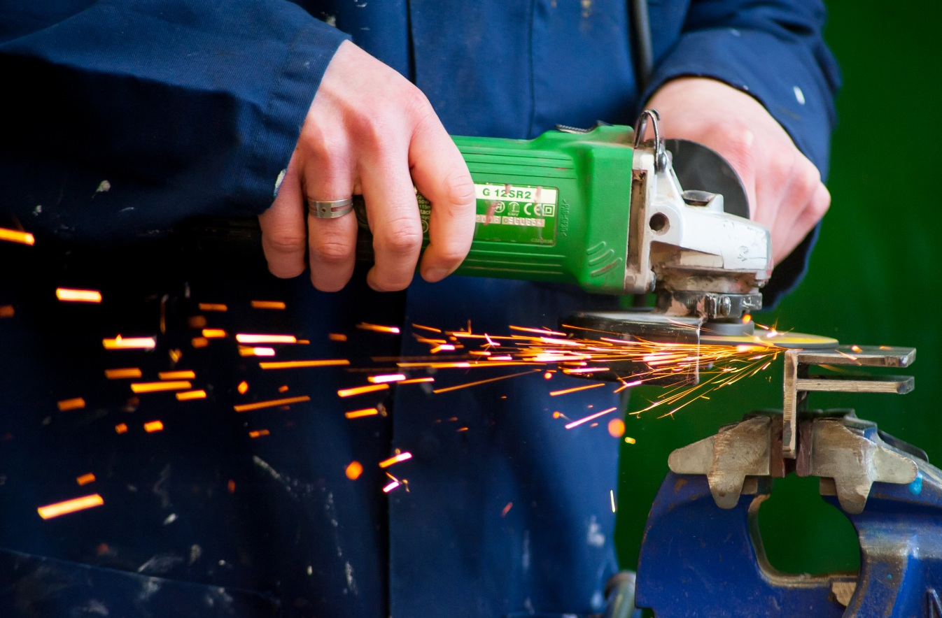

We operate an Open Access policy – which means you can use the facilities any time you do not have a lesson as well. There is a small yearly charge (currently £25) levied on this course to pay for all necessary materials to successfully complete the course.

**PRODUCT DESIGN**

**(3D DESIGN)**

AS/A Level

EDEXCEL

Tuesley Lane, Godalming

GU7 1RS

T: 01483 423526

E: [college@godalming.ac.uk](mailto:college@godalming.ac.uk)

W: www.godalming.ac.uk

Tuesley Lane

Godalming

Surrey

GU7 1RS

T: 01483

E: [college@godalming.ac.uk](mailto:college@godalming.ac.uk)

W: [www.godalming.ac.uk](http://www.godalming.ac.uk)

What are the entry requirements?

Standard college entry requirements.

Most of you will have done a GCSE Design Technology option but lots haven’t. It is not necessary because the ‘A’ level is so different from GCSE, we teach all students as if you are all starting from scratch.

This subject combines well with both the Arts (Art and Design, Textiles, Photography, and Media Studies) and the Sciences (Physics, Maths, and Further Maths) as it sits in the middle of the curriculum.

.

What are the progression routes for this qualification?

This course is highly regarded by the universities as an excellent foundation for degree study in any design field. However it is particularly useful to those of you considering architecture, engineering, furniture, interior design, theatre design, and of course especially industrial and product design. With either the AS or A Level you can simply use it as an entry subject for any university course.

What sort of work will I be doing?

Your week is divided into different

sessions initially, each designed to help improve your drawing and designing techniques. As the term progresses some

of the time is still devoted purely to techniques extending your abilities to

record your ideas as well as making; and some of the time is devoted to

understanding technological issues (material properties, manufacturing processes, and design movements). Gradually more and more

time is given over to your project work.

You will initially be designing based on three themes: furniture, product and architecture. You will then be free to choose your own project area.

A key difference you will notice from school is our departmental tutorial system. You will receive regular one-to-one sessions with your lead teacher to help discuss your progress and to plan your project work.

Visits trips and speakers also play an important part in the course. Each year we take students to London, to the New Designers’ Degree Show and to Munich to tour the BMW factory, the Allianz Arena, and The Pinakothek Design Museum.

What are the facilities?

A design studio with CAD/CAM facilities (including laser and 3D printing machines) as well as a well-equipped workshop. We use Corel, Photoshop, and proDESKTOP software in our teaching areas. You will

also be given a copy of our design software for use on your own computer.

You will be involved in designing, creating, and solving problems in order to meet functional and aesthetic needs. The emphasis is on learning how and why products are designed and made, and how you as a designer can make improvements.

If you like the idea of designing using freehand drawing as well as computer-generated techniques, and you want to make products using a variety of resistant materials then this is the course for you.

In your first year, for AS level you will develop your designing, sketching, CAD, and making capabilities through a series of short projects and activities culminating in your own project. You will also undertake an exam board set project at the end of the year.

In your first term you will rotate every two weeks through a variety of short projects, each developing your skills and techniques in the following areas

⬥ sketching/drawing  CAD software  workshop

⬥ designing  modeling and prototyping  research

In your second term you will move on to your own extended project work. Finally in your third term you will be working on your own response to an exam set theme.

In your second year, for A level you will extend and develop further your technical understanding of materials and manufacturing processes as well as your capabilities to generate ideas through drawing and CAD. You will undertake a personal study of a designer or design movement as well as complete a series of short projects together with an extended project of your own choosing. In your final period, you will also complete a project set by the exam board in response to their theme.

If you enjoy working with resistant materials such as wood, metals, and plastics and have an interest in designing products, furniture, engineering, architecture and building design then opt for this three-dimensional product design course.

What is the course about? ARCHITECTURE FURNITURE PRODUCT DESIGN