

How will I be assessed?

Assessment is entirely by examination, although individual research is encouraged during the course. It is available as an AS Level and an A level, however, it is assessed in a linear fashion covering three units. Knowledge of sociological research methods is integrated into these units.

Skills of analysis and evaluation are emphasized in the A level and it is important to focus on links between the subject matter across the course.

**Paper 1:** Education with theory and methods (first year topic)

**Paper 2:** Sociology of the Family (first year topic), Social Stratification (second year topic)

**Paper 3:** Crime and Deviance with theory and methods (second year topic)

What extra work can I do?

You will be given guidance on what you need to do to support your class work but you can help your progress and understanding and give yourself a better chance of a high grade if you get into good habits early and do some background work.

The mass media (in a critical way) can be helpful. Your teachers and course materials will guide you towards important current debates, but there is no substitute for knowledge you “own” yourself in discussion of current social policies and trends, especially as events can move quickly during the course itself (look at the massive changes in the education system in recent years, for example). Newspapers are helpful, as are good TV and radio programmes and selective use of Internet sources.

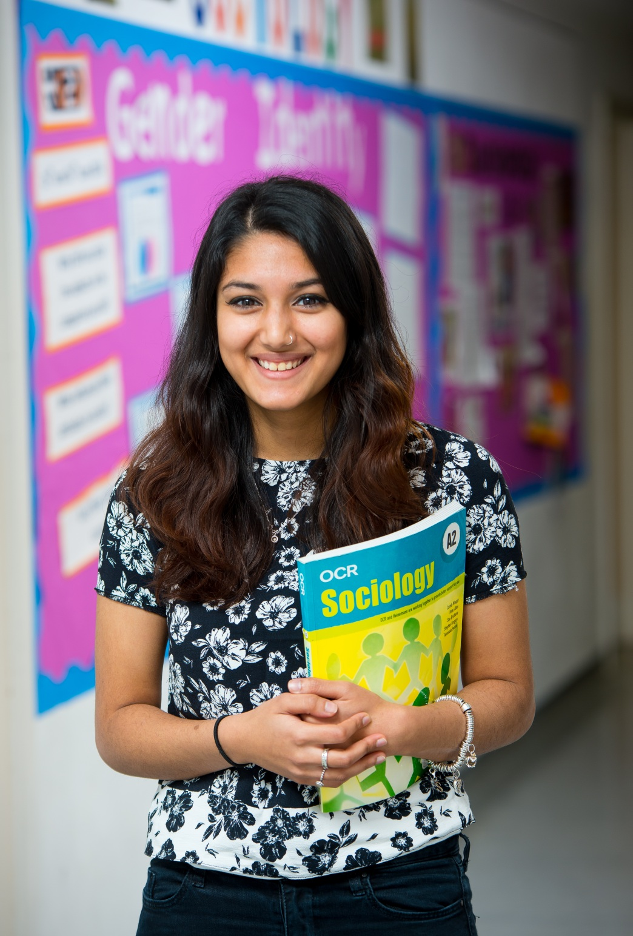

**Sociology** AS and A Level

AQA

Tuesley Lane, Godalming

GU7 1RS

T: 01483 423526

E: [college@godalming.ac.uk](mailto:college@godalming.ac.uk)

W: www.godalming.ac.uk

Tuesley Lane

Godalming

Surrey

GU7 1RS

T: 01483

E: [college@godalming.ac.uk](mailto:college@godalming.ac.uk)

W: [www.godalming.ac.uk](http://www.godalming.ac.uk)

What is the department like?

The Sociology Department is principally based in two adjoining classrooms. Each classroom is fitted with ILT and is well resourced.

We are enthusiastic, experienced and, we hope, approachable! We are all involved as a team in developing course materials and supporting students to develop their knowledge and skills.

The course is written around a “spine” of workbooks written by us, using a wide range of sources and supported by key textbooks and a range of supporting revision materials. These contain a variety of activities to deliver and reinforce the knowledge and skills you will need to be a critical Sociology student. In addition we use a variety of classroom activities encouraging skills of argument and debate.

What sort of work will I be doing?

Sociology students will engage in a variety of different types of class work, in groups, individually and the whole class. Where possible we like to find ways of students engaging in their own work using flexible learning workbooks. Our most successful students will take full advantage of the opportunities this provides for owning and developing their knowledge and skills.

What students say:

‘This course is definitely not a ‘doss’. The teachers are amazing and thorough and will do whatever they can to help- even when they no longer teach you.’ Sophie

‘Don’t take it because you think it will be easy or a ‘soft’ subject… the content is really interesting but the theory takes a while to get your head around’ Chloe

‘This subject has been useful in my other subjects [History, Psychology and English] because the topics overlap’ Megan

‘It’s good if you enjoy class debates, regular group interaction and discussion’ Kyle

The core of our course focuses upon developing an understanding of the ideas and concepts of different sociological theories to understanding the nature of society, how it changes, and how it shapes our life chances. These theories vary greatly in their approaches to understanding society. You will develop skills to critically compare and evaluate them in reference to contemporary materials. There is an emphasis upon the ways in which sociologists test these theories through using research methods. Sociology encourages you to develop a critical understanding of their work and of the world around you.

What is the course about?

What are the entry requirements?

You must have a minimum of five GCSE subjects at Grade 4 or above. We have highlighted the need for a good grade in English because of the essay based assessment and the use of complex terminology. It is also important to have done well in another Humanities subject (typically History, Geography, Religious Studies or even Sociology) because of some of the similarities in content and skills required.

Most students will not have had the chance to take Sociology at GCSE, and the course is written and delivered with this in mind. Whilst there may be some initial advantages for students who have taken the GCSE, the AS and A level will demand a wider range of skills and depth of understanding.

Most important, you should have an interest in the world around you and in current affairs as they shape our lives. Do you watch the news? Do you have opinions on what you see on it? Do you enjoy challenging these views?

What skills will I develop during this course?

Sociology will give you the opportunity to develop important key skills of argument and research. There is a strong emphasis in assessment on essay writing (as in many other subjects) and the potentialities and problems of social research.

What are the progression routes for this qualification?

Sociology is a very well established A level, both nationally and at this college. We have not found any university admissions departments who do not regard it as a full A level for any Social Science or Humanities degree.

Sociological content regularly appears as a part of many vocational courses at a higher level – for courses in management, marketing, caring professions, teaching, etc. Our students have gone on to make careers in journalism, the law, political research, social work, teaching, marketing, and many other areas where a critical understanding, evaluative skills and the ability to communicate and persuade are important.